BANK OF ISRAEL

Office of the Spokesperson and Economic Information

September 7, 2025

Press Release:

Foreign Exchange Reserves at the Bank of Israel, August 2025

Israel’s foreign exchange reserves at the end of August 2025 stood at $230,321 million, an increase of $3,553 million from their level at the end of the previous month. The level of the reserves relative to GDP was 41.0 percent (Figure 1).

The increase was mainly explained by a revaluation[1] of the reserves totaling approximately $3,759 million, which was partly offset by foreign exchange activity by the government totaling about $209 million.

**Israel's Foreign Exchange Reserves** ($ million)

|  |  |  |  |
| --- | --- | --- | --- |
| **Date** | **Reserves excluding IMF (including reserves bought under the natural gas purchase program)** | **Reserves at the IMF[2]** | **Total Foreign Exchange Reserves** |
| August 2025 | 225,695 | 4,626 | 230,321 |
| July 2025 | 222,157 | 4,611 | 226,768 |
| June 2025 | 223,651 | 4,599 | 228,250 |
| May 2025 | 219,086c | 4,553 | 223,639c |
| April 2025 | 217,489 | 4,546 | 222,035 |
| March 2025 | 214,394c | 4,416 | 218,810c |
| February 2025 | 215,898c | 4,356 | 220,254c |
| January 2025 | 211,710c | 4,358 | 216,068c |
| December 2024 | 210,170c | 4,400c | 214,570c |
| November 2024 | 212,684 | 4,416 | 217,100 |
| October 2024 | 211,638 | 4,436 | 216,074 |
| September 2024 | 215,807 | 4,570 | 220,377 |
| August 2024 | 212,847c | 4,538 | 217,385c |

**Figure 1**

**Level of foreign exchange reserves, and their ratio to GDP, 2008–2025**

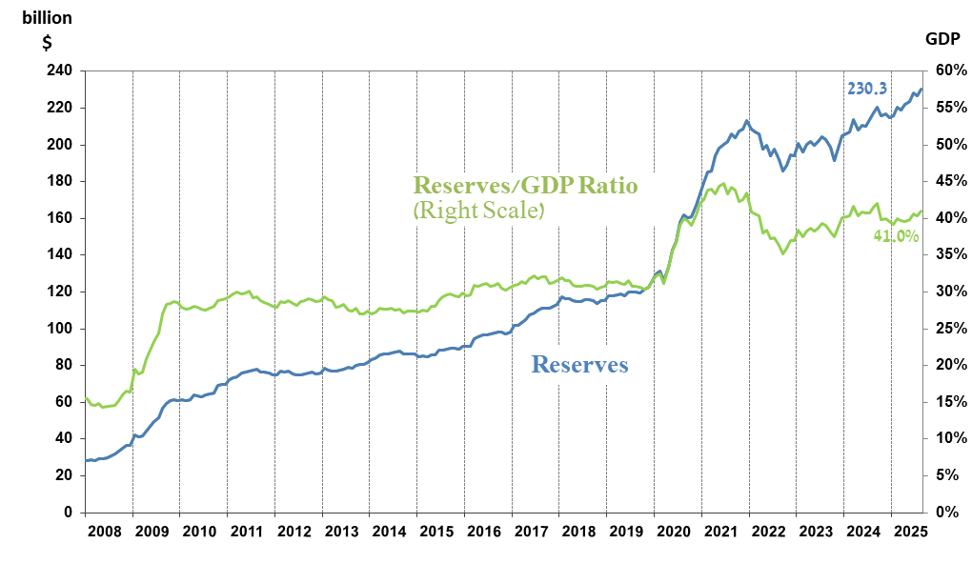

1. Including Bank of Israel payments and receipts in foreign currency.
2. b This column includes Special Drawing Rights (SDRs), the balance of NAB loans, and the balance of Israel's reserve tranche at the IMF.

   c Updated after the original date of publication.