

BANK OF ISRAEL

Office of the Spokesperson and Economic Information

Press release

February 8, 2022

**New Bank of Israel study: Creditor rights, implicit covenants, and the quality of accounting information**

* The study examines the effect of a precedent ruling from 2013 that granted power to creditors to force insolvency proceedings on firms whose value of assets is lower than the value of their liabilities, even in the absence of an explicit covenant on the bond’s debt certificate.
* Based on the market’s response, the study found that the ruling, which makes it possible to force debt restructuring at an earlier stage, when the company is still in a relatively benign state, was beneficial to bondholders (creditors) at the expense of shareholders. The study also found that the net value of firms in distress that were affected by the ruling increased relative to other firms. There are indications that firms in distress that were affected by the ruling raised more capital, but it seems that some of them also increased their value by using aggressive accounting. As a result, the financial statements of these firms provide less credible information to investors.
* This is the first study that examines the impact of an increase in creditors’ ability to force firms into debt restructuring, and is unique in its focus on the impact of creditors’ rights on the quality of firms’ financial reporting and accounting policies. The findings show that firms’ reactions to changes that are intended to increase creditors’ rights in certain situations may mitigate those changes.

Creditor rights are essential for the development of private credit markets that enable firms to borrow money in order to finance their operations. However, a number of studies in recent years have found that strong creditor protection rules may have potential adverse effects, such as less willingness on the part of firms to take business risks or to leverage themselves. A new study by Assaf Hamdani of Tel Aviv University, Yishay Yafeh of Hebrew University, Yevgeny Mugerman of Bar-Ilan University, Ruth Rooz of Hebrew University, and Nadav Steinberg of the Bank of Israel uncovers another negative effect of a reform that increased creditors’ rights.

The study examines a 2013 ruling of the Tel Aviv District Court, which gave creditors the power to force firms whose total liabilities exceed their total assets (negative equity) to enter debt restructuring even without a specific covenant in the debt certificate.[1] The study found that the bond prices of firms that were expected to be affected by the ruling responded positively to the ruling, while the share prices of those firms responded negatively, apparently because of creditors’ improved ability to force firms into debt restructuring at an earlier stage and prevent opportunistic actions by controlling shareholders and executives that could worsen the state of the company prior to the restructuring.

The study found that distressed firms that were affected by the ruling, and therefore had a greater incentive to maintain positive equity in order to avoid debt restructuring and the loss of control of the company, were able to significantly increase their equity. In particular, in the years following the ruling, there were far fewer firms that were affected by the ruling that reported negative equity than there were prior to the ruling (Figure 1).



What explains the increase in equity of the firms affected by the ruling? The study found an increase in share offerings among some of the firms, mainly those that had particularly low equity prior to the ruling. These firms were in significant financial distress, and following the ruling they were in material danger of entering debt restructuring. Therefore, many of them reacted by raising additional capital from shareholders. This is a way to improve the financial state of a company in distress, and it is good for creditors because it brings new money into the company that can be used to meet its liabilities. However, alongside the increase in share offerings, the study found that the ruling also led to a change in firms’ accounting policies. The study shows that common measures of accounting conservatism declined among these firms. Among other things, there was a greater-than-expected increase in a phenomenon known in the professional literature as “long-term discretionary accruals”—where firms present accounting data in a legal way, but where the data presents a rosy picture, sometimes too rosy, regarding the company’s actual results (Figure 2).

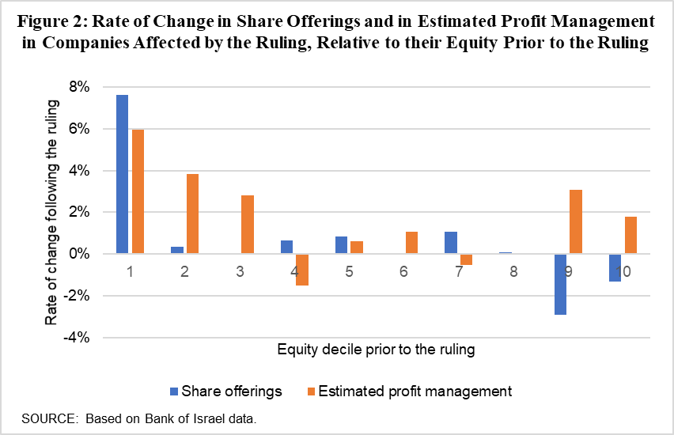

Finally, the study found evidence that the accounting aggressiveness that helped improve the firms’ balance sheets in the short term is correlated with lower profitability in the following years. More importantly, long-term discretionary accruals and a lack of conservatism in reporting may make the firms’ financial statements less informative, and thereby harm the value they provide to the firms’ stakeholders, particularly creditors. Accordingly, the study found that following the ruling, bondholders reacted more weakly to the financial statements of the firms that were affected by the ruling.

The study joins an increasing number of articles using a legislative or legal shock to examine the effects of increased creditors’ rights on company behavior. This is the first study that examines the impact of an increase in creditors’ ability to force firms into debt restructuring, and is unique in its focus on the impact of creditors’ rights on the quality of firms’ financial reporting and accounting policies. The findings show that changes that are intended to give creditors more rights in certain situations—changes that should be positive in many cases—may also lead to negative unintended results. On one hand, the power given to creditors may give firms in serious distress the incentive to raise capital or, alternatively, enable creditors to enforce a timely debt restructuring if the company cannot improve its financial situation. On the other hand, the increase in creditors’ rights may give firms in distress the incentive to inflate their profits and balance sheets, and thereby reduce the quality of information in the capital market.

1. The ruling in Civil Case 36681-04-13, Hermetic Trust (1975) Ltd. v IDB Development Company Ltd. (April 30, 2013). The ruling was handed down by Judge Eitan Orenstein in response to a request by the trustees in three of IDB’s bond series to force the company into debt restructuring. Judge Orenstein ruled that attorney Hagay Olman should be appointed as an observer of the company, and that Eyal Gabay should be appointed as an economic specialist to evaluate the state of the company, despite the company’s argument that a restructuring could not be forced upon it. The court’s ruling was precedent-setting in determining that creditors can force a debt restructuring on the company if they succeed in showing that the company is insolvent, even though the company had thus far met all of its payments and did not breach any covenant in the debt certificate. The ruling was surprising and controversial, and there were two unsuccessful attempts to challenge it in the Supreme Court.