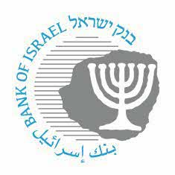

**BANK OF ISRAEL**

Office of the Spokesperson and Economic Information

October 18, 2022

Press Release:

**The Bank of Israel’s position regarding the separation of the Cal credit card company from Bank Discount**

On June 10, 2021, the Bank of Israel established a steering committee to examine the issue of separating the Cal credit card company from Bank discount and to make recommendations to the Governor regarding the Bank of Israel’s position on the matter.

The members of the steering committee were Director of the Research Department Prof. Michel Strawczynski, who also serves as cochair of the Committee to Examine Competition in the Credit Market; Supervisor of Banks Yair Avidan; and Head of the Bank of Israel’s Payment and Settlement Systems Department Oded Salomy.

The steering committee examined the issue through an internal work team. As part of the work, the team used a large number of broad databases, and implemented various econometric methodologies.

The team’s analysis provided many findings, some of which support the separation of Cal from Bank Discount, and some of which were less supportive of such a move. After weighting all of the findings, including those relating to some of the results of separations that were already made with regard to other companies and the effect of a nonuniform playing field where two credit card companies have already been separated from other banks, **the Bank of Israel’s position is that the separation should be completed, and that the exclusion of Bank Discount from the reform should be cancelled (by changing the benchmark in the law to a bank with a broad volume of activity).**