

**BANK OF ISRAEL**

Office of the Spokesperson and Economic Information

July 7, 2024

Press Release:

Foreign Exchange Reserves at the Bank of Israel, June 2024

Israel’s foreign exchange reserves at the end of June 2024 stood at $210,278 million, a decrease of $232 million from their level at the end of the previous month. The level of the reserves relative to GDP was 41.3 percent (Figure 1).

The decrease was mainly the result of the government’s foreign exchange activities totaling approximately $1,194 million, (which include a transfer of about $340 million by the government to the Citizens of Israel Fund account). This decrease was partly offset by a revaluation[1] that increased the reserves by approximately $949 million.

**Israel's Foreign Exchange Reserves** ($ million)

|  |  |  |  |
| --- | --- | --- | --- |
| **Date** | **Reserves excluding IMF (including reserves bought under the natural gas purchase program)** | **Reserves at the IMF[2]** | **Total Foreign Exchange Reserves** |
| June 2024 | 205,851 | 4,427 | 210,278 |
| May 2024 | 206,035c | 4,475 | 210,510c |
| April 2024 | 203,656 | 4,453 | 208,109 |
| March 2024 | 209,261c | 4,480 | 213,741c |
| February 2024 | 202,326c | 4,495 | 206,821c |
| January 2024 | 201,597 | 4,528 | 206,125 |
| December 2023 | 200,090c | 4,604c | 204,694c |
| November 2023 | 193,590 | 4,579 | 198,169 |
| October 2023 | 186,675 | 4,560 | 191,235 |
| September 2023 | 194,025 | 4,528c | 198,553c |
| August 2023 | 198,338 | 4,518 | 202,856 |
| July 2023 | 200,086c | 4,579 | 204,665c |
| June 2023 | 197,363c | 4,513 | 201,876c |

**Figure 1**

**Level of foreign exchange reserves, and their ratio to GDP, 2007–2024**

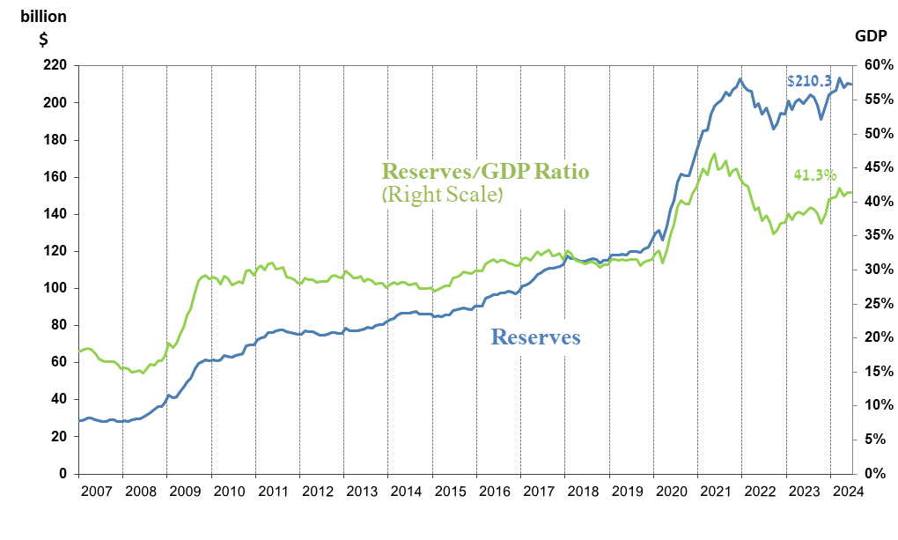

1. a Includes Bank of Israel payments and receipts in foreign currency.
2. b This column includes Special Drawing Rights (SDRs), the balance of NAB loans, and the balance of Israel's reserve tranche at the IMF.

   c Updated after the original date of publication.