

March 21, 2023

Press Release

Israel’s International Investment Position (IIP),

fourth quarter of 2022

* **In the fourth quarter of 2022, the balance of assets held abroad by Israeli residents increased by approximately $25 billion (about 4 percent), to about $643 billion at the end of December. The increase was mainly due to a rise in the prices of foreign securities held by Israelis.**
* **Outstanding liabilities to abroad increased by approximately $4 billion (about 1 percent) in the fourth quarter, to about $475 billion at the end of the quarter. The increase was primarily due to growth in the balance of direct investments, which was partly offset by realizations in the tradable securities portfolio.**
* **Israel’s surplus of assets over liabilities vis-à-vis abroad increased in the fourth quarter by approximately $21 billion (about 14 percent), to about $168 billion at the end of the quarter.**
* **The surplus of assets over liabilities vis-à-vis abroad in debt instruments alone (negative net external debt) increased during the fourth quarter by about $11 billion (5 percent), to approximately $207 billion at the end of December.**
* **The ratio of gross external debt to GDP increased by 0.3 percentage points during the course of the third quarter, to about 29.8 percent at the end of December. The decline in the debt to GDP ratio in the third quarter reflected a decline of about 3 percent in the balance of external debt and an increase of about 1 percent in GDP (in dollar terms).**

Table 1: Asset and liability balances, and changes in them

A table detailing the balance of Israel’s assets and liabilities vis-à-vis abroad, and the changes in those categories.  The table can be found in the Excel file attached to this notice in the “Table” worksheet.

1. **The balance of Israel’s assets abroad**

In the fourth quarter of 2022, the value of the assets held abroad by Israeli residents increased by about $25 billion (about 4.1 percent) to about $643 billion at the end of December. The increase in the balance was mainly due to a rise in the balance of investments in the tradable securities portfolio. Overall in 2022, the balance of assets held abroad by Israelis declined by about $59 billion (8.5 percent), mainly due to price declines abroad, which reduced the balance of Israelis’ securities portfolio.

* **The value of direct investments** increasedin the fourth quarter by about $2 billion, mainly as a result of profits accrued on investments.
* **The value of the securities portfolio** increased during the fourth quarter by about $9 billion (about 4 percent) mainly as a result of price increases on foreign securities held by Israelis.

During the fourth quarter, there were investments in the securities portfolio abroad totaling about $1 billion. Net investments in bonds totaling about $4 billion were partly offset by realizations totaling about $3 billion in foreign equities.

The banking sector invested about $2 billion in foreign bonds. In contrast, institutional investors realized investments in foreign equities totaling about $2.5 billion (Figure 1).

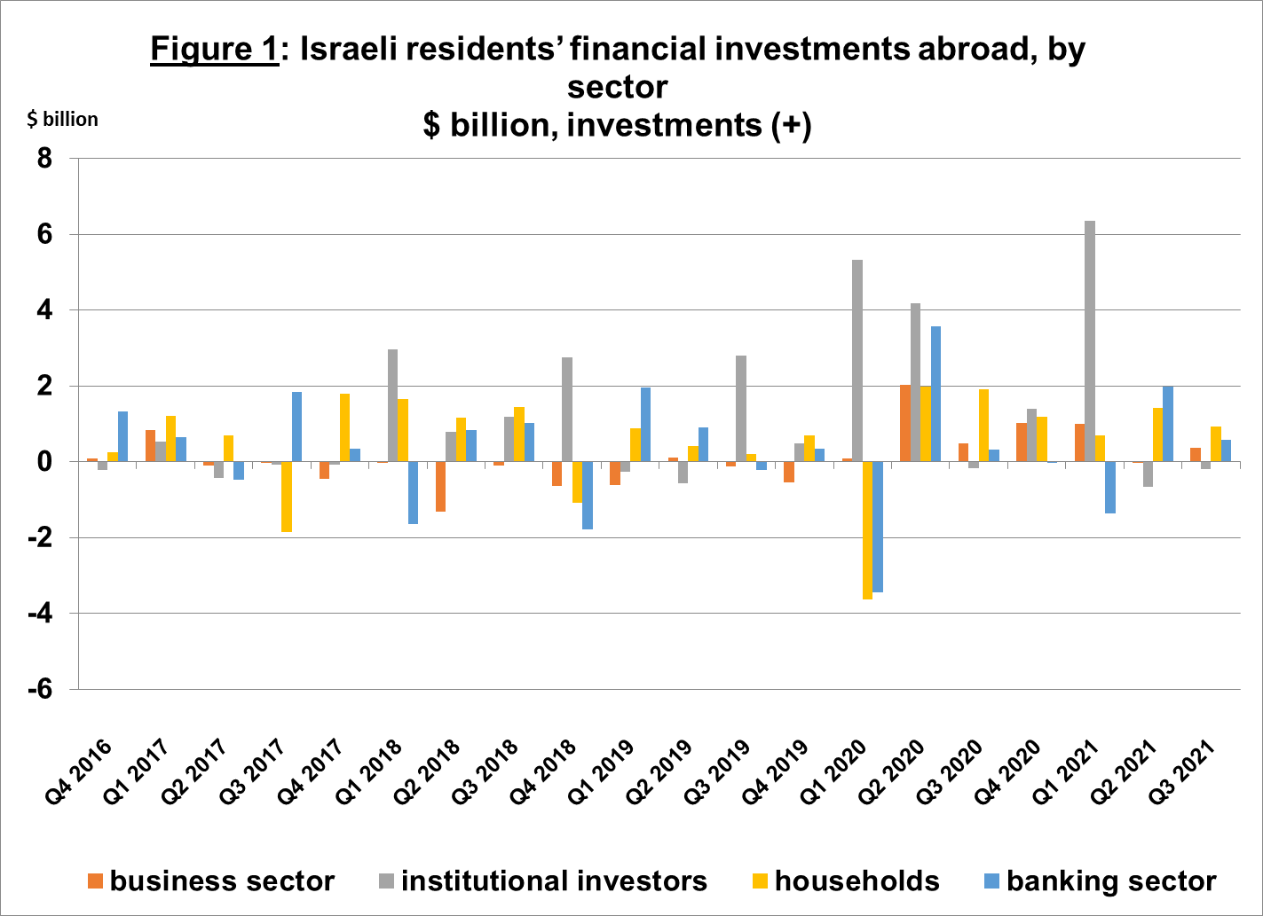

Source: Bank of Israel data and processing1.

* **The value of other investments** abroad increased by about $2.4 billion (about 1.8 percent) in the fourth quarter, mainly due to price increases totaling about $2.3 billion.
* **The value of reserve assets increased** during the third quarter by about $8 billion (about 4 percent), to about $194 billion at the end of December. The change was mainly due to a $4.4 billion increase in the dollar value of the reserve assets and price increases totaling about $3.4 billion.
* **The composition of Israelis’ securities portfolio abroad**: During the course of the fourth quarter, the share of equity instruments in Israeli residents’ portfolio abroad remained at 44 percent at the end of December. Accordingly, the share of debt instruments remained at 56 percent at the end of December.

1. **Israel’s liabilities to abroad**

The balance of Israel's liabilities to abroad increased by about $4 billion (about 1 percent) during the fourth quarter, to about $475 billion at the end of the quarter. The increase was mainly due to nonresidents’ direct investments in Israel.

* **The value of direct investments in the economy** increased during the fourth quarter by about $8 billion (about 3.5 percent), mainly due to net direct investments in share capital totaling about $9 billion, of which about $2 billion was in respect of accumulated profits on investments.
* **The value of the securities portfolio** declined by about $3 billion (about 1.6 percent) during the fourth quarter, as a result of realizations totaling about $3 billion and declines in equity prices totaling about $1 billion. In addition, the shekel’s appreciation against the dollar during the quarter increased the dollar value of the investment portfolio.
* **The value of nonresidents' financial portfolio on the Tel Aviv Stock Exchange,** which makes up a part of nonresidents’ investments in Israel, declined by about $1.5 billion in the fourth quarter, to about $88 billion at the end of December. The decline took place despite net investments in equities and in mutual funds totaling about $0.9 billion (Figure 2 and Figure 3).

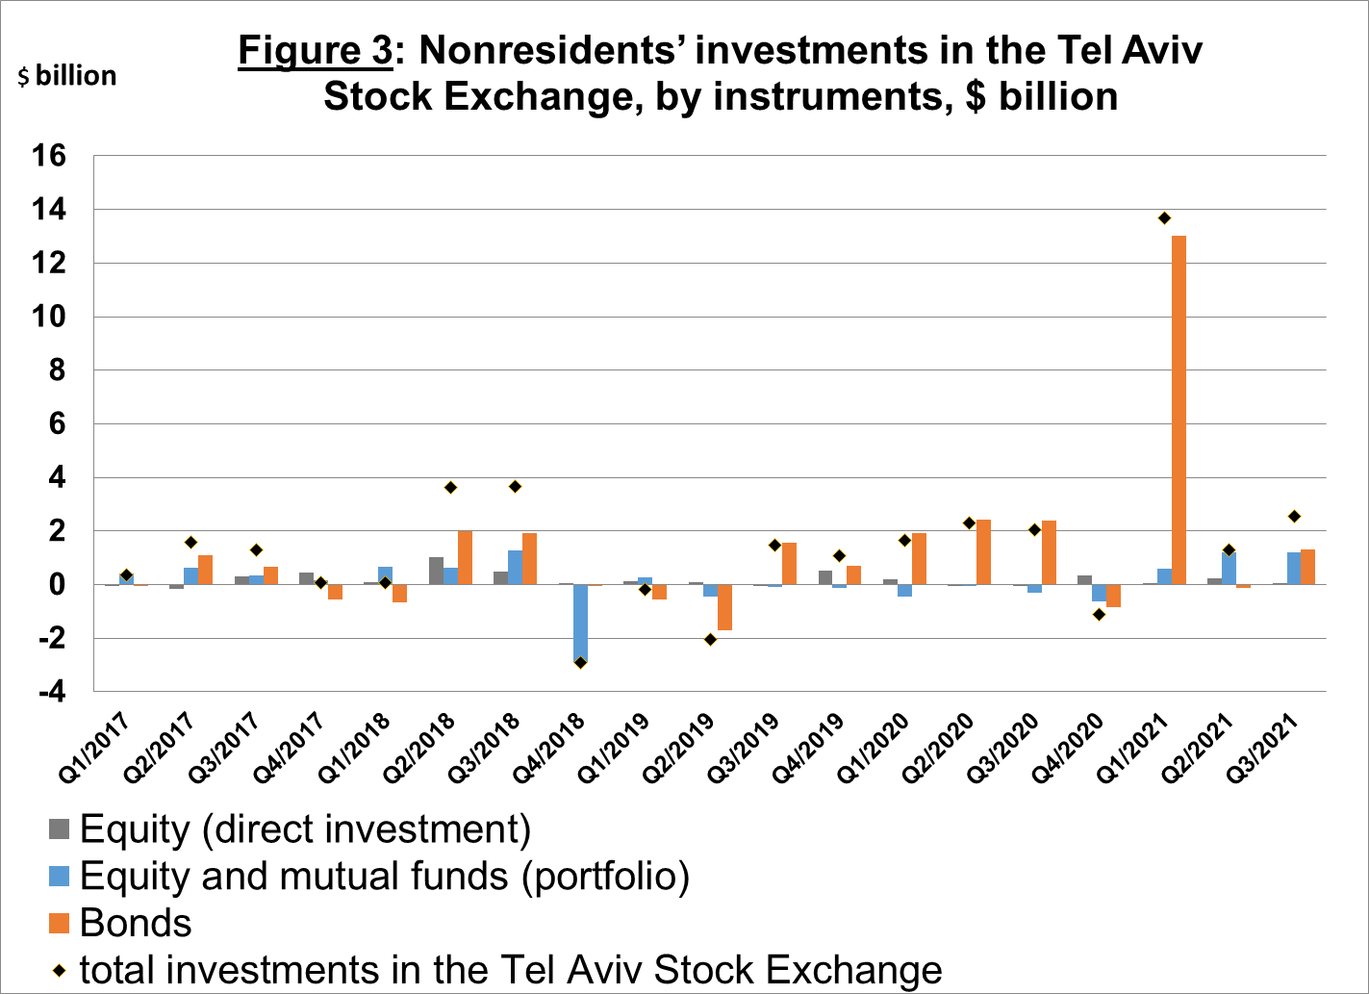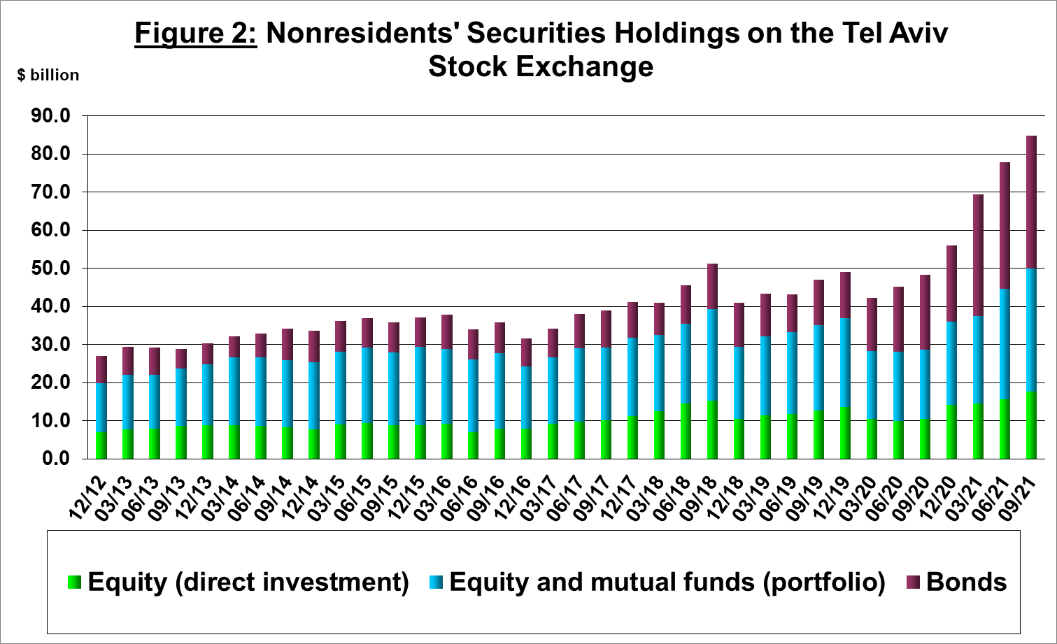

Source: Israel Securities Authority, and Bank of Israel data and processing1.

**The value of other investments in the economy** declined by about $0.7 billion (about 1.2 percent) in the fourth quarter, to about $58 billion. The decline was mainly due to withdrawals totaling about $1.5 billion from nonresidents’ deposits.

**The balance of liabilities in debt instruments alone,** which makes up **Israel's gross external debt,** declined by about $0.3 billion (0.2 percent) in the fourth quarter, to about $153 billion.

**The ratio of gross external debt to GDP** increased by about 0.3 percentage points during the course of the third quarter, to 29.8 percent at the end of December. The increase in the debt to GDP ratio reflected an increase of about 1 percent in the balance of external debt compared with a decline of about 0.3 percent in GDP (in dollar terms) (Figure 4).

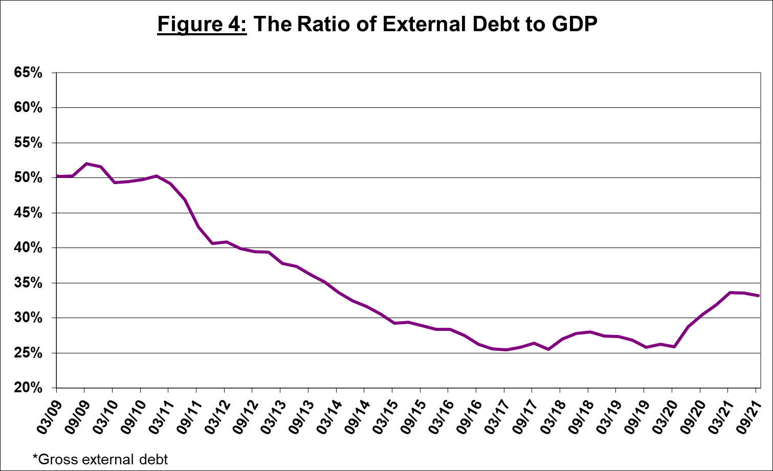

Source: Israel’s Ministry of Finance, Israel’s Central Bureau of Statistics, and Bank of Israel data and processing1.

1. **Israel’s surplus assets over liabilities vis-à-vis abroad**

An increase in outstanding assets that was greater than the increase in outstanding liabilities led to an increase of about $22 billion (about 15 percent) in surplus assets over liabilities vis-à-vis abroad, which totaled about $168 billion at the end of December (Figure 5).

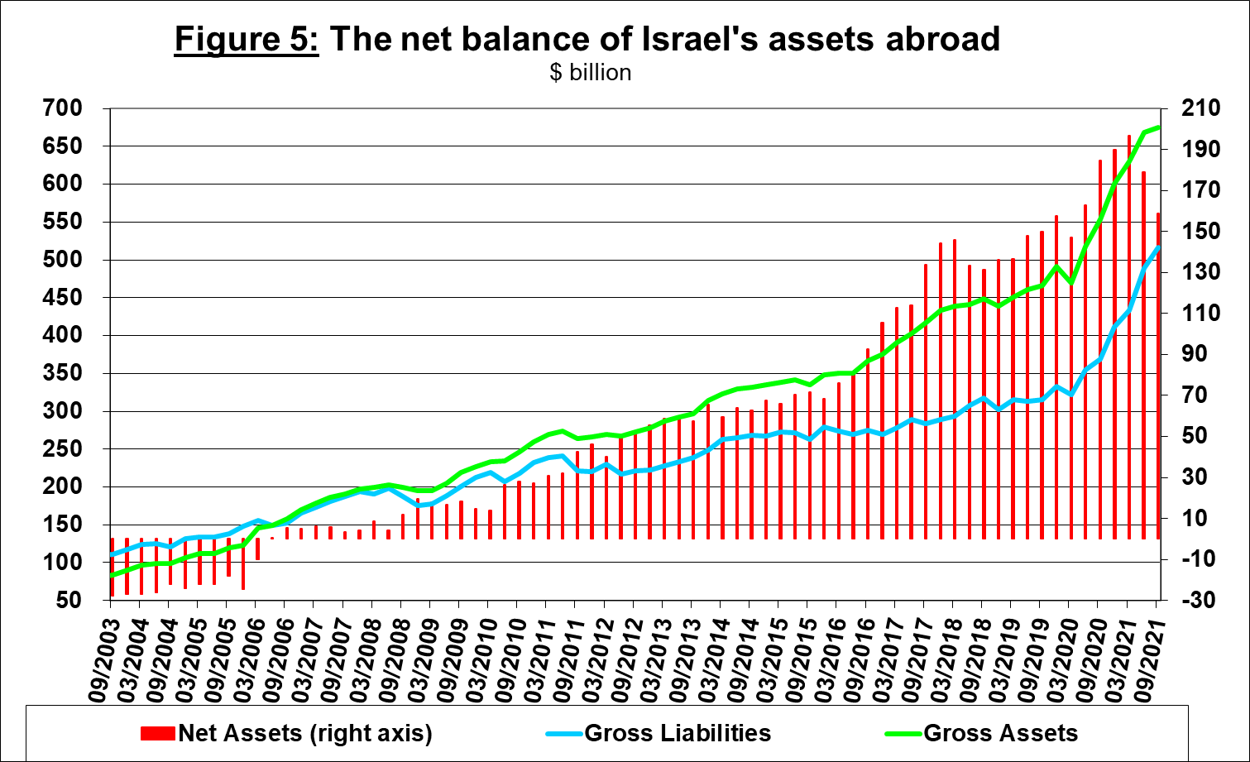

Source: Bank of Israel data and processing1.

1. **Net external debt**

The surplus of assets over liabilities vis-à-vis abroad in debt instruments alone (negative net external debt) increased by approximately $12 billion (about 6 percent) during the fourth quarter, to $208 billion at the end of December (Figure 6).

**The balance of assets in debt instruments** increased by about $14 billion in the fourth quarter, to about $361 billion at the end of the quarter, of which about $194 billion is the Bank of Israel's foreign exchange reserves. This balance reflects a coverage ratio of 2.3 times the gross external debt.

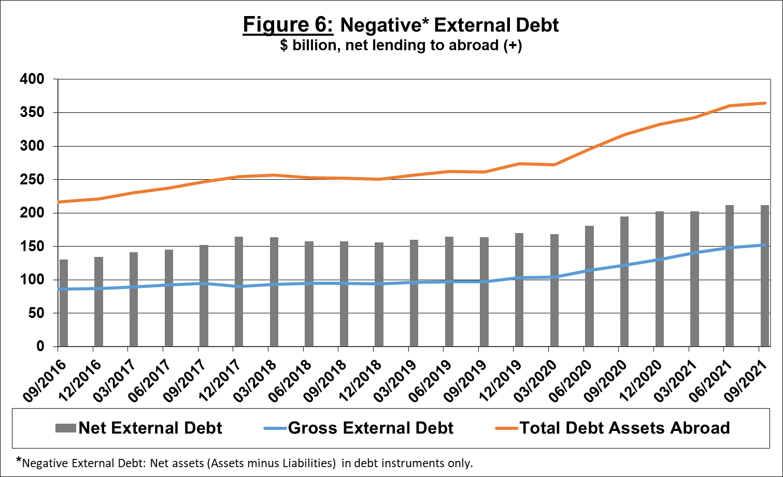

Source: Israel’s Ministry of Finance, and Bank of Israel data and processing[1].

[For the complete data file, click here](http://www.bankisrael.gov.il/deptdata/pik_mth/pikmth_e.htm).

1. Bank of Israel data and processing: The Bank of Israel’s Information and Statistics Department collects data from numerous varied sources. Most of the data on the economy’s activity vis-à-vis abroad are received by force of a Bank of Israel Order, from direct reports by corporations and individuals to the Bank of Israel. (See: “Information Regarding Foreign Exchange Market Developments in Israel”, 5770–2010). Additional data used for measuring economic activity vis-à-vis abroad are received by reports from the Bank of Israel’s Accounting Division, the Ministry of Finance, the Central Bureau of Statistics, the Israel Securities Authority, domestic banks and other financial intermediaries, and institutional investors. The Department carries out estimations and processing on data received from the various sources.