

BANK OF ISRAEL

Office of the Spokesperson and Economic Information

November 4, 2024

Press Release:

Israel’s foreign currency market in the third quarter of 2024

**1. The Exchange Rate**

**A strengthening of the shekel alongside a weakening of the US dollar worldwide.**

During the course of the third quarter, the shekel strengthened by about 1.3 percent against the US dollar, and weakened by 3.3 percent against the euro. In addition, the shekel weakened by 1.1 percent against the currencies of Israel's main trading partners, in terms of the nominal effective exchange rate (i.e., the trade-weighted average shekel exchange rate against those currencies).

In parallel, the US dollar weakened against most of the world’s major currencies (Figure 2) during the quarter, including by approximately 11.4 percent against the Japanese yen, and by 4.5 percent against the euro.

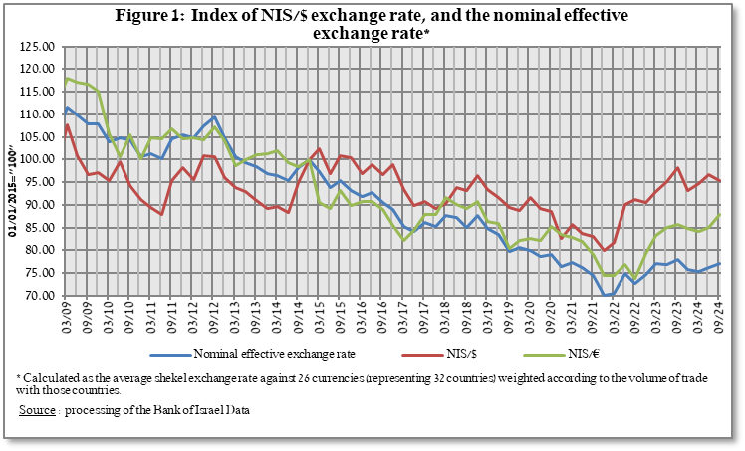

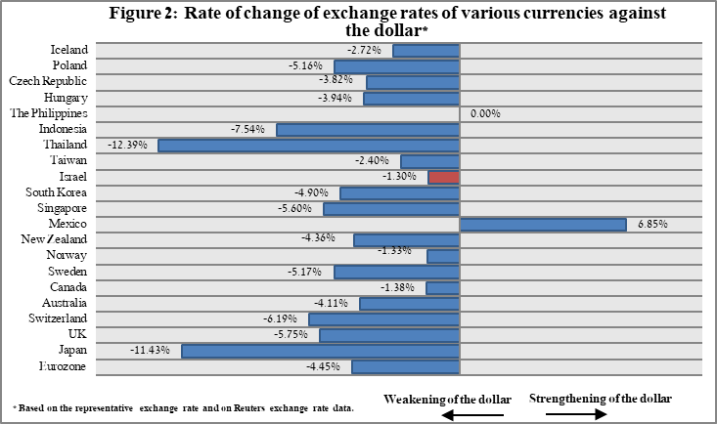

**2. Exchange Rate Volatility**

**Decline in actual volatility, alongside an increase in implied volatility**

The standard deviation of changes in the shekel/dollar exchange rate, which represents its **actual** volatility, declined by 1.4 percentage points during the quarter, to an average level of 10.1 percent.

The average implied volatility in over-the-counter shekel/dollar options—those traded outside the stock exchange—which is an indication of **expected** exchange rate volatility, increased by one percentage point during the quarter, to an average level of about 11 percent.

For comparison, the average level of implied volatility in foreign exchange options in emerging markets was 10 percent at the end of the quarter, an increase of 0.2 percentage points from its level at the end of the previous quarter. The average level of implied volatility in advanced-economy markets was 8 percent during the quarter, an increase of about 1.1 percentage points from the previous quarter (Figure 4).

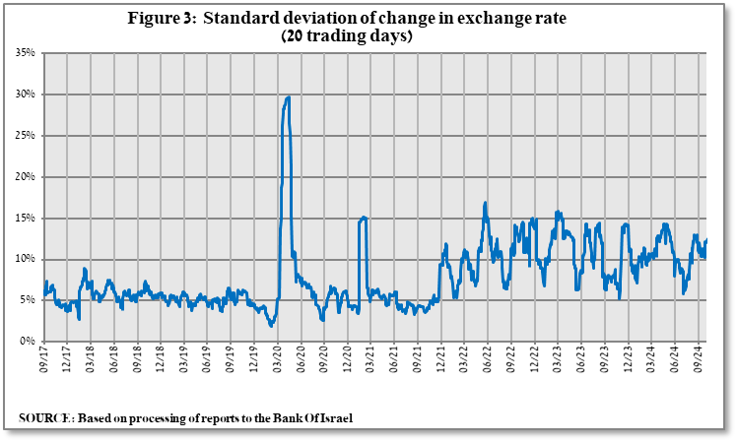

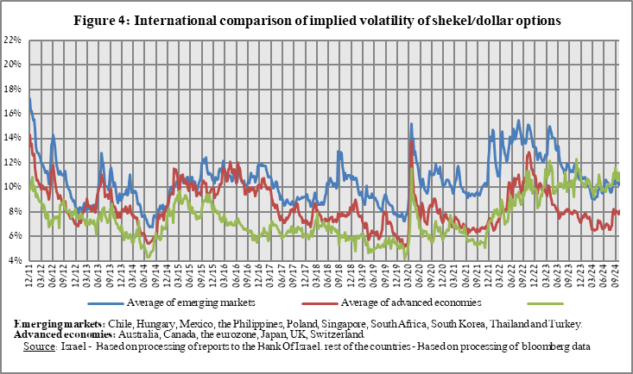

**3. The Activity of the Main Segments in the Foreign Exchange Market[1]**

During the third quarter, there was a change in the trend of activity of the main market segments. **Nonresidents** madea shift from net foreign currency purchases in the first half of the year to net foreign currency sales totaling about $6.2 billion in the third quarter. In contrast, **institutional investors (pension funds, provident funds, and insurance companies)** and the business sector moved from net foreign currency sales in the previous quarter to net foreign currency purchases in the third quarter. **The financial** sector continued to make net purchases in the third quarter, although at a smaller volume.

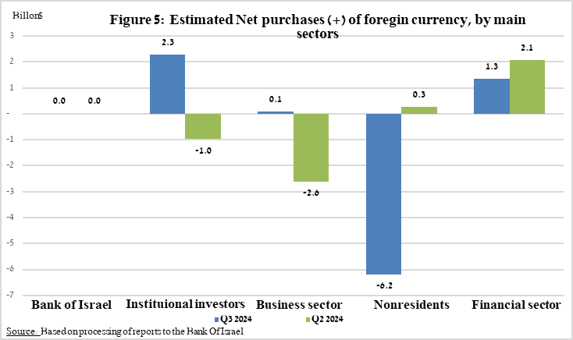

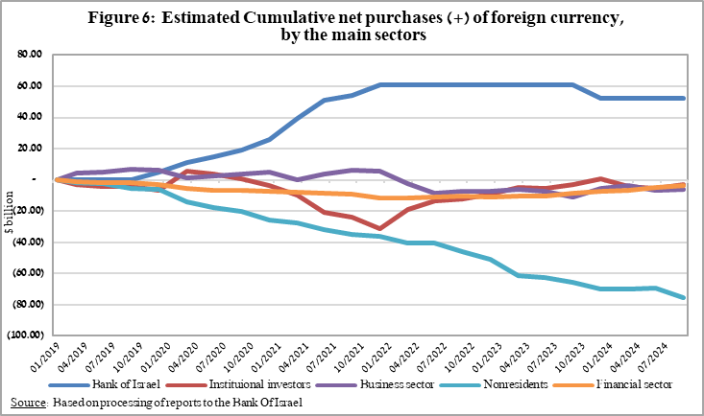

**4. Trading Volume in the Foreign Currency Market—Tables and Figures**

**Trading volume vis-à-vis the domestic banking system[2]**

**The average daily trading** **volume** increased by about 15.2 percent during the quarter to $12.3 billion, mainly due to an increase in the daily trading volume in swap transactions.

**Nonresidents' share of total trading volume vis-à-vis the domestic banking system** (spot and forward transactions, options, and swaps) declined by about 1.5 percentage points to about 43.5 percent at the end of the third quarter.

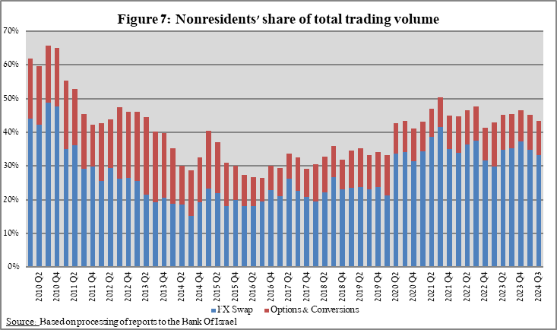



**Estimated total trading volume[3]—domestic banking system and foreign reporting entities**

The estimated total activity in transactions against the shekel, as reflected in reports from the domestic banking system and foreign reporting entities, indicates that the average total daily trading volume in the third quarter was $9.5 billion, Nonresidents’ relative share of trading volume in spot and forward transactions (excluding swaps and options) was about 82 percent in the third quarter. Trade between nonresidents constituted about 71 percent of the volume.



1. The main segments presented do not make up the entire market—for additional information, see the section on “The Database of Foreign Exchange Market Activity” in the Bank of Israel's "Statistical Bulletin" for 2018:

   https://boi.org.il/en/communication-and-publications/regular-publications/statistical-publications/statistical-bulletin-2018/
2. From the beginning of 2020, the data do not include branches of foreign banks in Israel.
3. Total trading volume is an estimate of total activity in transactions against the shekel, based on reports by the domestic banking system and by foreign reporting entities.