BANK OF ISRAEL
Office of the Spokesperson and Economic Information

December 7, 2025

Press Release:

Foreign Exchange Reserves at the Bank of Israel, November 2025

Israel’s foreign exchange reserves at the end of November 2025 stood at $231,425 million, a decline of $529 million from their level at the end of the previous month. The level of the reserves relative to GDP was 39.7 percent (Figure 1).

The decline was mainly explained by foreign exchange activity by the government totaling about $1,075 million. This decline was partly offset by a revaluation of the reserves totaling approximately $568 million.

Israel's Foreign Exchange Reserves ($ million)

Date | Reserves excluding IMF (including reserves bought under the natural gas purchase program) | Reserves at the IMF | Total Foreign Exchange Reserves
November 2025 | 226,794 | 4,631 | 231,425
October 2025 | 227,295 | 4,659 | 231,954
September 2025 | 227,246 | 4,634 | 231,880
August 2025 | 225,694^{c} | 4,626 | 230,320^{c}
July 2025 | 222,157 | 4,611 | 226,768
June 2025 | 223,651 | 4,599 | 228,250
May 2025 | 219,086^{c} | 4,553 | 223,639^{c}
April 2025 | 217,489 | 4,546 | 222,035
March 2025 | 214,394^{c} | 4,416 | 218,810^{c}
February 2025 | 215,898^{c} | 4,356 | 220,254^{c}
January 2025 | 211,710^{c} | 4,358 | 216,068^{c}
December 2024 | 210,170^{c} | 4,400^{c} | 214,570^{c}
November 2024 | 212,684 | 4,416 | 217,100

Figure 1
Level of foreign exchange reserves, and their ratio to GDP, 2008–2025

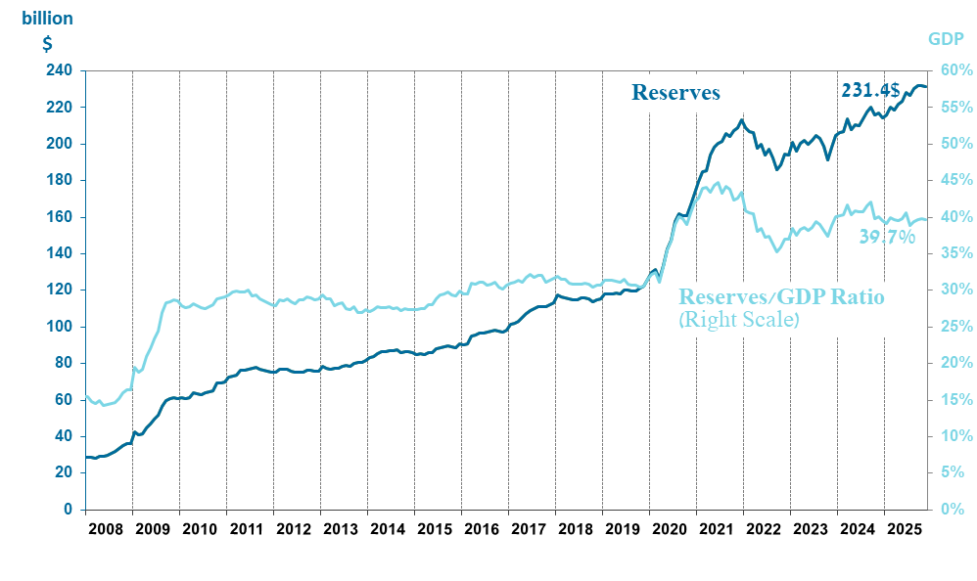

Including Bank of Israel payments and receipts in foreign currency.
^{b} This column includes Special Drawing Rights (SDRs), the balance of NAB loans, and the balance of Israel's reserve tranche at the IMF. c Updated after the original date of publication.

