

BANK OF ISRAEL

Office of the Spokesperson and Economic Information

November 2, 2023

Press Release:

Israel’s foreign currency market in the third quarter of 2023

**1. The Exchange Rate**

**Weakening of the shekel alongside strengthening of the dollar worldwide.**

During the course of the third quarter, the shekel weakened by 3.4 percent against the dollar and by 0.9 percent against the euro.

In addition, the shekel weakened by about 1.4 percent against the currencies of Israel's main trading partners, in terms of the nominal effective exchange rate (i.e., the trade-weighted average shekel exchange rate against those currencies).

The US dollar strengthened against most major currencies (Figure 2) during the quarter. It strengthened by approximately 2.5 percent against the euro, by about 3 percent against the Japanese yen, and by about 3.2 percent against the British pound.

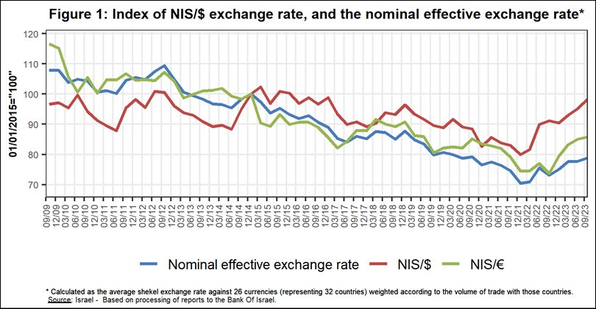

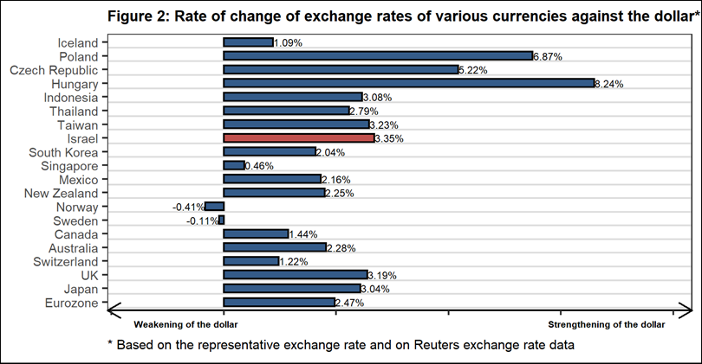

**2. Exchange Rate Volatility**

**A decline in actual volatility and an increase in implied volatility**

The standard deviation of changes in the shekel/dollar exchange rate, which represents its **actual** volatility, declined during the quarter, to an average level of 7.2 percent.

The average implied volatility in over-the-counter shekel/dollar options, an indication of **expected** exchange rate volatility, increased, to about 10.4 percent by the end of the quarter.

For comparison, the average level of implied volatility in foreign exchange options in emerging markets was 11.5 percent at the end of the quarter, a decline of 1.9 percentage points from its level at the end of the previous quarter. The average level of implied volatility in advanced-economy markets was 8 percent at during the quarter, a decline of about 0.3 percentage points from the previous quarter (Figure 4).

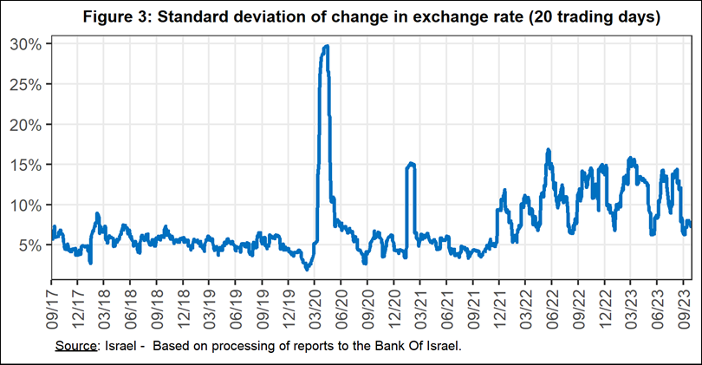

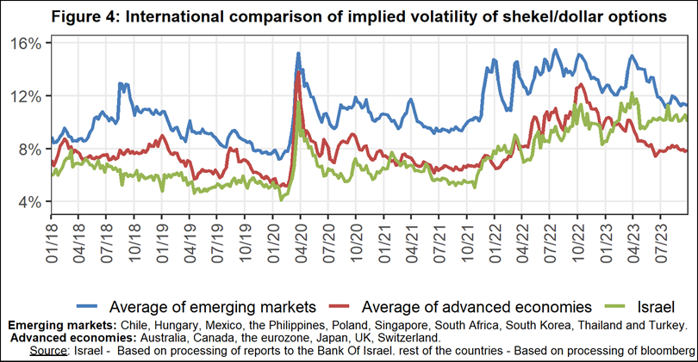

**3. The Activity of the Main Segments in the Foreign Exchange Market[1]**

An estimate of the activity of the **main** segments in the foreign exchange market indicates that during the course of the third quarter, **the financial sector** made net purchases of foreign exchange totaling about $3.3 billion, and **institutional investors (pension funds, provident funds, and insurance companies)** made net purchases totaling about $2.6 billion. **In contrast, the business sector** made net sales of foreign currency totaling about $3.3 billion, and **nonresidents** made net sales of about $2.7 billion.

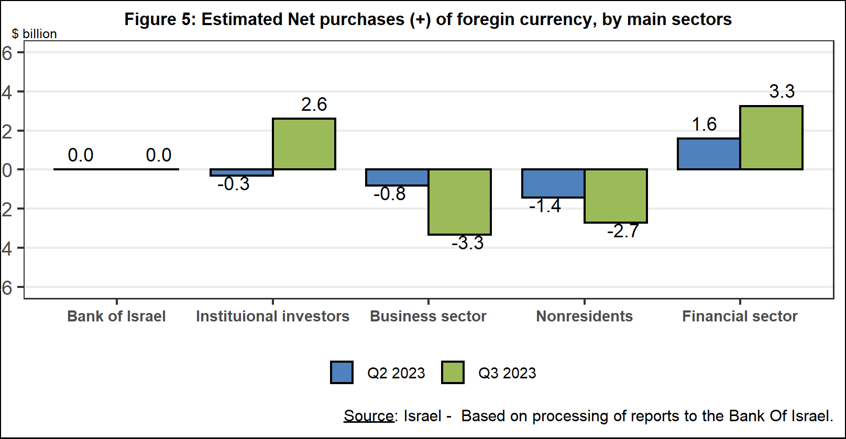

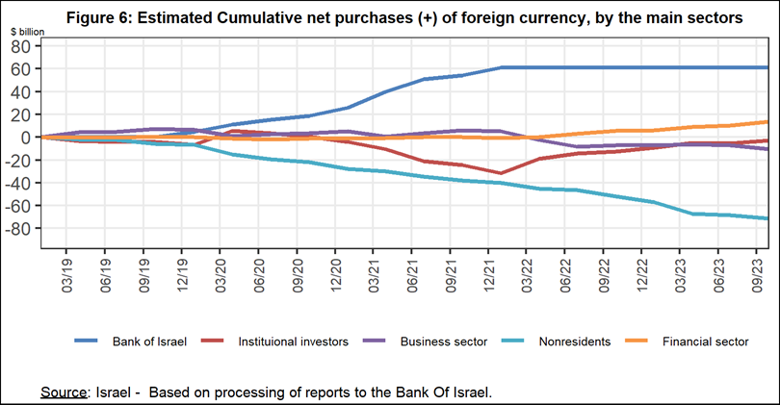

**4. Trading Volume in the Foreign Currency Market—Tables and Figures**

**Trading volume vis-à-vis the domestic banking system[2]**

**The average daily trading** **volume** increased by about 11.5 percent during the quarter to $10.6 billion, mainly due to an increase in the daily trading volume in swap transactions.

**Nonresidents' share of total trading volume vis-à-vis the domestic banking system** (spot and forward transactions, options, and swaps) increased by about 0.2 percentage points to about 45.6 percent at the end of the first quarter.

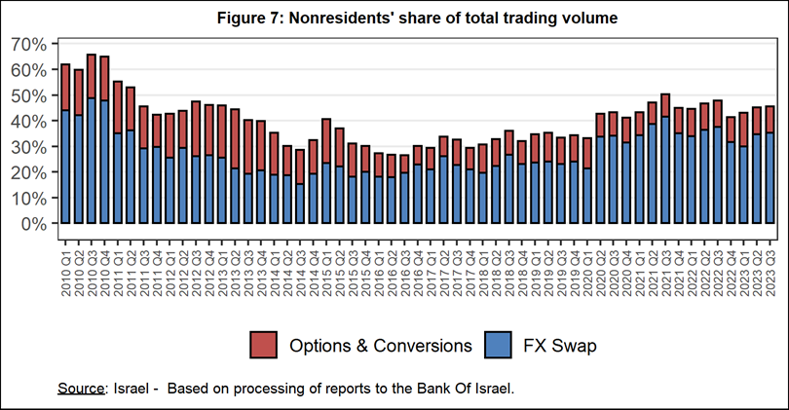



**Estimated total trading volume[3]—domestic banking system and foreign reporting entities**

The estimated total activity in transactions against the shekel reflected in reports from the domestic banking system and foreign reporting entities indicates that nonresidents’ relative share of trading volume in spot and forward transactions (excluding swaps and options) was 80.6 percent in the third quarter. Trade between nonresidents constituted 69.3 percent of the volume, which had a daily average of about $10.2 billion.



1. The main segments presented do not make up the entire market—for additional information, see the section on “The Database of Foreign Exchange Market Activity” in the Bank of Israel's "Statistical Bulletin" for 2018:

   https://boi.org.il/en/communication-and-publications/regular-publications/statistical-publications/statistical-bulletin-2018/
2. From the beginning of 2020, the data do not include branches of foreign banks in Israel.
3. Total trading volume is an estimate of total activity in transactions against the shekel, based on reports by the domestic banking system and by foreign reporting entities.