
BANK OF ISRAEL
Office of the Spokesperson and Economic Information

January 9, 2020

Press Release:

Research Department Staff Forecast, January 2020

Abstract
This document presents the forecast of macroeconomic developments compiled by the Bank of Israel Research Department in January 2020 regarding the main macroeconomic variables—GDP, inflation and the interest rate. According to the staff forecast, gross domestic product (GDP) is projected to increase by 2.9 percent in 2020, slightly lower than the previous forecast, and by 3.2 percent in 2021. The inflation rate in 2020 is expected to be 1.0 percent, lower than the previous forecast, and to be 1.4 percent in 2021. According to the forecast, the Bank of Israel interest rate in one year is expected to be 0.25 percent or 0.1 percent.

Forecast
The Bank of Israel Research Department compiles a staff forecast of macroeconomic developments on a quarterly basis. The staff forecast is based on several models, various data sources, and assessments based on economists’ judgment. The Bank’s DSGE (Dynamic Stochastic General Equilibrium) model developed in the Research Department—a structural model based on microeconomic foundations—plays a primary role in formulating the macroeconomic forecast. The model provides a framework for analyzing the forces that have an effect on the economy, and allows information from various sources to be combined into a macroeconomic forecast of real and nominal variables, with an internally consistent “economic story”.

- The global environment
Our assessments of expected developments in the global economy are based mainly on projections by international institutions and foreign investment houses. The forecast for import growth in advanced economies in 2020 was reduced to 2.0 percent, and the forecast for 2021 is 2.5 percent. The assumptions regarding output growth, inflation, and the interest rate in advanced economies are similar to those used in the previous forecast. Specifically, we assume that GDP in advanced economies will grow by 1.3 percent in 2020 and by 1.5 percent in 2021, and that the inflation rate will be 1.6 percent in 2020 and 1.7 percent in 2021. The average price of a barrel of Brent crude oil was $62 in the fourth quarter of 2019, similar to the third quarter, though toward the end of the quarter the price increased to $68.

- Real activity in Israel
GDP is expected to grow in 2020 by 2.9 percent, a slightly lower pace than in the previous forecast, and to grow by 3.2 percent in 2021 (Table 1). The forecast for 2020 includes the effect of the beginning of natural gas production from the Leviathan reservoir, which we assess will contribute approximately 0.3 percent to GDP growth in the year. Compared to the previous forecast, the exports forecast for 2020 was revised downward slightly in view of the decline in the world trade forecast and due to a change in the expected domestic activity of large companies. This activity is also expected to be reflected in an increase in imported investments in 2020, beyond these incorporated in the previous forecast. The assumptions regarding fiscal policy were revised in view of the decision to disperse the Knesset and to hold additional elections in the beginning of 2020. In particular, we assume that the first part of 2020 will be conducted using an interim budget. In addition, we assume that after the elections and the formation of a government, steps will be taken to reduce the deficit, through lowering the growth rate of public expenditure compared with previous years, and via an increase on the revenues side.

Table 1
Economic Indicators
Research Department Staff Forecast for 2020–2021
(rates of change, percent, unless stated otherwise)
 | 2019ª | Bank of Israel forecast for 2020 | Change from the previous forecast | Bank of Israel forecast for 2021
GDP | 3.3 | 2.9 | -0.1 | 3.2
Private consumption | 3.9 | 2.5 | 0.5 | 2.5
Fixed capital formation (excluding ships and aircraft) | 0.9 | -0.5 | 1.5 | 3.0
Public sector consumption (excluding defense imports) | 3.8 | 2.5 | 1.0 | 2.5
Exports (excluding diamonds and start-ups) | 4.7 | 4.5 | -1.0 | 4.0
Civilian imports (excluding diamonds, ships, and aircraft) | 4.3 | 1.0 | 1.5 | 2.5
Unemployment rate^{b} | 3.3 | 3.3 | -0.1 | 3.3
Inflation rate^{c} | 0.4 | 1.0 | -0.2 | 1.4
a) National Accounts data—first estimate by the Central Bureau of Statistics.
b) Annual average of unemployment in the prime working ages (25–64).
c) Average CPI reading in the final quarter of the year compared with the final-quarter average in the previous year.

- Inflation and interest rate estimates
According to the staff forecast, the inflation rate in the next four quarters is expected to be 1.0 percent, slightly lower than our previous assessment. The inflation rate in the end of 2021 is expected to be 1.4 percent. We assess that the labor market is stabilizing in the environment of full employment, so that pressures on domestic prices from this direction are not expected to increase. In particular, we assess that wage increases will continue to contribute to inflation in the prices of services and nontradable goods to the same extent that they contributed in the recent period. As far as inflation in tradable goods prices, we assess that the process of growth in competition has not yet been exhausted, a process that was impacted, among other things, by the development of e-commerce. The prices of tradable goods are expected to continue being impacted by this process as well as by the accumulated appreciation in the shekel. In view of all this, we continue to assess that the increase in overall inflation in the forecast range will be gradual.

We assess that the interest rate in one year will be 0.25 percent or 0.1 percent (Table 2). Toward the end of 2021, the expected increase of the inflation rate, together with expected growth in a full employment environment, are likely to lead to a gradual increase in the interest rate.

Table 2 indicates that the forecast compiled by the Research Department regarding inflation in one year is similar to those of the private forecasters and slightly higher than expectations derived from the capital market. The forecast compiled by the Research Department regarding the interest rate in one year is similar to those of the private forecasters and to expectations derived from the capital market.

Table 2
Inflation and interest rate forecasts for the coming year
(percent)
 | Bank of Israel Research Department | Capital marketsª | Private forecasters^{b}
Inflation rate^{c} | 1.0 | 0.8 | 1.1
(range of forecasts) |  |  | (0.5–2.0)
Interest rate^{d} | 0.1–0.25 | 0.1 | 0.1
(range of forecasts) |  |  | (-0.40–0.25)
a) Average expectations following publication of the Consumer Price Index for November. Inflation expectations are seasonally adjusted.
b) One-year forward forecasts published following the publication of the Consumer Price Index for November.
c) Inflation rate in the coming year. Research Department: in the four quarters ending in the fourth quarter of 2020.
d) The interest rate one year from now. (Research Department: in the fourth quarter of 2020.) Expectations from the capital market are based on the Telbor market.
SOURCE: Bank of Israel.

- Main risks to the forecast
Several factors may lead to economic developments that differ from those in the forecast. In the domestic environment, the dispersal of the Knesset and the decision to hold elections in March 2020 kept the considerable uncertainty in place regarding the steps that the next government will take in order to deal with the deviation of the deficit from the target, and their effect on growth, inflation, and the interest rate. The risks to the global environment decreased compared with the previous forecast, but they still tend to the downside. These risks include the possibility of a worsening in the trade tensions between the US and China and the uncertainty regarding a Brexit agreement.

Figures 1 and 2 present fan charts around the inflation rate and GDP growth forecasts. The center of the fan (the white line) reflects the Research Department’s staff forecast. The broken line represents the baseline forecast from the previous quarter. The width of the fan does not reflect a judgmental assessment of the risks to the forecast or their distribution, but is derived from the estimated distribution of the shocks in the Research Department's DSGE model. The fan encompasses 66 percent of the expected distribution.

Figure 1
Actual Inflation and Fan Chart of Expected Inflation
(Cumulative increase in prices in the previous four quarters)
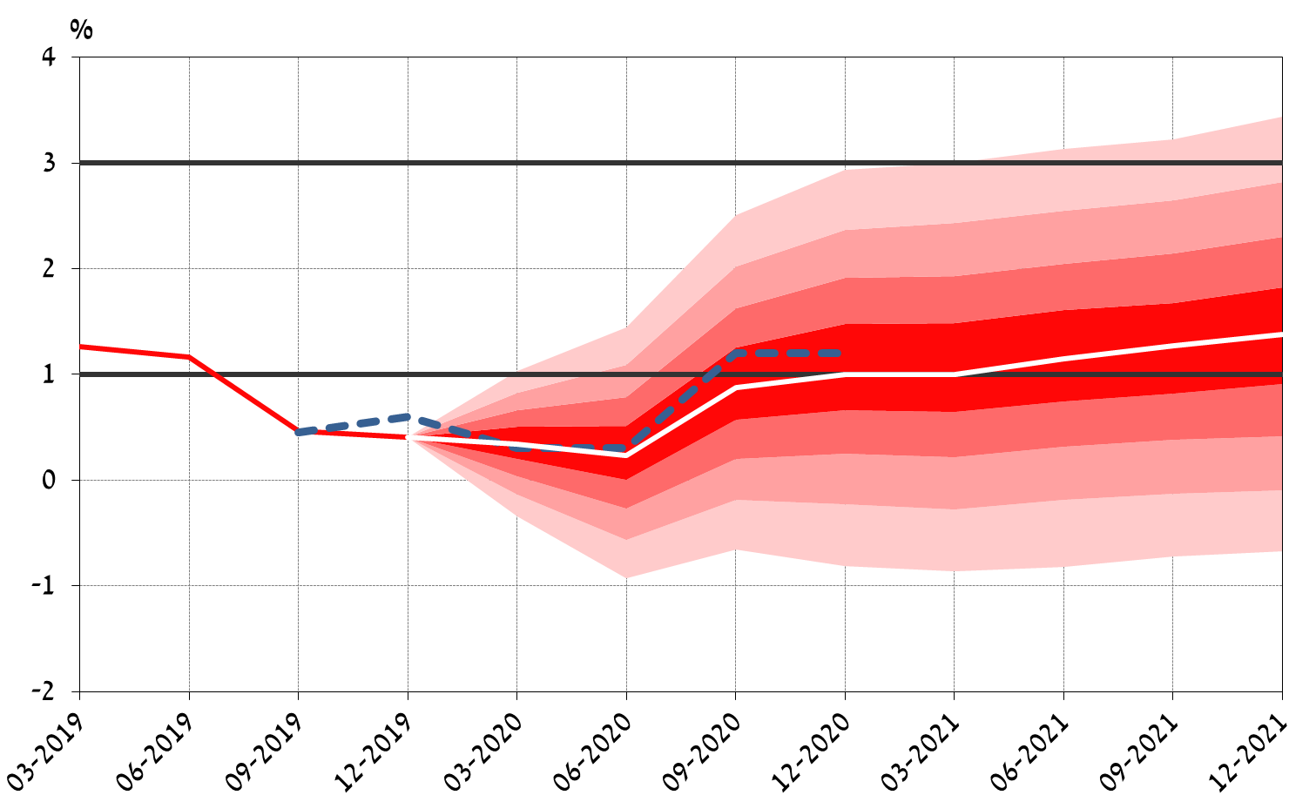

Figure 2
Actual GDP Growth Rate in the Past Four Quarters and Fan Chart of Expected Growth Rate
(Total GDP over the past four quarters relative to GDP in the preceding four quarters)
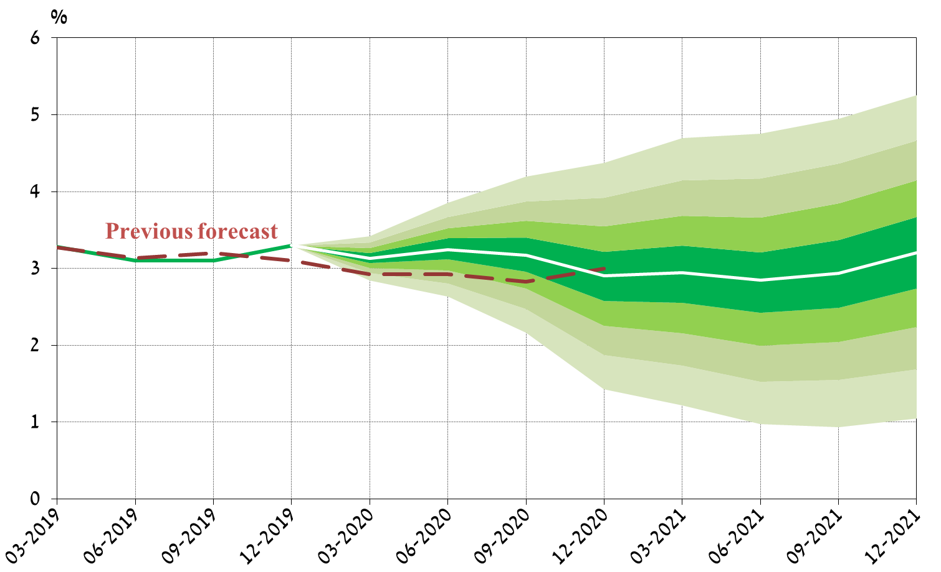

The forecast was presented to the Monetary Committee on January 8, 2020 during its meeting prior to the decision on the Bank of Israel interest rate reached on January 9, 2020.
An explanation of the macroeconomic staff forecasts compiled by the Research Department, as well as a review of the models on which they are based, appear in Inflation Report number 31 (for the second quarter of 2010), Section 3c.
A Discussion Paper on the DSGE model is available on the Bank of Israel website, under the title: “MOISE: A DSGE Model for the Israeli Economy,” Discussion Paper No. 2012.06.
A fan chart for the interest rate forecasts will no longer be published.
Regarding GDP growth (Figure 2), until December 2019, the broken line represents the data and estimates that were available at the time the previous forecast was compiled, while the solid line represents the up to date data and estimates (the difference between them derives from new data and overall changes carried out by the Central Bureau of Statistics).

