

BANK OF ISRAEL

Office of the Spokesperson and Economic Information

September 22, 2019

Press Release:

Debt Developments in the Nonfinancial Private Sector,

Second Quarter of 2019

In the second quarter of 2019, the balance of **nonfinancial private sector debt** increased by approximately NIS 14 billion (1 percent) to about NIS 1.5 trillion. Most of the increase came from growth in the balance of **household** **debt** (approximately NIS 9 billion; 1.7 percent), most of which was in housing debt.

**The nonfinancial business sector’s outstanding debt[1]**

* In the second quarter of 2019, the balance of business sector debt increased by approximately NIS 5 billion (0.5 percent), to NIS 948 billion. The increase derived from quantitative growth in all financing channels, which totaled approximately NIS 9 billion, and that was made up primarily of bank loans and nonbank loans. This increase was partly offset by a 1.8 percent appreciation of the shekel against the dollar, which reduced the value of the debt denominated in and indexed to foreign currency. (Figure 1).
* In the second quarter, the **business sector** **issued** about NIS 9.4 billion in bonds, higher than the quarterly average amount raised in the preceding 4 quarters (an average of about NIS 8.2 billion per quarter). About half the issuances in the quarter were by companies in the real estate and construction industry. In July 2019, the business sector issued bonds worth about NIS 3.3 billion, mostly in tradable bonds. (Figure 3).
* In the second quarter, **the spread between yields on corporate bonds that are included in the Tel Bond 60 index, and the yield on CPI-indexed government bonds** narrowed by about 0.1 percentage points to about 1.14 percentage points, further to a narrowing in the previous quarter. In July 2019, the spread continued to narrow, to about 1.11 percentage points (Figure 4).

**Table 1: The Composition of Business Sector Debt**



**Figure 1: Estimated Net Quarterly Quantitative Change in Business Sector Debt**

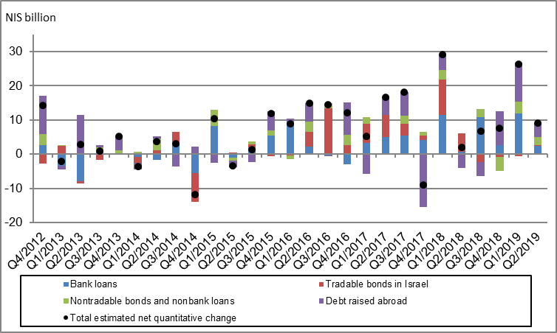

**Figure 2: Rate of Change (Year on Year) in the Business Sector's Bank and Nonbank Debt**

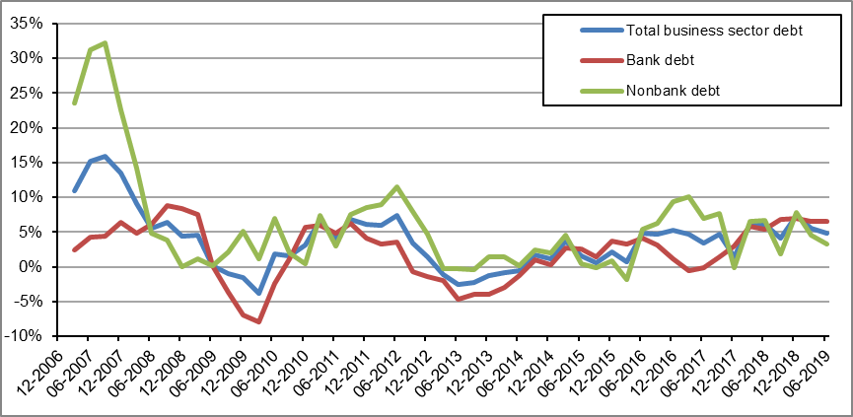

**Figure 3: Nonfinancial Business Sector Bond Issuance during the quarter, by Industry**

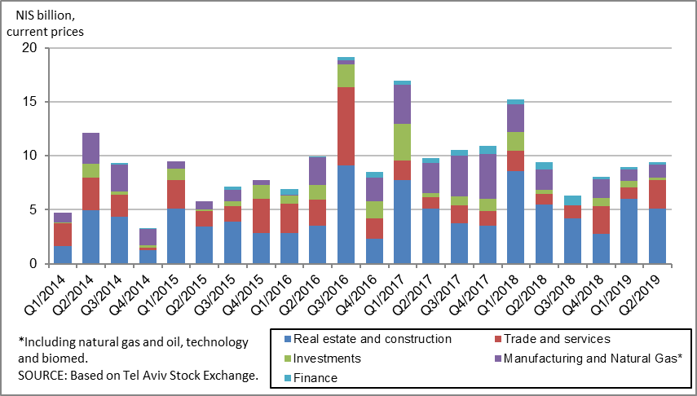

**Figure 4 : Spread between Indexed Corporate Bonds (Tel-Bond 60) and Indexed Government Bonds (monthly average)**

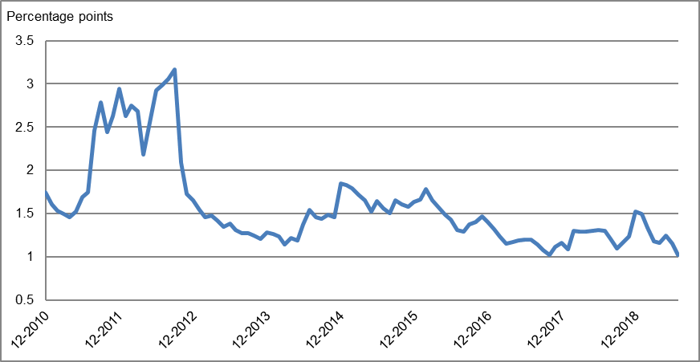

**Household debt**

* **Households’ outstanding debt** increased by approximately NIS 9 billion (1.7 percent) in the second quarter of 2019, to about NIS 572 billion. Most of the increase—about NIS 8 billion—was in **housing debt** (to about NIS 373 billion), and the rest—about NIS 1 billion—was in **nonhousing debt** (to about NIS 199 billion).
* In the second quarter of 2019, new mortgages taken out totaled about NIS 16.7 billion, higher than the corresponding period in the previous year (about NIS 14.8 billion). In July 2019, there was an additional increase, mostly seasonal, in new mortgages taken out, and they totaled about NIS 6.7 billion, (Figure 6).

**Table 2: Outstanding Debt Balances of Households1**



**Figure 5: Rates of Change in Households’ Housing and Nonhousing Debt, Current Quarter vs. Corresponding Quarter of Previous Year**

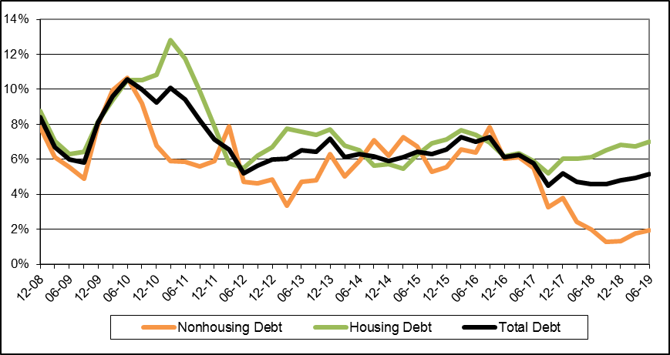

**Figure 6: Amount of New Home Purchase Loans Provided by Banks to the Public (Mortgages)**

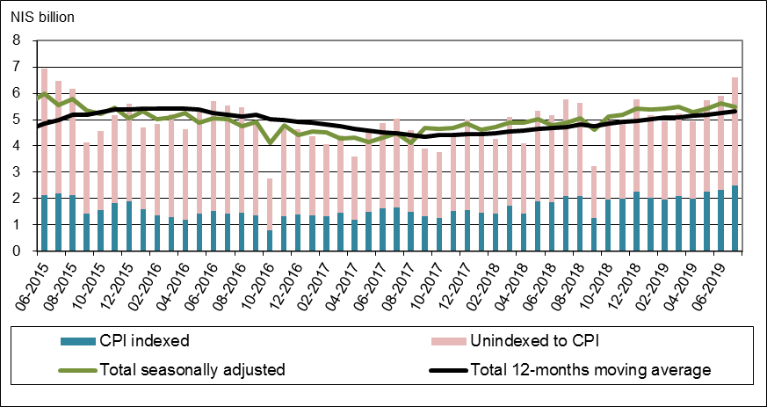

Links to Data and Statistics on the Bank of Israel website:

<http://www.boi.org.il/en/dataandstatistics/pages/default.aspx>

<http://www.boi.org.il/en/bankingsupervision/data/pages/tables.aspx?chapterid=13>

<http://www.boi.org.il/en/BankingSupervision/Data/Pages/Tables.aspx?ChapterId=19>

<http://www.boi.org.il/en/DataAndStatistics/Pages/MainPage.aspx?Level=3&Sid=74&SubjectType=2>

1. Israeli firms, excluding banks, credit card companies, and insurance companies.