March 29, 2026

Press Release:

The public's financial assets portfolio in the fourth quarter of 2025

For an analysis of the assets portfolio over the full year of 2025, see “The public's financial assets portfolio” in Part 1 of the “Statistical Bulletin for 2025” (translation forthcoming).

- In the fourth quarter of 2025, the balance of the public’s financial assets portfolio increased by approximately NIS 287.4 billion (4.2 percent), to about NIS 7.2 trillion. For the year overall, the portfolio increased by approximately 15.5 percent.
- The increase in the portfolio’s value in the fourth quarter was mainly due to increases in the balance of equities in Israel (12.6 percent) and in the balance of cash and deposits (3.9 percent).
- The balance of the assets portfolio managed by institutional investors increased in the fourth quarter by approximately NIS 111 billion (3.5 percent), to approximately NIS 3.3 trillion at the end of the quarter.
- The scope of the portfolio managed by mutual funds in Israel increased by approximately NIS 33.6 billion (4.6 percent) in the fourth quarter, to a level of NIS 756 billion. There were net new investments, mainly in funds specializing in domestic bonds and in funds specializing in domestic equities.

1. The public’s total assets portfolio

In the fourth quarter of 2025, the balance of the public’s financial assets portfolio increased by approximately NIS 287.4 billion (about 4.2 percent), to about NIS 7.2 trillion (Figure 1). For the year of 2025 overall, the portfolio increased by 15.5 percent. The share of the public’s financial assets portfolio relative to GDP increased by approximately 9.6 percentage points, to about 341 percent at the end of the quarter, as a result of an increase in the balance of the asset portfolio that was greater than that of GDP.

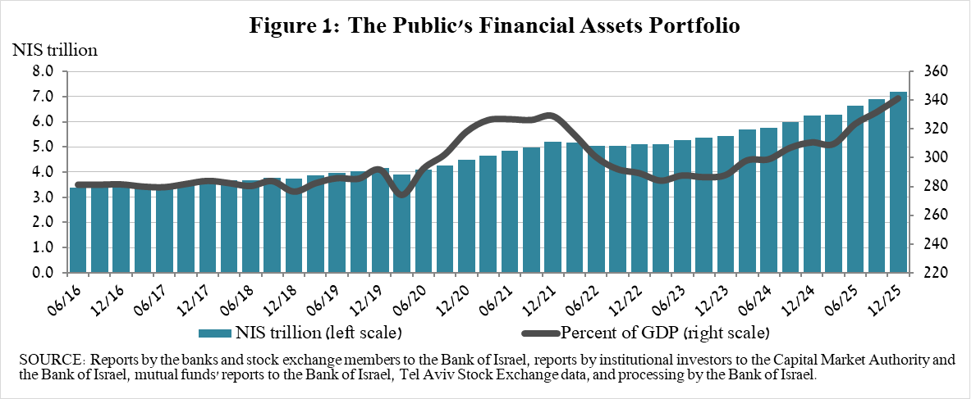
2. Analysis of the changes in the overall portfolio

Over the course of the fourth quarter, there were increases in the balances of the public’s holdings in all components of the portfolio. The increases in equities in Israel (12.6 percent) and in cash and deposits (3.9 percent) were notable.
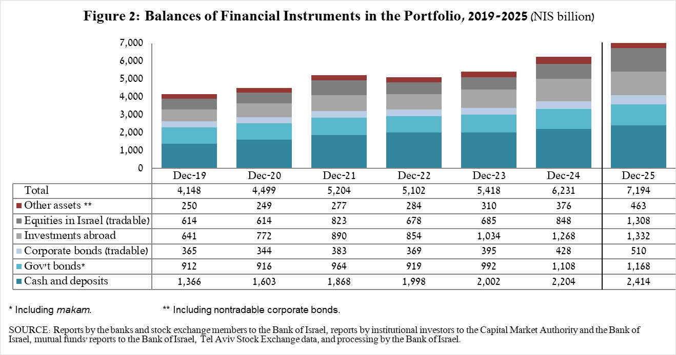

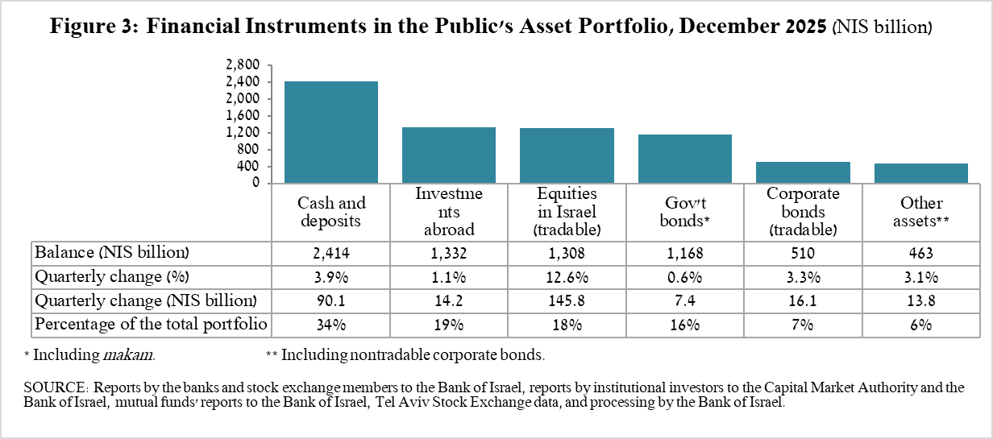

- The balance of equities in Israel increased by about NIS 145.8 billion (12.6 percent), mainly in view of price increases.
- The balance of cash and deposits increased during the fourth quarter by about NIS 90 billion (3.9 percent) to about NIS 2.41 trillion, which is about 34 percent of the total portfolio.
- The balance of tradable corporate bonds in Israel increased during the quarter by about NIS 16 billion to about NIS 510 billion at the end of the quarter, due to a combination of net investments (estimated at NIS 13.1 billion) and price increases.
- The balance of Makam (central bank bills) held by the public increased by about NIS 5.4 billion, to a level of NIS 202 billion.
- The balance of tradable government bonds held by the public increased during the quarter by about NIS 11.6 billion to about NIS 502 billion at the end of the quarter (Figure 4). In a breakdown by holders of government bonds, institutional investors are the main holders, increasing the balance of their holdings during the quarter by about NIS 5.8 billion to a level of NIS 369 billion.
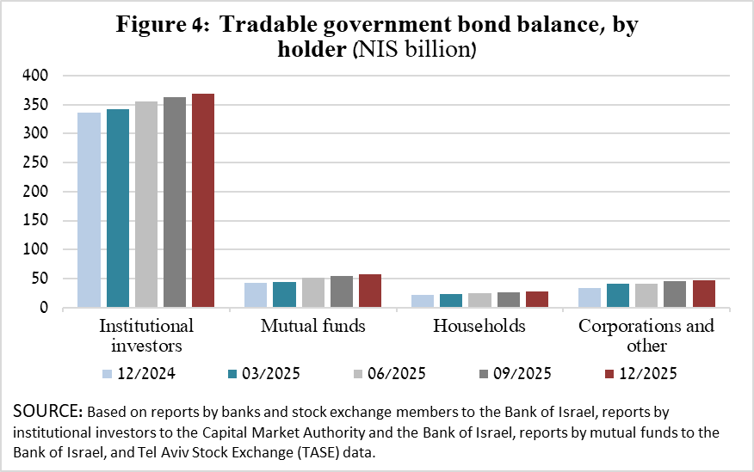

The balance of investments abroad increased by approximately NIS 14.2 billion during the quarter, to about NIS 1.33 trillion at the end of the quarter, accounting for approximately 19 percent of the total asset portfolio. The development in the balance of investments abroad was mainly due to the following components:

- The balance of equities held abroad increased by approximately NIS 20.4 billion (2.6 percent), to about NIS 801 billion at the end of the quarter, mostly against the background of net investments.
- The balance of tradable (corporate and government) bonds abroad declined by approximately NIS 4 billion (1.4 percent) during the quarter, to about NIS 274 billion at quarter end. This was mainly in view of the appreciation of the shekel vis-à-vis the dollar.

As a result of the developments during the quarter, there was a decrease in the share of foreign currency assets of about 0.73 percentage points (from 24.9 percent to 24.2 percent) and a decline of around 0.56 percentage points (from 19.1 percent to 18.5 percent) in foreign assets.

3. The portfolio managed by institutional investors
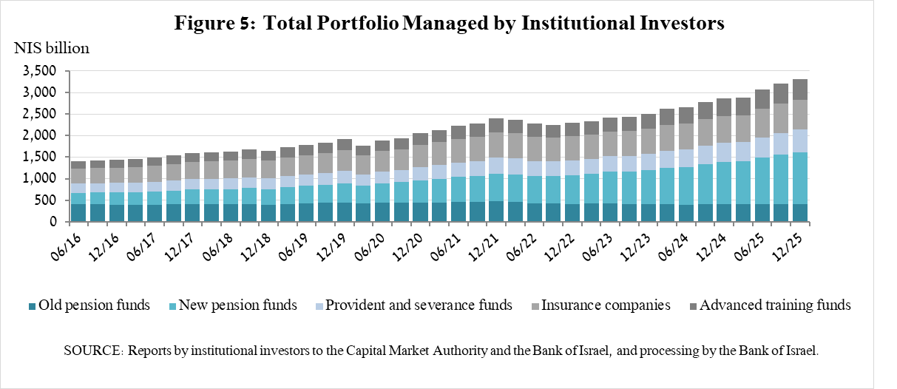

- The balance of assets managed by all institutional investors increased in the fourth quarter by about NIS 111 billion (3.5 percent), to about NIS 3.3 trillion (approximately 46 percent of the public’s total financial assets portfolio). The increase in the balance of the managed portfolio during the quarter was reflected in the following components: equities in Israel—an increase of about NIS 47 billion (13.2 percent) mainly in view of price increases; cash and deposits in Israel—an increase of NIS 36 billion (10.9 percent); equities abroad—an increase of NIS 15 billion t (8.6 percent), a combination of price increases and net investments.

4. The portfolio managed by mutual funds

The value of the portfolio managed by Israeli mutual funds increased in the fourth quarter by approximately NIS 33.6 billion (4.6 percent), to about NIS 756 billion at the end of the quarter, making up about 11 percent of the public’s asset portfolio.

The increase in the fourth quarter was mostly due to price increases and net new investments in funds, totaling NIS 12.6 billion. Most of the new investment was in funds specializing in bonds in Israel (about NIS 10 billion), and in funds specializing in equities in Israel (NIS 4.5 billion). In contrast, there were net withdrawals from shekel money market funds (about NIS 2.6 billion).
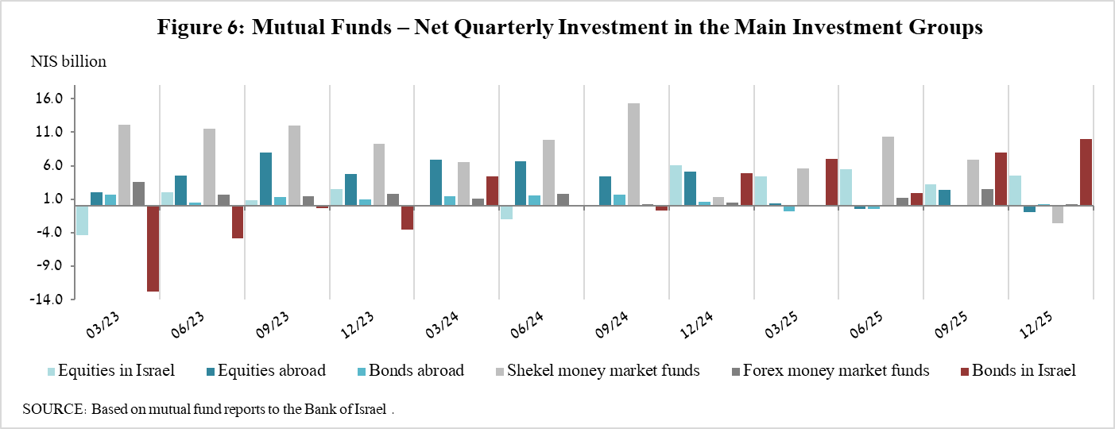

Further information and details:

Long-term tables on the asset portfolio are available here.

Long-term tables on institutional investors’ exposure to foreign exchange and to foreign assets are available here.

Long-term tables on mutual funds are available here.

Excluding mutual funds.

