

**BANK OF ISRAEL**

Office of the Spokesperson and Economic Information

March 6, 2024

Press Release:

**Research Department Policy Paper:**

**Analysis of the implementation of the five-year plan for the economic development of the Arab population as part of Government Resolution 922: Budgets, achievements, and barriers**

* The 5-year plan based on Government Resolution 922 was implemented in 2016–2021, and markedly advanced the economic development in Arab society. It was allocated a budget of NIS 13 billion, and through November 2021, approximately 70 percent of the program’s budget was utilized.
* Most of the budget was allocated to education, infrastructure, and construction. In the years of the program’s implementation, the gap between Arab and Jewish society narrowed considerably in many areas of the program.
* In some sections of the five-year plan, there were difficulties in implementation, mainly in budgets earmarked for local authorities where the share of utilization of the budgets reached only 50 percent. The main barriers to utilization were the lack of registration and availability of lands, and difficulties in complying with self-financing (“matching”) requirements.
* In October 2021, a new 5-year plan was approved for 2022–26 as part of Government Resolution 550, at a total allocation of NIS 30 billion. As part of the revised Government budget for 2024 that was submitted to the Knesset, there was a comprehensive budget cut in Government Resolution 550. A notable cut in the budget sections of the 5-year plan may have a negative impact on the future growth of the Israeli economy.
* Parallel to the further progress of the 5-year plan, measures should be taken so that in the long run, the budget allocation to Arab society will be permanently anchored in the state budget, according to equal and transparent criteria.

Government Resolutions 922, reached in 2015, and 550, reached in 2021, and the resulting 5-year plans, were a significant milestone in promoting the economic development of Arab society. In a paper written by Elad DeMalach and Sefi Bahar, both from the Bank of Israel Research Department, in collaboration with Sami Miaari from Tel Aviv University, the first 5-year budget plan (922) is comprehensively analyzed. The analysis examines the scope of utilizing the budgets and overviews the plan’s achievements and the general trends in its fields during those years. In addition, the document analyzes the main barriers that have hindered local authorities in implementing some of the program’s budgets and presents a brief overview of the second 5-year plan (550) that has been implemented since 2022. In the 5-year plan 922, which was actually implemented in 2016–21, a budget of NIS 13 billion (including differential budgeting in education) was allocated. Through November 2021, approximately 70 percent of the program’s budgets had been utilized. Most of the funds were allocated to education, infrastructure, and construction, which accounted for about 70 percent of the budgets allocated in the program (Figure 1). In the area of education, the utilization rate was very high, at 90 percent, while in the area of infrastructure and construction the utilization was about 50 percent.



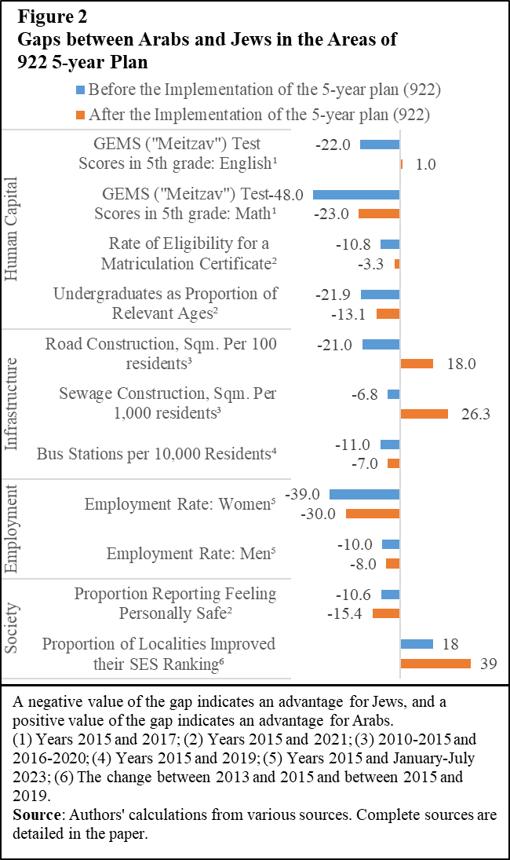

After the beginning of the implementation of the 922 5-year plan, the gaps between Arabs and Jews narrowed in many areas covered by the plan: in school test-scores, in participation in higher education, in the provision of infrastructures, and in the areas of public transportation and women’s employment. The 5-year plan had a significant contribution in promoting the urban planning processes in Arab localities, which are necessary for the further development of the localities. However, the gaps between Jews and Arabs still exist in many areas of life.

Alongside this, the 5-year plan of 922 had implementation difficulties mainly reflected in the budgets allocated to utilization by the local authorities, and only half were actually realized (NIS 3.1 billion out of an allocation of NIS 6.4 billion). In particular, a marked share of the infrastructure and construction budgets were not utilized due to a lack of availability and registration of lands. This problem is unique to Arab localities, which are characterized by a marked share of ownership of private land with multi-ownerships, and a low amount of government land. An additional difficulty that was reported by the Arab local authorities is the government’s requirement to participate in the financing of the project in order to receive State funds (self-financing—“matching”). Many Arab local authorities are in deficit and find it difficult to provide ongoing services to their residents, among other things due to their low socioeconomic ranking and lack of employment and commercial areas that would make it possible to rely on commercial municipal tax (“arnona”) revenues, which is a significant pillar in Jewish authorities’ revenues.

In October 2021, a new 5-year plan for Arab society was approved, as part of Government Resolution 550, which began being implemented in 2022, with a budget of approximately NIS 30 billion. In the first implementation year, about a fifth of the program’s funds (NIS 6 billion) were allocated, and 90 percent of those budgets were utilized. However, the share of budget allocation in the areas of housing and planning in that same decision was relatively low (only 14 percent), indicating ongoing land barriers in Arab localities.

As part of the revised Government budget for 2024, which was approved by the government and submitted to the Knesset, there was a comprehensive budget cut in Government Resolution 550 due to the need to finance the expenses of the war. The size of the budget cut in all the sections of the plan is expected to reach NIS 4–5 billion, which make up approximately 18–22 percent of the program’s remaining budget. Although at this time adjustments in the Government budget are required, a notable budget cut in the sections of the 5-year plan can negatively impact the future growth of the Israeli economy, as the program makes a marked contribution to the integration of Israeli Arabs into society and the economy and to reducing underinvestment in this society.

The 5-year plans have large advantages in that they include setting orderly goals, involving various government entities, establishing follow-up mechanisms, and promoting processes to reduce gaps. Therefore, it is important to continue implementing the 5-year plan based on Government Resolution 550 in order to advance the economic development in Arab society and to adjust the budgeting mechanisms. Alongside that, action should be taken so that in the long run, the fair allocation to Arab society is permanently anchored in the Government budget base, according to equal and transparent criteria. The continued integration of Arab society in Israel is essential to promoting the welfare of the Arab residents and to exhausting the potential growth of the Israeli economy in the long term.