

BANK OF ISRAEL

Office of the Spokesperson and Economic Information

**Press Release**

September 8, 2013

**Israel’s foreign currency market in August 2013**

**1. The Exchange Rate**

**The shekel weakened against the dollar, in parallel with the dollar's strength against global currencies.**

The shekel weakened by about 1.4 percent against the dollar, and by about 1.1 percent against the euro during August. Against the currencies of Israel's main trading partners, in terms of the nominal effective exchange rate of the shekel (i.e., the trade-weighted average shekel exchange rate against those currencies), the shekel weakened by about 0.9 percent.

In August, the dollar strengthened against most global currencies—including by about 0.1 percent against the Swiss franc, by about 0.1 percent against the euro, and by about 0.3 percent against the Japanese yen. However, the dollar weakened by about 2.1 percent against the British pound.

**2. Exchange Rate Volatility**

**Actual volatility of the exchange rate increased as its implied volatility declined.**

The standard deviation of changes in the shekel-dollar exchange rate, which represents its actual volatility, increased in August by about 0.8 percentage points to 8.1 percent, compared with 7.3 percent in July.

The average level of implied volatility in over the counter shekel-dollar options––an indication of expected exchange rate volatility––declined to 8.9 percent at the end of August, compared with 9.6 percent in July.

In August, the implied volatility in foreign exchange options declined in both emerging and advanced economies—to 10.3 percent in emerging markets and 9.4 percent in advanced economies, compared with 11.1 percent in emerging markets and 10 percent in advanced economies in July.

**3. The Volume of Trade in the Foreign Currency Market**

**Average daily trading volume declined.**

**The total volume of trade in foreign currency** in August was about $82 billion, compared with about $83.5 billion in July. Average daily trading volume declined by about 2 percent in August, and reached about $3.7 billion.

**The volume of trade in spot and forward transactions (conversions)** was about $32 billion in August, compared with $33 billion in July. The average daily trading volume in those transactions declined in August by about 5 percent compared with July. During August, the Bank of Israel bought $290 million through conversion transactions[1], as part of the purchase program intended to offset the effect on the exchange rate of natural gas production.

**The volume of trade in over the counter foreign currency options** (which are not traded on the stock exchange) totaled about $9.7 billion in August. The average daily trading volume in those options in August was $443 million, an increase of about 15 percent from its level in July.

**The trading volume of swap transactions** was about $40 billion in August. Average daily turnover was unchanged from the previous month, at around $1.8 billion.

**Nonresidents' share of total trade** (spot and forward transactions, options and swaps) increased by about 1 percentage point in August to about 34.8 percent.

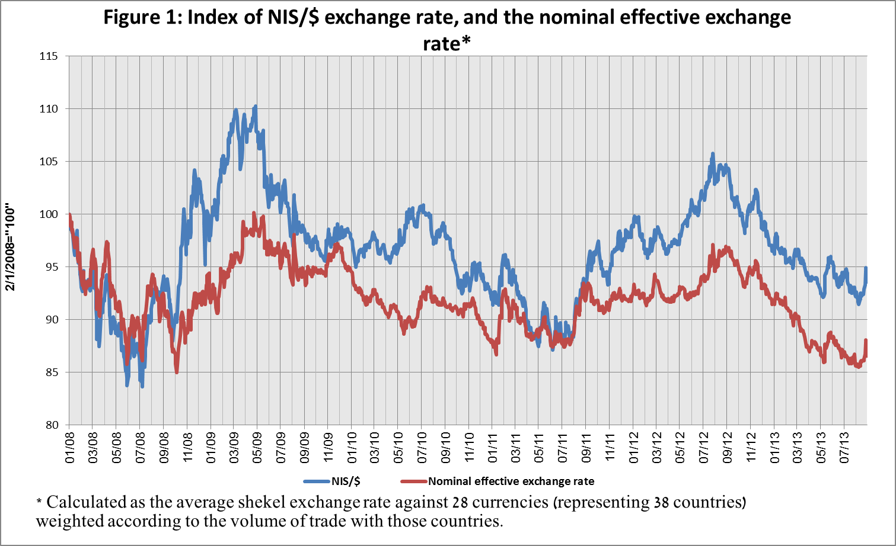

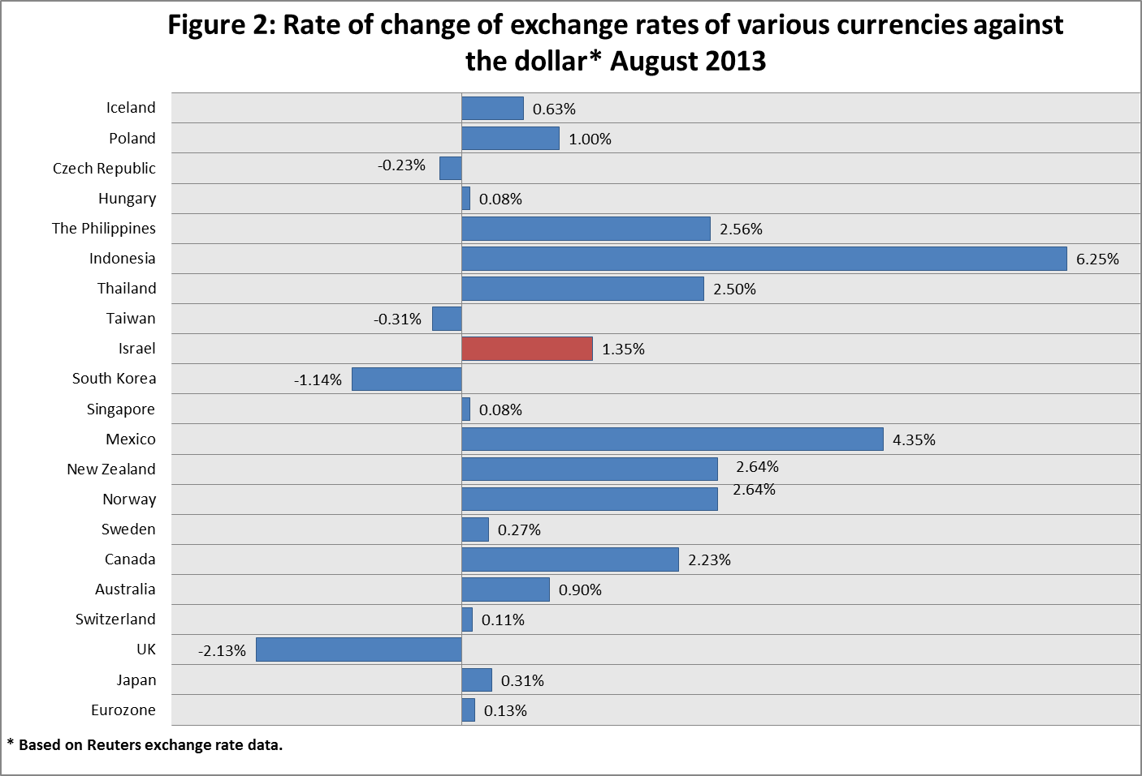

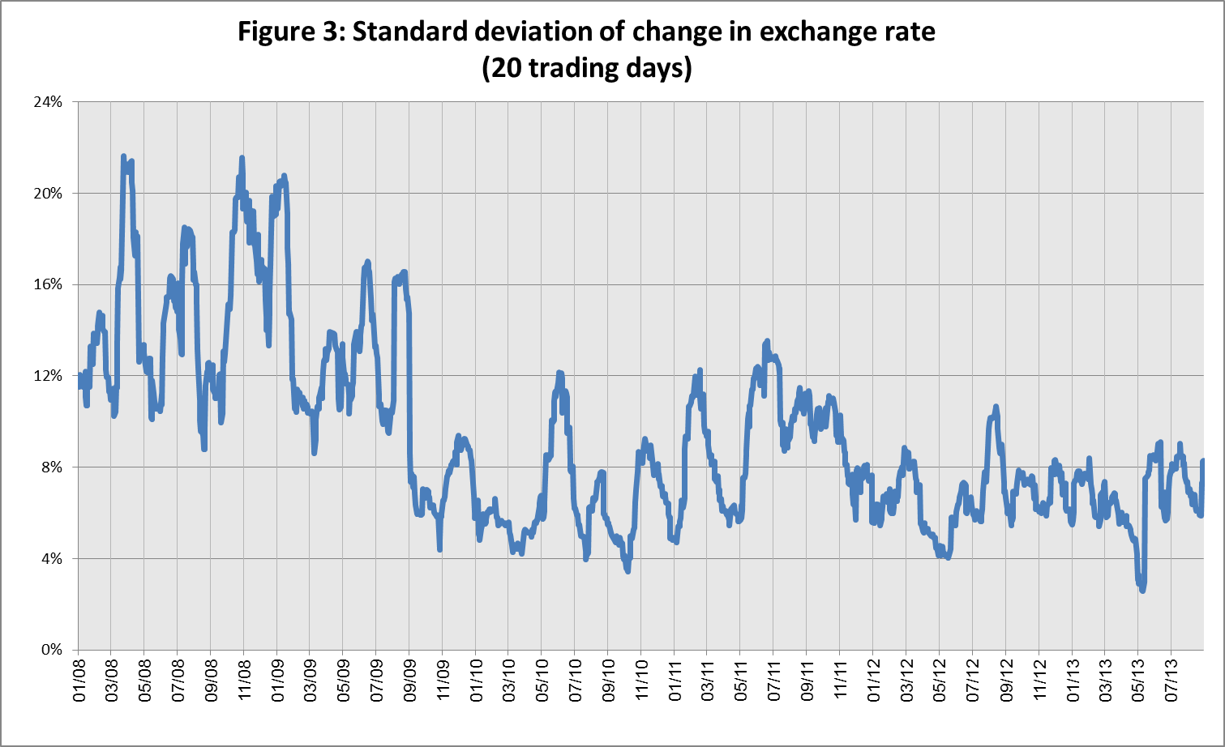

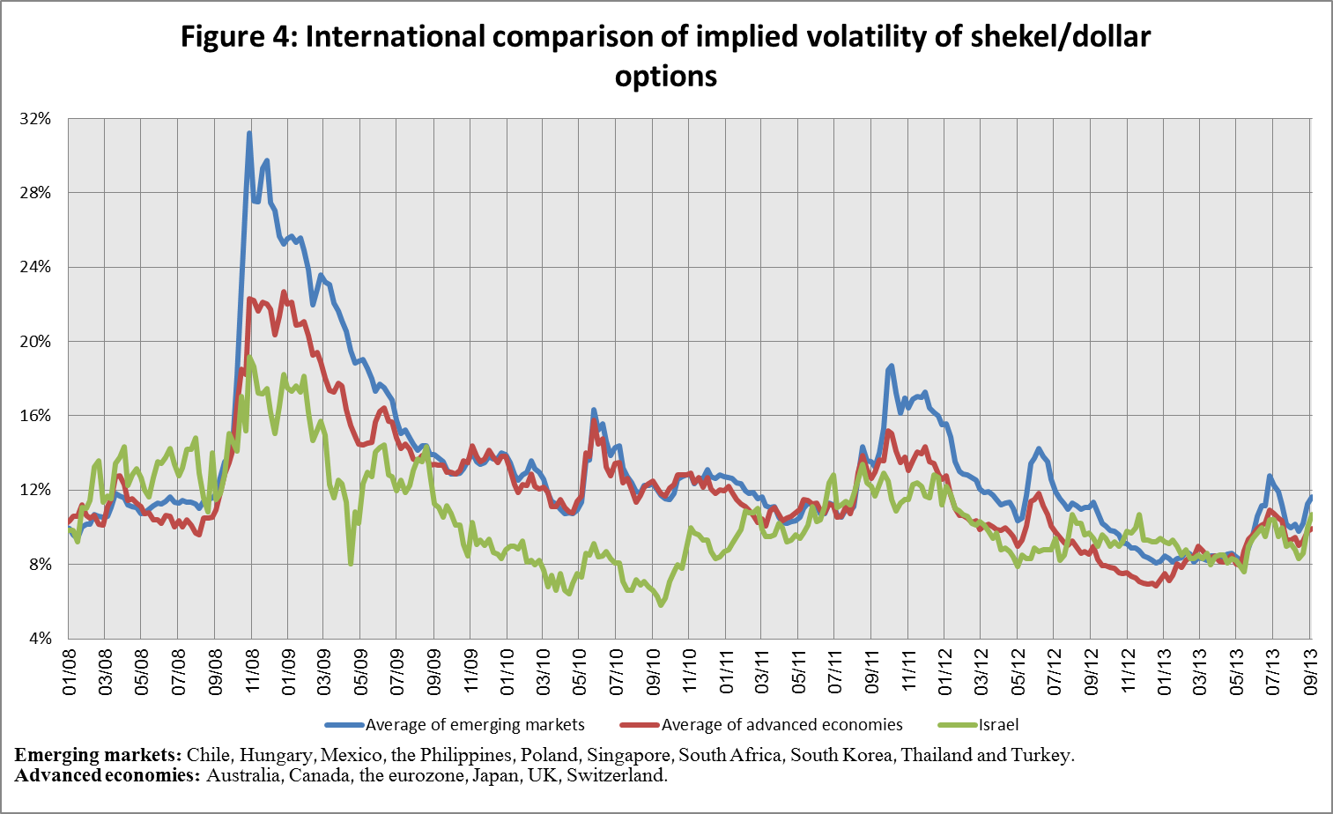

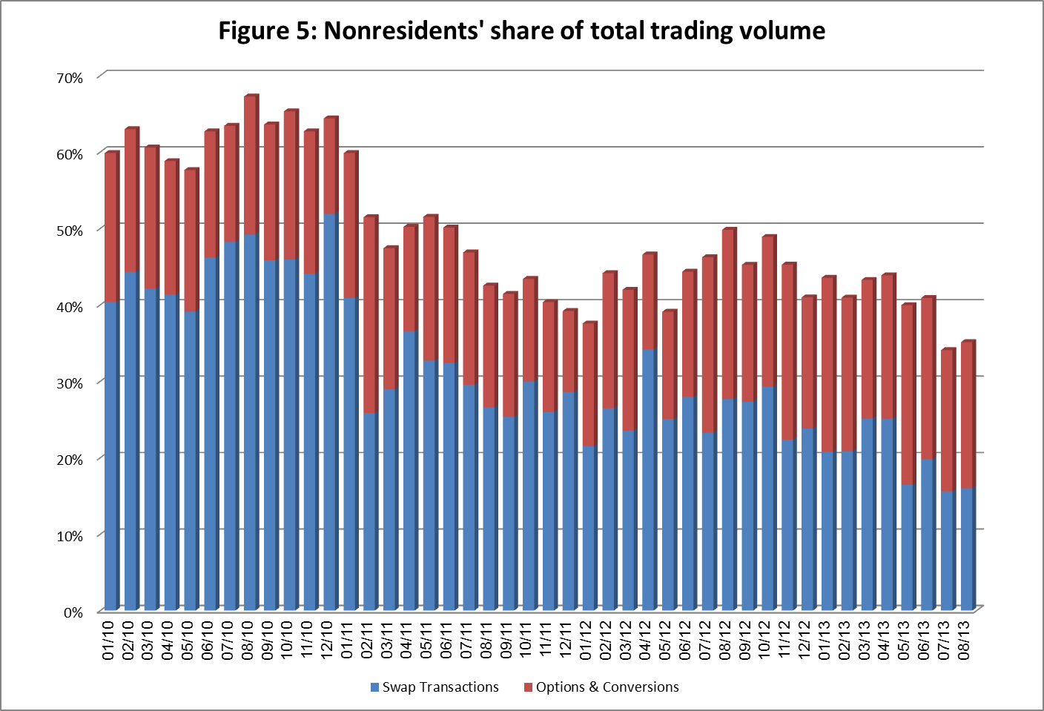

**Forex transactions with domestic banks, by instruments and derivatives ($ million)**

|  |  |  |  |  |  |  |  |
| --- | --- | --- | --- | --- | --- | --- | --- |
|  |  | **Conversions (1)** | **Swaps1 (2)** | **Cross Currency swap5 (3)** | **Options2 (4)** | **Total volume of trade (1)+(2)+(3)+(4)** | |
| **August -13**  **(Not final)** | Total | **31,268** | **40,122** | **602** | **9,752** | **81,744** | |
| Daily average (21 days) | **1,421** | **1,824** | **27** | **443** | **3,716** | |
| Nonresidents | 11,345 | 13,026 | 0 | 4,208 | 28,579 | |
| of which Foreign financial institutions | 10,627 | 12,994 | 0 | 3,995 | 27,616 | |
| Residents | 19,923 | 27,096 | 602 | 5,544 | 53,165 | |
| of which Real sector | 6,067 | 3,786 | 112 | 2,063 | 12,028 | |
| Financial sector | 3,966 | 7,928 | 0 | 1,670 | 13,564 | |
| Institutions (incl. insurance companies) | 2,203 | 4,754 | 40 | 0 | 6,997 | |
| Individuals and provident funds | 642 | 142 | 0 | 361 | 1,145 | |
| The Bank of Israel | 290 | 0 | 0 | 0 | 290 | |
| ***of which:*** Within the program to offset the effect of natural gas production | 290 | 0 | 0 | 0 | 290 | |
| *Other*3 | 3,071 | 31 | 0 | 104 | 3,206 | |
| Domestic banks4 | 3,684 | 10,455 | 450 | 1,346 | 15,935 | |
|  |  |  |  |  |  |  | |
| **July**  **2013** | Total | **33,007** | **40,794** | **1,003** | **8,468** | **83,272** | |
| Daily average (20 days) | **1,500** | **1,854** | **46** | **385** | **3,785** | |
| Nonresidents | 11,392 | 12,872 | 190 | 3,848 | 28,302 | |
| of which Foreign financial institutions | 10,765 | 12,867 | 190 | 3,824 | 27,646 | |
| Residents | 21,615 | 27,922 | 813 | 4,620 | 54,970 | |
| of which Real sector | 6,027 | 3,854 | 538 | 2,161 | 12,580 | |
| Financial sector | 4,890 | 8,349 | 0 | 1,347 | 14,586 | |
| Institutions (incl. insurance companies) | 2,601 | 5,227 | 0 | 1 | 7,829 | |
| Individuals and provident funds | 646 | 341 | 0 | 321 | 1,308 | |
| The Bank of Israel | 255 | 0 | 0 | 0 | 255 | |
| ***of which:*** Within the program to offset the effect of natural gas production | 255 | 0 | 0 | 0 | 255 | |
| *Other*3 | 3,294 | 62 | 0 | 37 | 3,393 | |
| Domestic banks4 | 3,902 | 10,089 | 275 | 753 | 15,019 | |
| 1 Only one leg of the swap, i.e., the nominal value of the transaction (in accordance with the BIS definition). | | | | | | | |
| 2 The notional value, that includes purchases and sales of put and call options. | | | | | | | |
| 3 Including other entities such as portfolio managers, nonprofit organizations, national institutions, and those not included elsewhere. | | | | | | | |
| 4 Total interbank trade, *divided by* 2 | | | | | | | |
| 5 The exchanged founds through Cross Currency Swap transactions considered for the volume, as one leg only in cases where the two legs offset each other. | | | | | | | |

1. This figure reflects transactions by trade date, not settlement date. Therefore, it is not necessarily identical to the data published in the foreign exchange reserves notice, which reflects transactions by settlement date.