

**BANK OF ISRAEL**

Office of the Spokesperson and Economic Information

July 12, 2023

Press Release:

**The Bank of Israel launches a minisite on the Bank’s website: “The Bank of Israel’s Equator”—expanding the comparative information related to various financial products**

**Governor of the Bank of Israel Prof. Amir Yaron** said, “Enhancing financial literacy, including exposure to various financial products and understanding those products and comparing among them helps strengthen the negotiating ability of the consumers and the ability to make an informed financial decision simply and conveniently, based on data that are made more accessible. This is another stage in the Bank of Israel’s measures to transfer the power to the customer, and as a direct result to promote competition in the financial system”.

The Bank of Israel announces additional steps to enhance transparency and consumers’ comparative ability:

**1. The launch of a new minisite at the Bank of Israel website, which concentrates comparative information related to the various financial products and relevant guides, which was promoted by the Bank’s Communication Division.** Among the financial products are consumer loans, mortgages, deposits, including an explanation on saving and investment channels (deposits, money market funds, and makam), and more. The dashboards and the guides on the site are intended to assist the public to act in an informed manner in the financial world in general and vis-à-vis the banks in particular. The comparative information among the banks and the various products that the Bank of Israel is now publishing in a user-friendly manner, is concentrated in one place and is accompanied by explanatory videos that explain how to use the data. It is intended to provide knowledge and tools that will enable customers to make a comparison as simply as possible.

**2. Expansion of the dashboards' comparative information presented on additional financial products and on additional entities, within the framework of the comparative tool and study of the information promoted by the Banking Supervision Department.** In addition to that, today we:

* Expanded the comparison from now on to interest rates charged by credit card companies on consumer loans
* Added a comparison between banks on the interest rates charged in respect of current-account overdrafts, within the credit facility
* Added a comparison of the average interest rates on credit card transactions, in both credit transactions and revolving credit transactions
* Added the interest on makam to the deposit dashboard in order to illustrate the alternative investment to deposits and the return on it.

**\* It is important to emphasize that the information does not include all the existing financial products and it should not be viewed as advice, opinion, or a recommendation of any decision whatsoever.**

Presenting the minisite that was established, “Equator”

**The Bank of Israel Equator:**

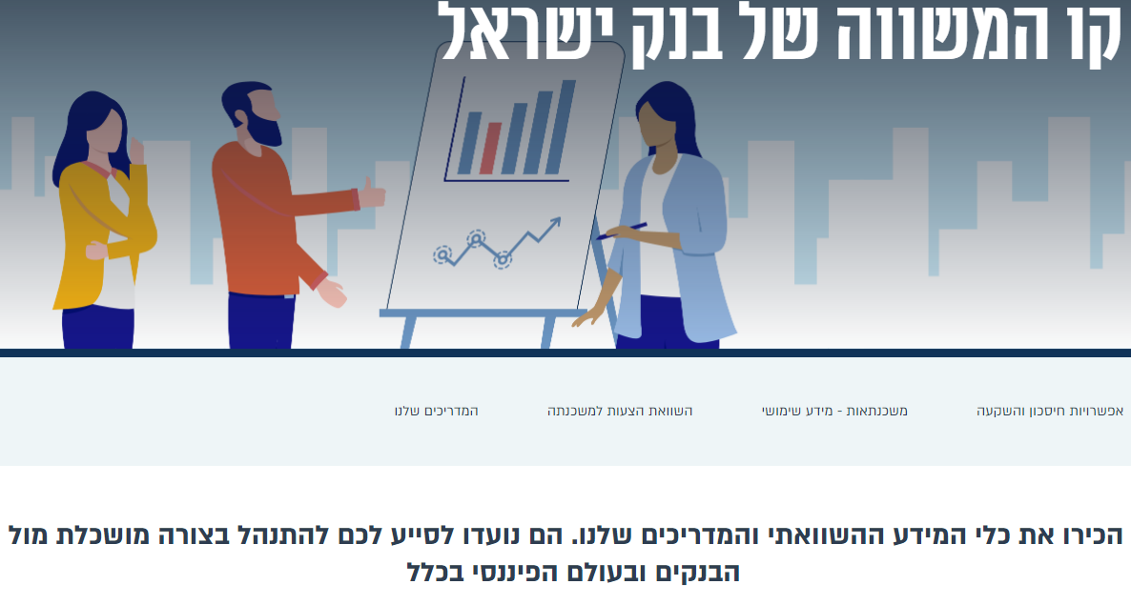

The new minisite—“The Bank of Israel’s Equator”—concentrates the tools existing today on the Bank of Israel’s website, and expands the comparative data for consumers’ use.

The Bank of Israel intends to promote public awareness steps to encourage consumers to enter and use the extensive information on the website as well as to conduct virtual public awareness conferences for the public to become familiar with the tools and how to use them.

The issues presented on the “Equator”:

**Interest rates on deposits and loans dashboard**—enables consumers to compare between banks

**Interest rates on makam** (integrated within the abovementioned dashboard)—so that consumers will be able to integrate the comparison of the makam yield into the process of comparison on interest rates on bank deposits and to choose the preferred option

**Interest rates on consumer loans from credit card companies** (integrated within the above mentioned dashboard)—expands the comparison to include now the interest rates charged by credit card companies for consumer loans

**Interest rates on overdraft** (integrated within the abovementioned dashboard)——comparison between banks on the interest rate charged on overdraft (negative balances within the credit framework.

**Average interest rates from banks for housing credit (a new dashboard)**—presents data intended to help borrowers in the process of taking out a mortgage with transparency, simplicity, efficiency, and the ability to compare

**Interest rates on utilized credit cards and revolving credit** (integrated within the interest's rate dashboard)—comparing the interest rates on utilized credit cards and revolving credit at banks and at credit card companies

**Current account balances and shift to deposits (graph)**—increasing their accessibility to the public on the information on the amount of money that households have in current accounts, and the amount of money invested in interest-bearing deposits

**Information on the possibility of saving and investment** (online miniguides)—explanations on specific savings and investment options, in and outside the banking system

**Guides to the public on various issues that help them, to manage vis-à-vis the banking system (online miniguides)**—including reducing the costs of managing a bank account, revolving credit, debit card, the credit data system, the open banking reform, and more.