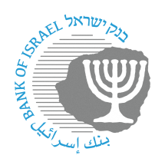
BANK OF ISRAEL
Office of the Spokesperson and Economic Information

Press release

July 17, 2024

New reporting requirement for the banking system as another stage in promoting the securitization market in Israel

The Bank of Israel is working to promote the securitization market in Israel. Securitization enables the efficient flow of credit in the economy by shortening the financial intermediation process and making it less expensive. Credit securitization enables credit providers to make capital available for the provision of new credit and to expand the credit supply. Securitization is expected to reduce funding costs for nonbank credit providers, and thereby increase competition in the credit market. Securitization will also make it possible to combine the expertise of the banks and the nonbank credit providers in underwriting and monitoring credit with the availability of funding sources from the institutional investors and their need to expand the diversification of their investments.

Securitization legislation, which is intended to provide certainty to main participants in the economy and to minimize associated risks, is in advanced stages. A necessary precondition for making a securitization transaction is the ability of the various ratings agencies to assess the risks in the relevant portfolios and to rate them based on reliable and relevant information. In order to make this possible, the Banking Supervision Department today issued a new reporting directive, “Individual Report on Housing Loans – Refinancing, Arrears, and Early Repayment”.

The new reporting directive will make it possible to publish static and dynamic information on the market in order to provide a response for the common ratings methodology. The information obtained through this directive will provide the Banking Supervision Department with a better and more advanced risk assessment of the mortgage market, and will make important information on housing credit available to decision makers.

