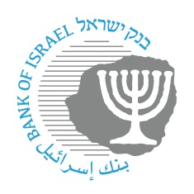
BANK OF ISRAEL
Office of the Spokesperson and Economic Information

November 19, 2023

Press Release:

The Bank of Israel leads an additional step by publishing information for nonbank entities on participation in the Zahav system

Participation in the Zahav (RTGS) system—the core and most critical system in the financial sector - was traditionally reserved for banking corporations. The Bank of Israel as recently published principles, according to which, access to this system was opened to nonbank entities as well. In the past week, the Clearing Houses Division published the conditions and requirements for joining the Zahav system, including fees for participation and use of the system, as well as details on the manner of initiating the joining process.

Payment and Settlement Systems Department Director Mr. Oded Salomy: “I believe that the clarity and transparency we are providing in this document will help to promote competition in the economy in the financial sphere. It will lead to expanding the range and increasing the number of participants, which will enhance the substitutability of each one, and thus we will enhance the stability of the economy, particularly in this complex time.”

Real Time Gross Settlement.

