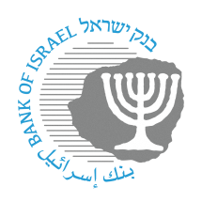

BANK OF ISRAEL

Office of the Spokesperson and Economic Information

Press release

January 21, 2024

**Bank of Israel Governor Prof. Amir Yaron traveled to the World Economic Forum in Davos, Switzerland**

Bank of Israel Governor Prof. Amir Yaron returned to Israel over the weekend following his participation at the annual conference of the World Economic Forum in Davos, Switzerland.

During the conference, the Governor met with many of the world’s foremost economists, including central bank governors, senior investment bankers, investors from the business and private sectors, and professionals from the world of academia.

The Governor also conducted interviews with international media outlets including CNN, CNBC, and Bloomberg.