

BANK OF ISRAEL

Office of the Spokesperson and Economic Information

November 7, 2024

Press Release:

Foreign Exchange Reserves at the Bank of Israel, November 2024

Israel’s foreign exchange reserves at the end of November 2024 stood at $217,100 million, an increase of $1,026 million from their level at the end of the previous month. The level of the reserves relative to GDP was 41.7 percent (Figure 1).

The increase was mainly the result of a revaluation[1] that increased the reserves by approximately $2,255 million. This increase was partly offset by the government’s foreign exchange activities totaling approximately $1,111 million.

**Israel's Foreign Exchange Reserves** ($ million)

|  |  |  |  |
| --- | --- | --- | --- |
| **Date** | **Reserves excluding IMF (including reserves bought under the natural gas purchase program)** | **Reserves at the IMF[2]** | **Total Foreign Exchange Reserves** |
| November 2024 | 212,684 | 4,416 | 217,100 |
| October 2024 | 211,638 | 4,436 | 216,074 |
| September 2024 | 215,807 | 4,570 | 220,377 |
| August 2024 | 212,847c | 4,538 | 217,385c |
| July 2024 | 209,141 | 4,493 | 213,634 |
| June 2024 | 205,854c | 4,427 | 210,281c |
| May 2024 | 206,035c | 4,475 | 210,510c |
| April 2024 | 203,656 | 4,453 | 208,109 |
| March 2024 | 209,261c | 4,480 | 213,741c |
| February 2024 | 202,326c | 4,495 | 206,821c |
| January 2024 | 201,597 | 4,528 | 206,125 |
| December 2023 | 200,090c | 4,604c | 204,694c |
| November 2023 | 193,590 | 4,579 | 198,169 |

**Figure 1**

**Level of foreign exchange reserves, and their ratio to GDP, 2007–2024**

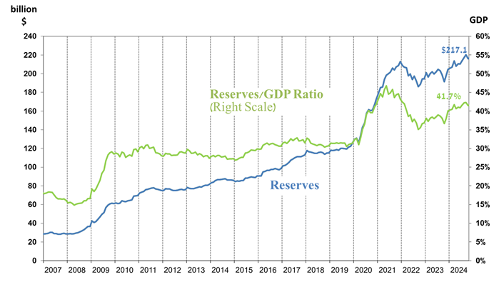

1. a Includes Bank of Israel payments and receipts in foreign currency.
2. b This column includes Special Drawing Rights (SDRs), the balance of NAB loans, and the balance of Israel's reserve tranche at the IMF.

   c Updated after the original date of publication.