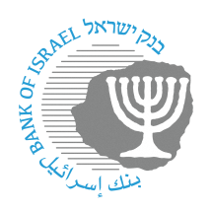

BANK OF ISRAEL

Office of the Spokesperson and Economic Information

Press release

February 14, 2023

**The Bank of Israel announces another step toward the entry of a new bank in Israel: Allocation of a new identification code for esh bank Israel (in establishment) Ltd.**

Financial system participants in Israel are identified by a two-character identification code that is unique for each entity (known today as a “**bank code**”). For a financial entity to operate in the various payment systems and to provide account numbers to its customers, it must be identified in all the systems related to the matter in the economy.

Further to the conditional license issued by the Bank of Israel Governor and the Supervisor of Banks on December 25, 2022 to **esh bank Israel (in establishment) Ltd.**, the Bank of Israel has approved **esh bank Israel** to receive an identification code in the Israeli payment systems.

The identification code allocated to **esh bank Israel (in establishment) Ltd. is 3.**

Payment system operators and participants are asked to prepare for identification and assimilation of the code in their systems no later than three months from the date of allocation.

Oded Salomy, Director of the Bank of Israel’s Payment and Settlement Systems Department, said, “Today we have announced the allocation of an identification code to esh bank Israel (in establishment) Ltd. The allocation of the identification code will enable it to operate in the payment systems, and will serve its future customers as part of their account identification for making payments. As part of opening the payment systems to new participants, an identification code will be allocated to all bank and nonbank payment service providers who meet the conditions for receiving a code, so that all payment service providers in the economy will be identified in a uniform manner.”