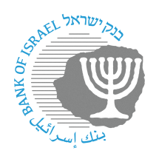
BANK OF ISRAEL
Office of the Spokesperson and Economic Information

Press release

May 12, 2024

Allocation of identification codes to nonbank payment service providers:

GMT Tech Innovation Ltd. (GMT)
V-Check Ltd.

Participants in the Israeli financial system are identified using an identification code that is unique to each participant (formerly known as a “bank code”), composed of two characters.

The Bank of Israel announces the allocations of identification codes to fintech firms that are in the process of connecting to the payments systems in Israel.

This step is consistent with the other measures advanced by the Bank of Israel to open access to nonbank participants and to advance competition in the payments market, such that fintech firms will be able to operate directly and independently in the supervised payment systems in Israel, while reducing their dependence on the banks. Together with a proper license from the relevant regulator, the identification code will enable fintech firms to be uniquely identified by other payment system participants, and will enable them to allocate payment account numbers, similar to bank account numbers, to their customers.

The Bank of Israel has allocated identification code 69 to GMT Tech Innovation Ltd., and has allocation identification code 75 to V-Check Ltd.

Payment and Settlement Systems Department Director Oded Salomy said: “It is important to continue adding a variety of participants to the system. These new participants will contribute by increasing competition and reducing concentration in the market, developing advanced and innovative payment solutions, streamlining business processes and services, and lowering costs for consumers and merchants in Israel.”

