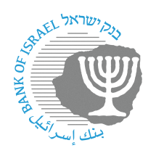

BANK OF ISRAEL

Office of the Spokesperson and Economic Information

Press release

November 12, 2024

**Bank of Israel Governor Prof. Amir Yaron participated in a BIS meeting in Basel, Switzerland with other central bank governors**

Bank of Israel Governor Prof. Amir Yaron returned to Israel after participating in a meeting of central bank governors from around the world who are members of the Bank for International Settlements (BIS) in Basel, Switzerland.

During the meeting, the Governor, who serves as Chairman of the Small and Open Economies Forum, led a discussion with other governors in the forum on the topic of the development of inflation in the prices of goods and services.

* Background:

The BIS (Bank for International Settlements) is the oldest international financial organization. Its role is to promote cooperation between central banks, of which 63 are currently members. The BIS’s activities include the development of international banking supervision standards and criteria (the “Basel” regulations), monitoring the stability of the international financial system, providing banking services to central banks, and assisting various financial institutions in performing their functions. The Bank of Israel joined the BIS as a full member in September 2003.