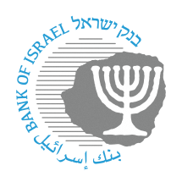
BANK OF ISRAEL
Office of the Spokesperson and Economic Information

Press release

October 2, 2022

Consumer-related transparency in a changing financial environment – Publication of the banking corporations’ interest rates – completion of the first stage

Supervisor of Banks Yair Avidan sent a letter to the banking corporations’ CEOs on September 7, 2022, in which he noted the Banking Supervision Department’s intention to publish the interest rates actually paid by each of the banking corporations on shekel deposits, and those actually charged for the provision of credit.

We are pleased to announce that the first stage in the process has been completed, and average interest rate data are now being made accessible for each of the banks regarding interest actually paid on deposits (fixed- and variable-rate) and actually charged on credit (variable rate) unindexed in Israeli currency. The information is being made available on a dedicated page (in Hebrew) on the Bank of Israel’s website, and will be published on a monthly basis, updated to the end of the previous month.

During the first quarter of 2023, the information presented on the page will be expanded, with the addition of data that will enhance the comparison.

Supervisor of Banks Yair Avidan said, “As part of the many consumer-related reforms that the Bank of Israel has advanced in recent years, we are today publishing information regarding the interest rates on deposits and credit to households, by bank. I believe that this measure will help strengthen the customer’s power and provide customers with the ability to make informed decisions after examining all the information in a simple, accessible, and convenient manner.”

The following are screenshots (in Hebrew) illustrating how the comparison can be made in the system:

