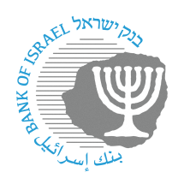
BANK OF ISRAEL
Office of the Spokesperson and Economic Information

Press release

Jun 11, 2023

The Supervisor of Banks attended lectures that were held in various cities as part of the “Digital Fraud Awareness Week”

Supervisor of Banks Yair Avidan today attended a lecture on increasing awareness of digital fraud, together with the head of the Israel Police Investigations Division, Brig.-Gen. Shlomit Landes, and Israel Association of Banks Director General Eitan Madmon.

The lecture took place in Jerusalem, one of dozens of lectures being held across the country as part of “Digital Fraud Awareness Week”—a program being run by the Banking Supervision Department in conjunction with the Association of Banks and the banking system, and in cooperation with the Israel Police.

The Supervisor of Banks noted that the Banking Supervision Department is increasing its public awareness efforts on this matter, with the aim of raising public awareness and providing the public with tools for dealing with digital fraud. He invited participants in the program to increased their knowledge by visiting a dedicated website established for the Digital Fraud Awareness Week.

Registration for the program’s webinars is still open, and the public is invited to register at https://camp.mini-sites.net/financialforumil for a Hebrew language webinar that will take place on June 13, 2023 at 7:00 pm.

Photographed (l-r): Supervisor of Banks Yair Avidan, Head of the Israel Police Investigations Division Brig.-Gen. Shlomit Landes, and Association of Banks Director General Eitan Madmon. Credit: Yankele Kasirer

