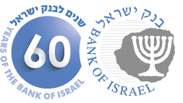

**BANK OF ISRAEL**

Office of the Spokesperson and Economic Information

July 27, 2014

**Press Release**

**Debt Developments in the Economy, May-June 2014**

**Business sector debt** increased by 0.7 percent to around NIS 786 billion in May. **Household debt** increased by about NIS 3.2 billion (0.8 percent) to around NIS 417 billion at the end of the month.

**The business sector’s outstanding debt**

* The total outstanding debt of the business sector increased by NIS 5.5 billion (0.7 percent) to around NIS 786 billion in May. The increase derived mostly from net raising of debt, the result of funds raised through tradable and nontradable bonds and non-bank loans, as well as from an increase of 0.1 percent in the Consumer Price Index and a depreciation of 0.3 percent in the shekel vis-à-vis the dollar, which increased the shekel value of both indexed and foreign currency-denominated debt.
* Following more than a year of decline in business sector debt, the trend has halted in the past two months (see Figure 1).
* In June, the business sector (excluding banks and insurance companies) issued about NIS 3.6 billion in bonds, all of which were tradable bonds.

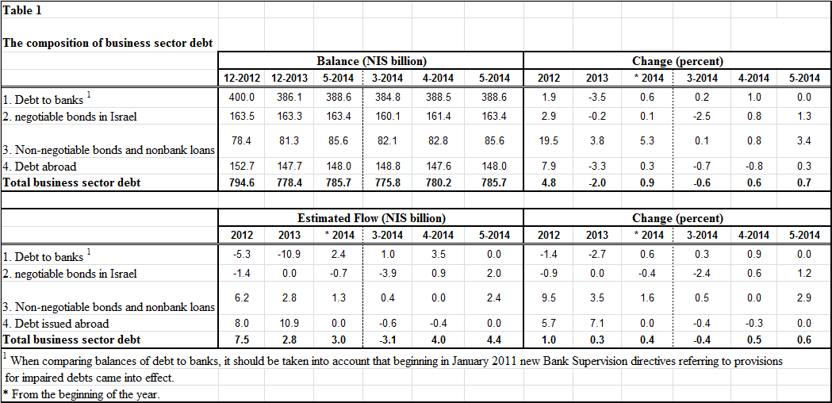

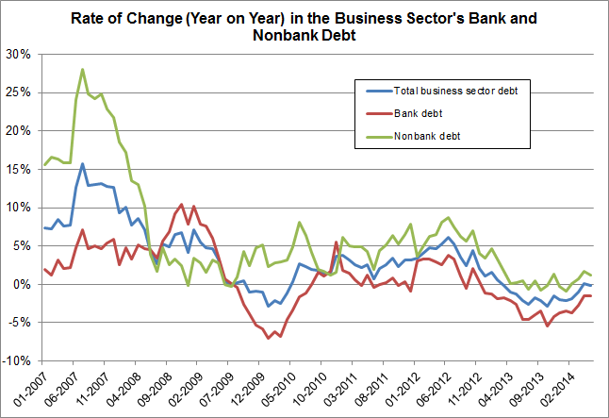

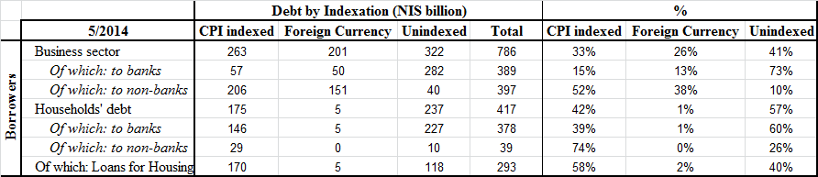

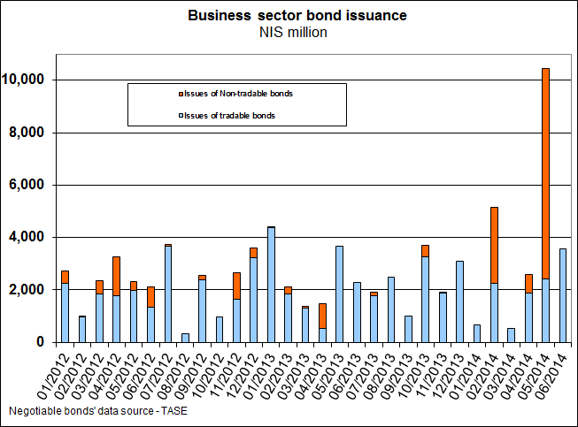

**Household debt**

* Households’ outstanding debt increased by about NIS 3.2 billion (0.8 percent) to about NIS 417 billion in May. Of that, the balance of outstanding housing debt increased by about NIS 1.6 billion, to about NIS 293 billion at the end of May.
* In June, there were about NIS 4.6 billion in new mortgages taken out. The average since the beginning of the year is about NIS 4.3 billion per month.

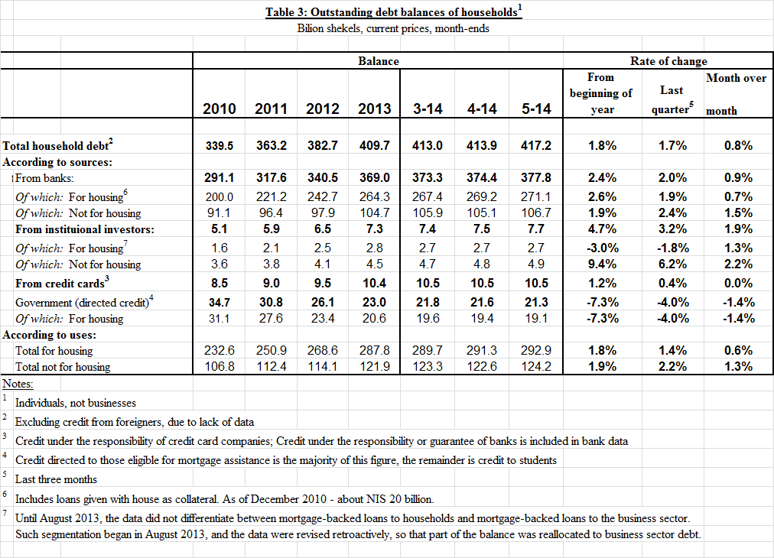

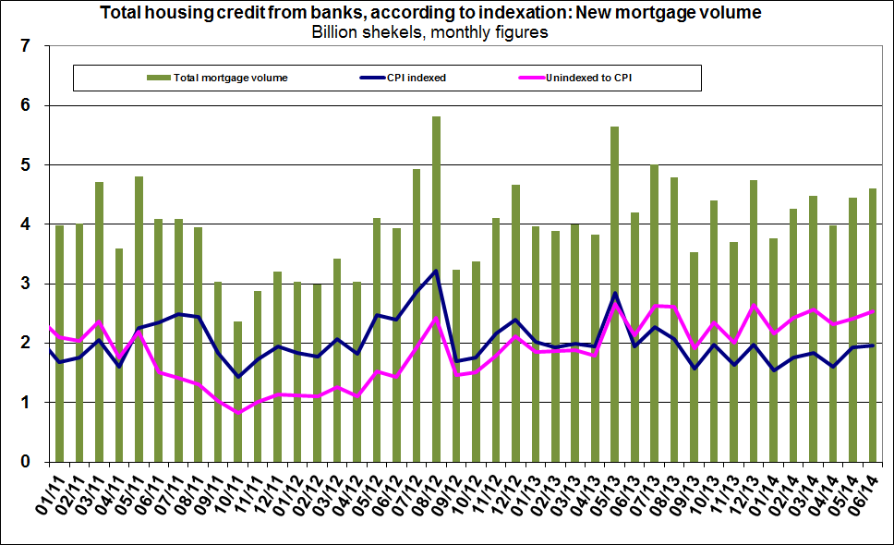

**The cost of the debt**

* In May, the interest rate spread in the unindexed track narrowed by about 0.04 percentage points, mainly as a result of a decline in interest rates on outstanding credit.
* In the CPI-indexed track, the spread between the interest rate on new bank credit granted and the interest rate on deposits narrowed in May by about 0.11 percentage points, mainly due to an increase in interest on deposits.
* In May, the spread between the yield on CPI-indexed corporate bonds—measured by the Tel Bond 60—and yields on CPI-indexed government bonds was 1.2 percentage points, virtually unchanged from the spread in the previous month.
* In June, the average interest rate on new CPI-indexed mortgages declined by around 0.07 percentage points. The interest rate on new unindexed mortgages declined by around 0.02 percentage points.

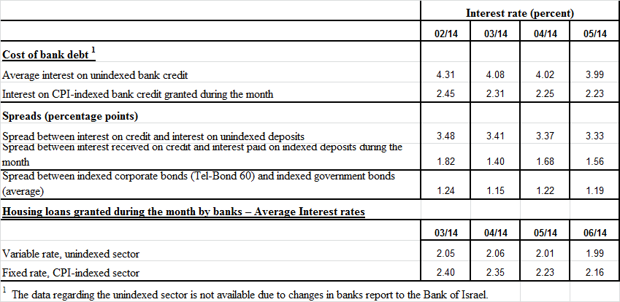

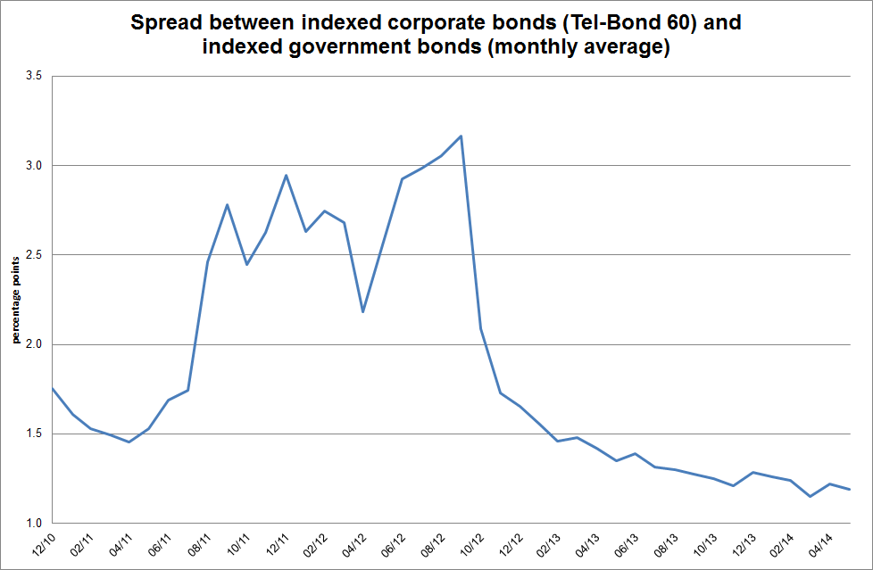

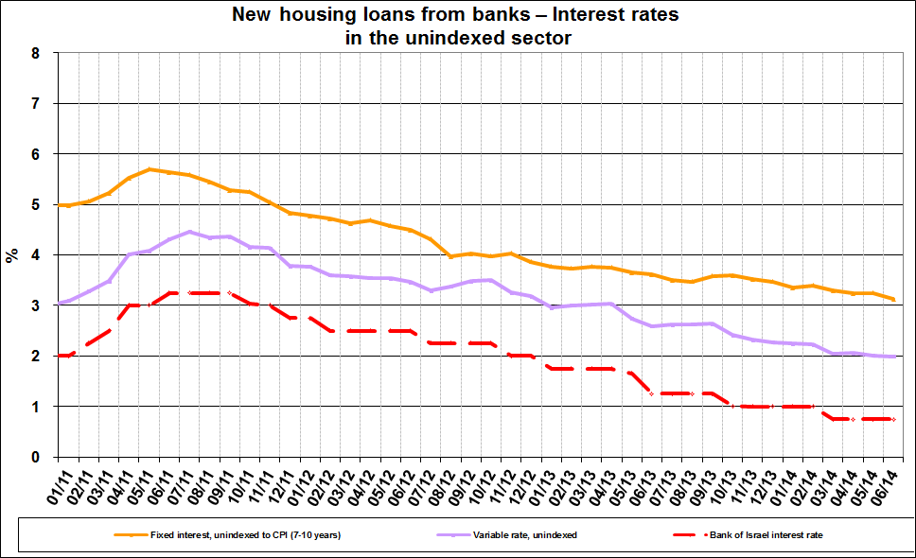

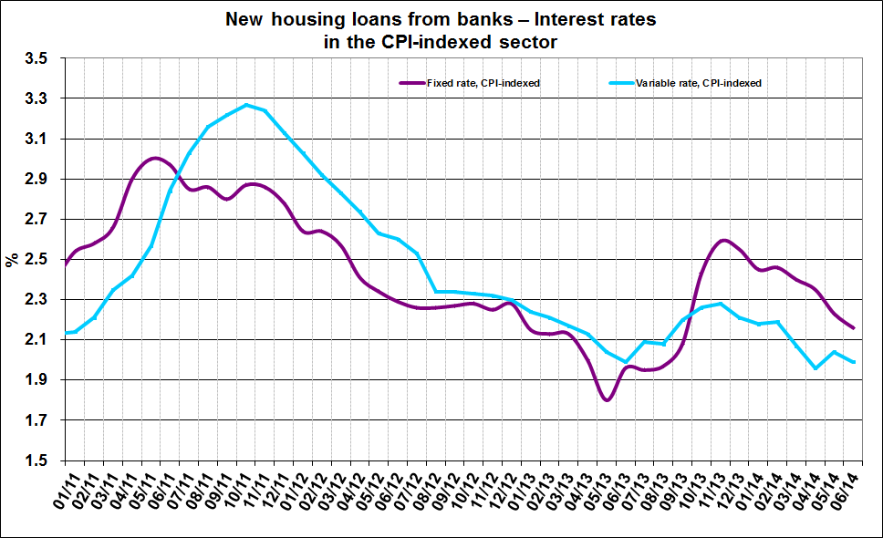

For links to Data and Statistics on the Bank of Israel website:

[http://www.boi.org.il/en/dataandstatistics/pages/default.aspx](https://e.boi.org.il/en/dataandstatistics/pages/default.aspx)

[http://www.boi.org.il/en/bankingsupervision/data/pages/tables.aspx?chapterid=13](https://e.boi.org.il/en/bankingsupervision/data/pages/tables.aspx?chapterid=13)