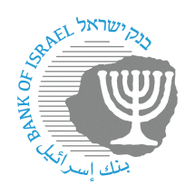
BANK OF ISRAEL
Office of the Spokesperson and Economic Information

October 8, 2023
Press release:

Operations of the banking system branches in view of the security situation

In view of the security situation and in accordance with guidelines from national agencies, the Bank of Israel is holding constant situation assessments. The Banking Supervision Department is in constant contact with all relevant entities in the banking system, which is prepared for emergencies and is working to provide essential banking services to the public as required by regulatory directives.

In accordance with the Home Front Command’s protection policy, and with the aim of maintaining the safety of bank employees and customers, the banking system is permitted to operate on a reduced footing in terms of customer reception, in the following manner: Closure of bank branches within a range of 40 km from the Gaza Strip; opening central branches on a reduced footing in a range of 40–80 km; and change in the hours of a branch’s operation as circumstances dictate.

As part of this, the banks must adopt various means of notifying their customers regarding changes that are implemented, and on the alternatives available to customers in order to receive banking services, including directing them to options for making banking transactions through direct channels—phone, ATMs, banking application, and the bank’s website—and must do so as soon as possible.

The Banking Supervision Department will continue to monitor banking system operations, closely track developments, and instruct the banking system and its customers accordingly.

In addition, the Banking Supervision Department has opened a telephone call center for the public at 02-655-2680, or *9086.

A Banking Supervision Department letter defining “central branches” is attached.

