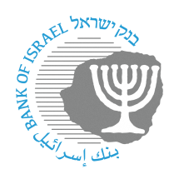

BANK OF ISRAEL

Office of the Spokesperson and Economic Information

Press release

March 26, 2024

**Bank of Israel Governor Prof. Amir Yaron traveled to a conference on “The Global Economy and Stability of the Financial Markets” at the University of Chicago**

Bank of Israel Governor Prof. Amir Yaron returned to Israel from the US after participating in a conference on “The Global Economy and Financial Stability” that was held by the Kent A. Clark Center for Global Markets at the University of Chicago Booth School of Business.

The conference took place in Miami, with the participation of past and present governors and other senior central bank officials, academics from leading universities, and others. During the conference, the Governor led a session on “Monetary Policy in Small Open Economies”.