|  |  |  |
| --- | --- | --- |
| **BANK OF ISRAEL**  Office of the Spokesperson and Economic Information | 60Y+bank_Color_RGB_300DPI (2) | September 29, 2015 |

Press Release

**Debt Developments in the Economy, July–August 2015**

**Business sector debt** remained virtually unchanged in July, at around NIS 812 billion. **Household debt** increased by about NIS 5.4 billion (1.2 percent) to around NIS 451 billion at the end of the month.

**The business sector’s outstanding debt**

* In July, business sector debt remained virtually unchanged at around NIS 812 billion, despite debt repayments totaling about NIS 2 billion in tradable and nontradable bonds in Israel and credit from abroad. These repayments were offset as a result of the net raising of debt through bank and nonbank loans and by the effect of the shekel’s depreciation against the dollar on 0.4 percent, which increased the shekel value of debt indexed to and denominated in foreign currency.
* In August, the business sector (excluding banks and insurance companies) issued about NIS 1.9 billion in bonds, mostly in tradable bonds. This is lower than the average issuance of the first seven months of the year (NIS 2.4 billion).

**Table 1: The Composition of Business Sector Debt**



**Figure 1: Rate of Change (Year on Year) in the Business Sector's Bank and Nonbank Debt**

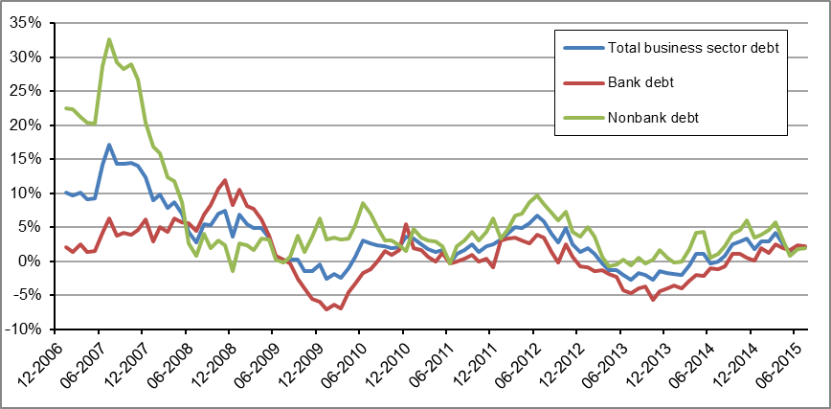

**Table 2: Debt by Indexation**



**Figure 2: Business Sector Bond Issuance**

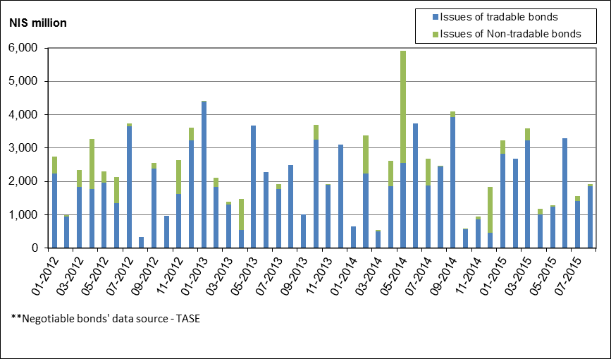

**Household debt**

* Households’ outstanding debt increased by about NIS 5.4 billion (1.2 percent) in July, to about NIS 451 billion. Of that, the balance of outstanding housing debt increased by about NIS 2.9 billion, to about NIS 314 billion.
* In August, there was a small decline in new mortgages taken out, but the volume remained significant, with new mortgages totaling about NIS 6.2 billion, higher than the average since the beginning of the year, which is about NIS 5.5 billion (see Figure 3).

**Table 3: Outstanding Debt Balances of Households**

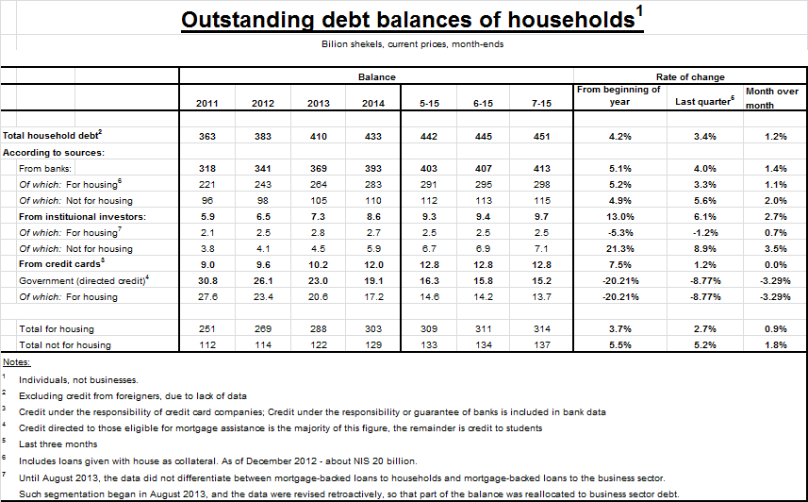

**Figure 3 :Total Housing Credit from Banks, According to Indexation: New Mortgage Volume**

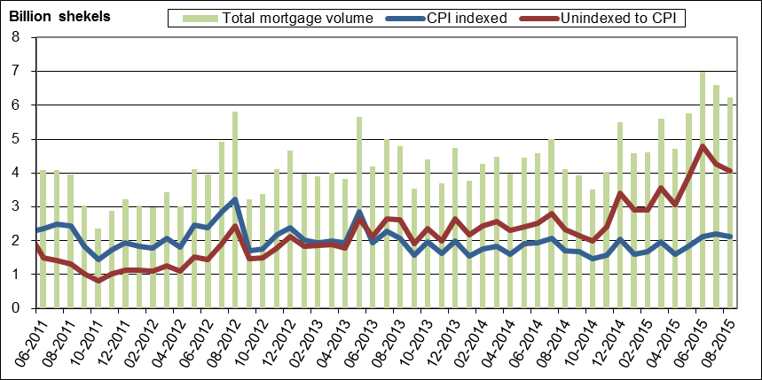

**The cost of the debt**

* In the CPI-indexed track, the spread between the interest rate on new bank credit granted and the interest rate on deposits narrowed by about 0.05 percentage points in July, compared with the previous month, due to a larger increase in the interest on marginal indexed deposits than the increase in interest on marginal indexed credit.
* In August, the average spread between the yield on CPI-indexed corporate bonds—measured by the Tel Bond 60—and the yields on CPI-indexed government bonds narrowed to about 1.5 percentage points.
* In August, the average interest rate on new unindexed mortgages (variable-rate interest) increased by about 0.04 percentage points. The average interest rate on new CPI-indexed mortgages (fixed interest) also increased, by about 0.14 percentage points.

**Table 4: The Cost of the Debt**



**Figure 4 : Spread between Indexed Corporate Bonds (Tel-Bond 60) and Indexed Government Bonds (monthly average)**

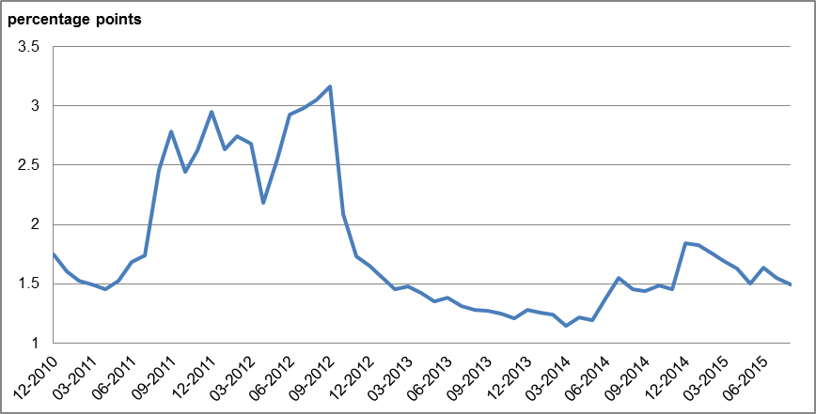

**Figure 5 : New Housing Loans from Banks – Interest Rates**

**in the Unindexed Sector**

**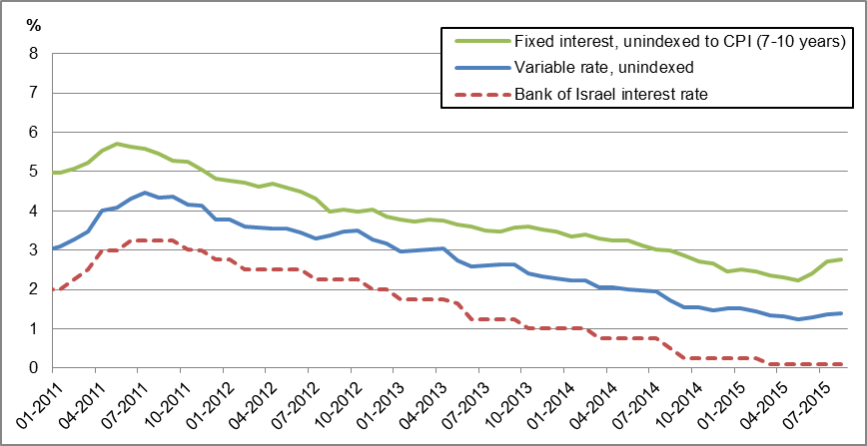**

**Figure 6 : New Housing Loans from Banks – Interest Rates   
in the CPI-indexed Sector**

**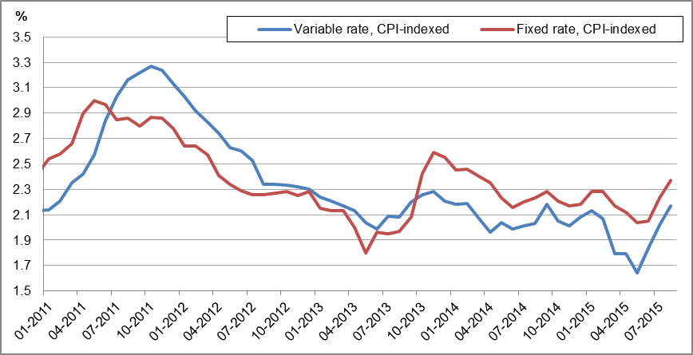**

For links to Data and Statistics on the Bank of Israel website:

[http://www.boi.org.il/en/dataandstatistics/pages/default.aspx](https://e.boi.org.il/en/dataandstatistics/pages/default.aspx)

[http://www.boi.org.il/en/bankingsupervision/data/pages/tables.aspx?chapterid=13](https://e.boi.org.il/en/bankingsupervision/data/pages/tables.aspx?chapterid=13)