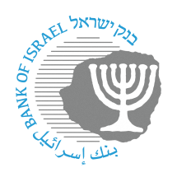

BANK OF ISRAEL

Office of the Spokesperson and Economic Information

Press release

February 11, 2024

**Bank of Israel Governor Prof. Amir Yaron attended a conference on “Central bank independence in a changing world”, held by the National Bank of Belgium**

Bank of Israel Governor Prof. Amir Yaron returned to Israel from Brussels, Belgium, following his participation at a conference of central bank governors from the group of countries to which Israel belongs on the International Monetary Fund Board of Directors. The conference was hosted by the National Bank of Belgium. The subject of the conference was central bank independence in a changing world, and participants in the conference included central bank governors, senior academic professionals, and the Chairman of the Board of the International Monetary Fund.

During the conference, the Governor chaired a session on “Perspectives on central bank independence”, and delivered remarks during a panel discussion on “Interest rate increases and financial stability”. In his remarks, the Governor emphasized that maintaining central bank independence is essential for the economy in order to attain the bank’s objectives, which include maintaining price stability, and supporting financial stability and economic activity. In addition, the Governor discussed the challenges facing central banks in raising interest rates, particularly maintaining financial stability, as well as measures taken by the Bank of Israel during the war to maintain stability.

During the conference, the Governor met with IMF Board Chairman Kristalina Georgieva.

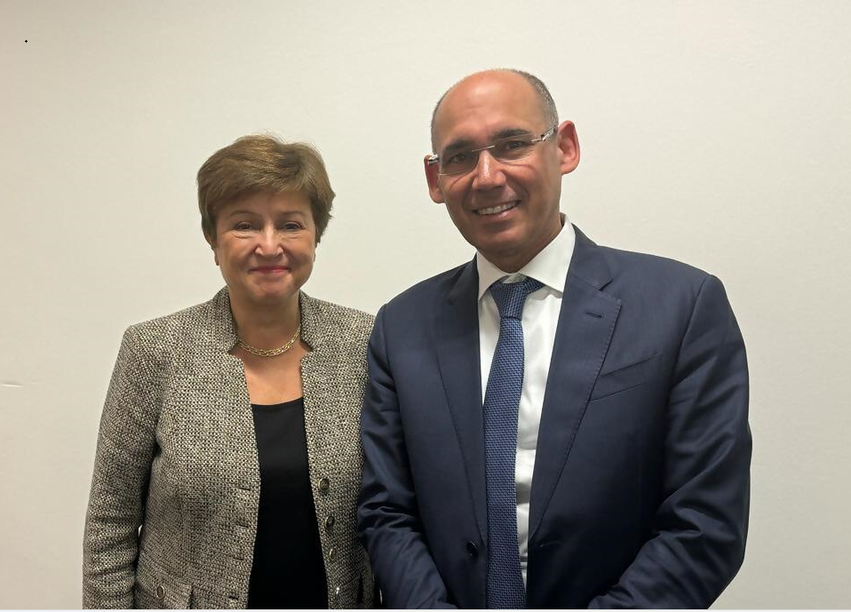

Bank of Israel Governor Prof. Amir Yaron with International Monetary Fund Chairman Kristalina Georgieva.

Credit: Bank of Israel Office of the Spokesperson and Economic Information