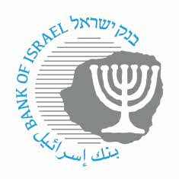

BANK OF ISRAEL
Office of the Spokesperson and Economic Information

April 16, 2024

Press Release:

Decision to cease the publication of Telbor after June 30, 2025

Bank of Israel Markets Department Director Dr. Golan Benita said, “The cessation date decision for Telbor interest rate, is an important milestone in the transition process from Telbor to SHIR. The shift to the SHIR interest rate is expected to contribute to the advancement and development of the shekel interest rate derivative market."

The Telbor Committee has decided today that the publication of all tenors of TELBOR will permanently cease immediately following a final publication on June 30, 2025.
This announcement constitutes an "Index Cessation Event" under the 2021 ISDA Interest Rate Derivatives Definitions and the November 2022 Benchmark Module of the ISDA 2021 Fallbacks Protocol.

In February 2022, the Telbor committee decided that the SHIR (Shekel overnight Interest Rate) rate will eventually be the replacement for the Telbor interest rate, in shekel interest rate derivative transactions, at a time in the future when Telbor ceases and will serve as the overnight interest rate for the same day. At that time, the future cessation of Telbor was not decided. The decision to switch the Telbor interest rate is in accordance with the decisions reached in major economies worldwide, according to which IBOR type interest rates will be replaced by risk-free overnight interest rates.
For further information, please refer to the ISDA Statement relating to the TELBOR cessation announcement.
Further information regarding the TELBOR and SHIR is available on the BOI website.
Any comments or queries regarding this SHIR cessation announcement should be sent to shir@boi.org.il.

