

**BANK OF ISRAEL**

Office of the Spokesperson and Economic Information

February 7, 2024

Press Release:

Foreign Exchange Reserves at the Bank of Israel, January 2024

Israel’s foreign exchange reserves at the end of January 2024 stood at $206,125 million, an increase of $1,442 million from their level at the end of the previous month. The level of the reserves relative to GDP was 39.8 percent (Figure 1).

The increase was mainly the result of the government’s foreign exchange activities totaling approximately $2,241 million. This increase was partly offset by a revaluation[1] that decreased the reserves by approximately $766 million.

**Israel's Foreign Exchange Reserves** ($ million)

|  |  |  |  |
| --- | --- | --- | --- |
| **Date** | **Reserves excluding IMF (including reserves bought under the natural gas purchase program)** | **Reserves at the IMF[2]** | **Total Foreign Exchange Reserves** |
| January 2024 | 201,597 | 4,528 | 206,125 |
| December 2023 | 200,079c | 4,604c | 204,683c |
| November 2023 | 193,590 | 4,579 | 198,169 |
| October 2023 | 186,675 | 4,560 | 191,235 |
| September 2023 | 194,025 | 4,528c | 198,553c |
| August 2023 | 198,338 | 4,518 | 202,856 |
| July 2023 | 200,086c | 4,579 | 204,665c |
| June 2023 | 197,363c | 4,513 | 201,876c |
| May 2023 | 195,100 | 4,521 | 199,621 |
| April 2023 | 197,390 | 4,505 | 201,895 |
| March 2023 | 195,951c | 4,535 | 200,486c |
| February 2023 | 191,987c | 4,292 | 196,279c |
| January 2023 | 196,460c | 4,525c | 200,985c |

**Figure 1**

**Level of foreign exchange reserves, and their ratio to GDP, 2007–2024**

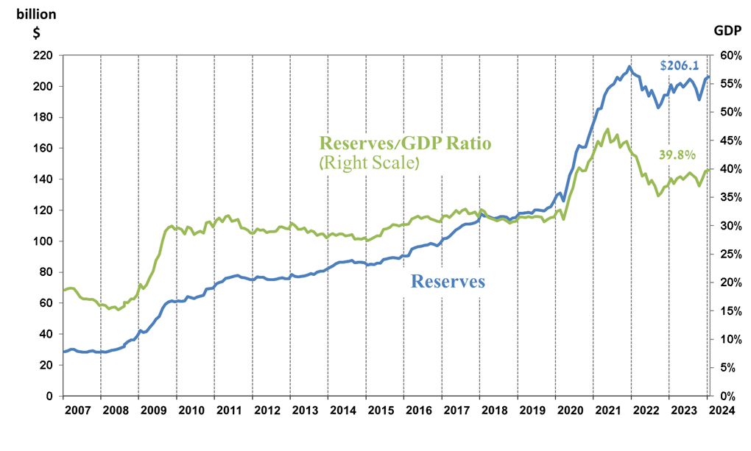

1. a Includes Bank of Israel payments and receipts in foreign currency.
2. b This column includes Special Drawing Rights (SDRs), the balance of NAB loans, and the balance of Israel's reserve tranche at the IMF.

   c Updated after the original date of publication.