

BANK OF ISRAEL

Office of the Spokesperson and Economic Information

Press release

June 30, 2025

# The public's financial assets portfolio in the first quarter of 2025

* **In the first quarter of 2025, the balance of the public’s financial assets portfolio increased by approximately NIS 41 billion (1 percent), to about NIS 6.3 trillion.**
* **The increase in the portfolio’s value in the first quarter derived mainly from increases in the balance of corporate bonds(4.7 percent) and of equities in Israel (2.8 percent).**
* **The balance of the asset portfolio managed by institutional investors increased in the first quarter by approximately NIS 25 billion (0.9 percent), to NIS 2.89 at the end of the quarter.**
* **The scope of the portfolio managed by mutual funds in Israel increased by approximately NIS 19.9 billion (3.3 percent) in the first quarter, to NIS 617.4 billion. There were net new investments, mainly in funds specializing in domestic bonds, money market funds, and in funds specializing in domestic equities.**

# 1. The public’s total assets portfolio

**In the first quarter of 2025,** the balance of the public’s financial assets portfolio increased by approximately NIS 41 billion (about 1 percent), to about NIS 6.3 trillion (Figure 1). The share of the public’s financial assets portfolio relative to GDP decreased by approximately 1.4 percentage points, to about 310 percent at the end of the quarter, as a result of an increase in GDP that was greater than that of the asset portfolio.

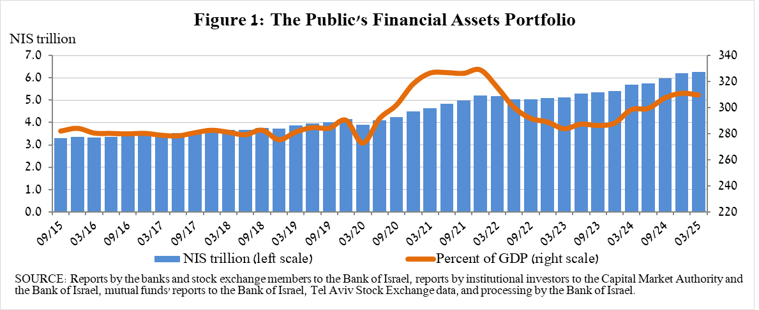

**2. Analysis of the changes in the overall portfolio**

Over the course of the first quarter, there were increases in the balances of the public’s holdings in most components of the portfolio, except for the cash and deposits component and the investment abroad component. The increases in corporate bonds (4.7 percent) and equities in Israel (2.8 percent) were notable.

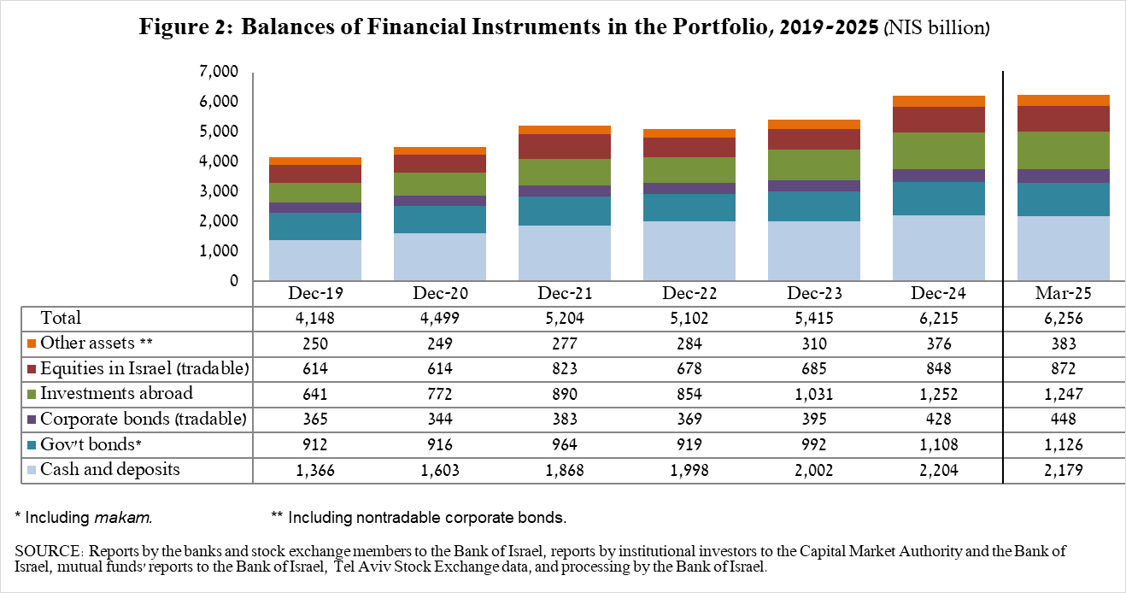

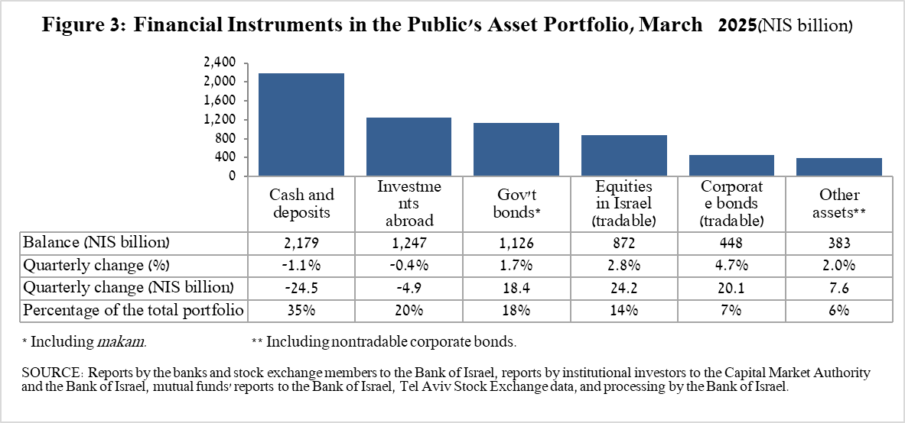

* The balance of **equities in Israel** increased by about NIS 24 billion (2.8 percent), mainly in view of price increases that were partly offset by net realizations (estimated at NS 4.2 billion).
* The balance of **tradable corporate bonds in Israel** increased by about NIS 20 billion, to about NIS 448 billion at the end of the quarter, due to a combination of net investments and price increases.
* The balance of **cash and deposits** decreased during the first quarter by about NIS 24.5 billion (1.1 percent) to about NIS 2.18 trillion, which is about 35 percent of the total portfolio.
* The balance of **tradable** **government bonds** increased during the quarter by about NIS 17 billion to about NIS 450.8 billion at the end of the quarter (Figure 4). In a breakdown by holders of government bonds, the institutional investors are the main holders, increasing the balance of their holdings during the quarter by about NIS 6 billion to a level of NIS 342 billion.
* The **Makam** balance remained virtually unchanged, with an increase of NIS 1 billion to around NIS 212 billion (Figure 5). Mutual funds and institutional investors are the main holders of Makam—during the first quarter the institutional investors increased the balance of their holdings by about NIS 13 billion, to NIS 94 billion, while mutual funds’ holdings declined by about NIS 10 billion, to about NS 10 billion. Households hold about NIS 7 billion of Makam.

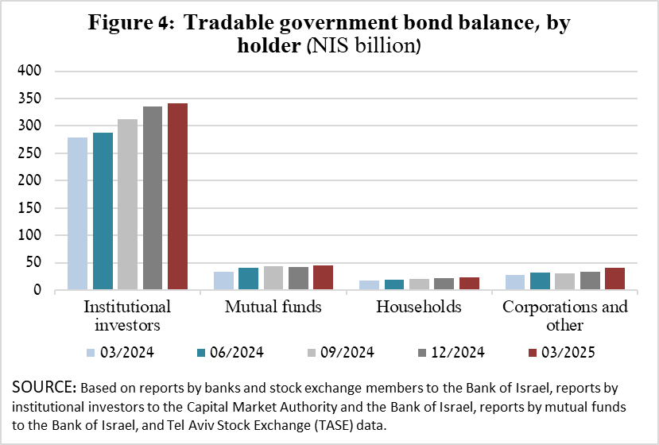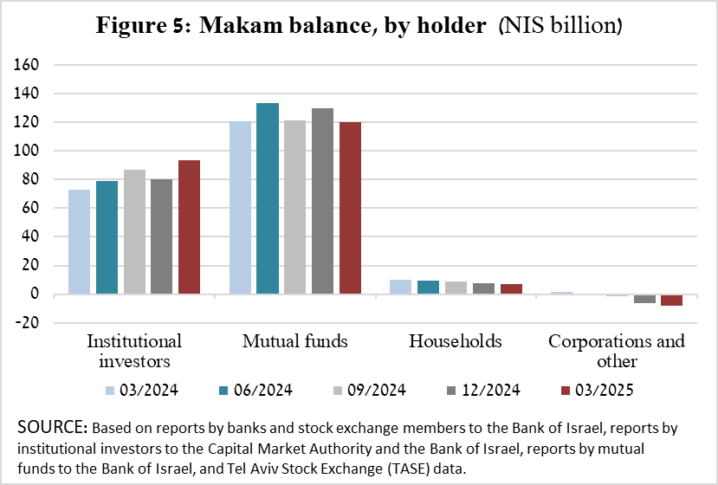

The balance of investments abroad decreased by approximately NIS 4.9 billion during the quarter, to NIS 1.25 trillion at the end of the quarter, making up approximately 20 percent of the total asset portfolio. The development in the balance of investments abroad was mainly due to the following components:

* The balance of **equities held abroad** decreased by approximately NIS 23 billion (3.1 percent), to about NIS 707.5 billion. This was against the background of price declines that were partly offset by net investments (estimated at about 5.1 billion).
* The balance of **investment funds** increased by about NIS 12 billion (4.8 percent) to around NIS 260 billion at the end of the quarter.
* The balance of **tradable (corporate and government) bonds abroad** increased by approximately NIS 6.2 billion (2.3 percent) during the quarter, to about NIS 279 billion. This increase was mainly due to net price increases and the shekel’s appreciation vis-à-vis the dollar.

As a result of the developments during the quarter, there was a decline in the share of foreign currency assets of around 0.4 percentage points (from 26.6 percent to 26.2 percent) and in the share of foreign assets of 0.2 percentage points (from 20.1 percent to 19.9 percent).

# 3. The portfolio managed by institutional investors[1]

* **The balance of assets managed by all institutional investors** increased in the first quarter by about NIS 25 billion (0.9 percent), to about NIS 2.89 trillion (approximately 46 percent of the public’s total financial assets portfolio). The increase in the balance of the managed portfolio during the quarter was mainly due to price increases in capital markets in Israel, and was reflected in the following components: government bonds and *Makam—*an increase of about NIS 24 billion (2.7 percent); equities in Israel—an increase of NIS 4.3 billion (1.6 percent) in view of price increases and despite withdrawals; cash and deposits in Israel—a decline of NIS 10.5 billion (3.7 percent); equities abroad – a decline of about NIS 4.6 billion (3 percent), in view of price declines and despite net purchases (about NIS 2.5 billion).

# 4. The portfolio managed by mutual funds

The value of the portfolio managed by Israeli mutual funds increased in the first quarter by approximately NIS 19.9 billion (3.3 percent), to about NIS 617.4 billion at the end of the quarter, constituting about 10 percent of the public’s asset portfolio.

The increase in the first quarter derived mostly from a combination of net new investment totaling NIS 17.8 billion in funds and from price increases. Most of the new investment was in funds specializing in bonds in Israel, totaling approximately NIS 7 billion, in money market funds totaling about NIS 5.6 billion, and in funds specializing in equities in Israel, totaling about NIS 4.5 billion.

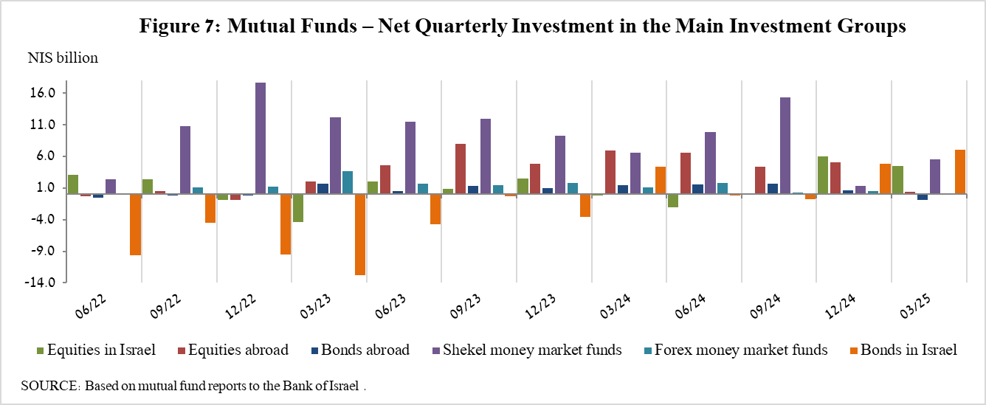

**Further information and details:**

Long-term tables on the asset portfolio are available here.

Long-term tables on institutional investors’ exposure to foreign exchange and to foreign assets are available here.

Long-term tables on mutual funds are available here.

1. Excluding mutual funds.