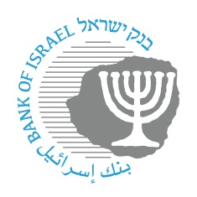

**BANK OF ISRAEL**

Office of the Spokesperson and Economic Information

May 24, 2023

Press Release:

**Conference marking 50 years of the Banking Supervision Department’s annual survey**

With the publication of the Banking Supervision Department’s annual survey for 2022, which was the 50th survey since the survey began to be published, in 1972, the Banking Supervision Department held a conference to mark the issue and to survey the Banking Supervision Department’s activity over the years.

The conference was opened by Governor of the Bank of Israel Prof. Amir Yaron, followed by Supervisor of Banks Yair Avidan. Their remarks are attached to this notice.

This was followed by a panel, with the participation of some of the Supervisors of Banks over the years, in which they provided various insights on their terms as head of the Banking Supervision Department and the various economic developments and challenges from their tenure. (Picture attached – Credit: Bank of Israel Spokesperson).

The conference was concluded by Dr. Ziv Naor, head of the Economics Unit at the Banking Supervision Department, which is responsible for writing the Banking Supervision Department surveys. In her address, she reviewed the various characteristics of the banking system over the 50 years of the survey.