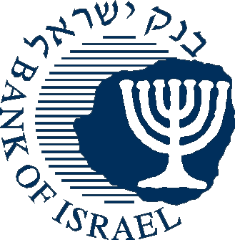

BANK OF ISRAEL

Office of the Spokesman and Economic Information

**Press Release**

July 3, 2013

**Nonresidents' investments in Israel, and Israelis' investments abroad in May 2013**

**NONRESIDENTS**

**Sales of government bonds and *makam***

**Bonds and *makam***: In **May**, nonresidents sold around $220 million, net, in government bonds, and around $30 million, net, in *makam.* Preliminary figures for **June** indicate net sales of about $440 million in government bonds and net investments of about $80 million in *makam*.

**Investments in Israeli shares**: In **May**, nonresidents invested approximately a net $175 million in shares on the Tel Aviv Stock Exchange (TASE), following net investments of about $660 million in January–April. Preliminary figures for **June** indicate net investments of about $90 million in TASE-traded shares.

**Nonresidents' direct investment**: In **May**, nonresidents' net direct investment in Israel totaled about $520 million, of which about $115 million was an investment in an Israeli insurance company.

.

**RESIDENTS**

**Sales of foreign shares by institutional investors**

**Shares**: In contrast to institutional investors’ trend between May 2012 and March 2013 of investment in foreign shares abroad (investments of about $5.4 billion), in **May 2013**, institutional investors sold a net $90 million, following sales of about $310 million in April.

Total sales in **May** were about $60 million, as sales by the business sector (totaling $150 million) and by institutional investors were partially offset by net investment of $180 million by the by households.

**Bonds**: In **May**, Israeli residents invested about $35 million, net, abroad. Investments of about $90 million by institutional investors were offset by sales of about $65 million by households.

**Direct investment abroad**: In **May**, residents invested about $250 million, net, in direct investment abroad, most of which was by financial companies.



