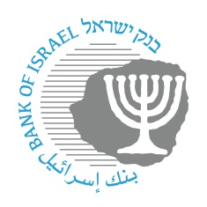
BANK OF ISRAEL
Office of the Spokesperson and Economic Information

June 6, 2024

Press release:

Governor of the Bank of Israel Prof. Amir Yaron’s trip to the US

Governor of the Bank of Israel, Prof. Amir Yaron, returned to Israel from a work trip to New York.
The Governor spoke at the opening of the Jerusalem Post annual conference. His remarks dealt with the strengths and challenges of the Israeli economy, against the background of the war and in view of global economic developments.

In addition, during his trip, the Governor held meetings with senior officials of the international financial institutions, foreign investors, and representatives of the Jewish community in New York.

