

BANK OF ISRAEL

Office of the Spokesperson and Economic Information

December 22, 2024

Press Release:

Debt Developments in the Nonfinancial Private Sector,

Third Quarter of 2024

The following is a summary of developments in nonfinancial private sector debt in the third quarter of 2024:

* In the third quarter of 2024, the balance of **nonfinancial private sector debt (both** **business and household)** increased, by approximately 3 percent to about NIS 2.2 trillion. The annual growth rate of outstanding debt increased to about 5 percent, following a downward trend that began in the second half of 2022. This rate is lower than the growth rates recorded in previous years.
* The balance of **business sector** debt increased by about 3 percent (about NIS 40 billion) during the quarter, to about NIS 1.4 trillion. This was mainly due to net debt raised via bank loans, which were concentrated in the large business segment, and debt raised through tradable bonds in Israel.
* Bond issuances in the **business sector** in Israel totaled about NIS 21 billion during the third quarter, significantly higher than the quarterly average of the previous four quarters. About half of the bond issuances were made by companies in the construction and real estate industry, which continues to lead bond issuances similar to previous years.
* The balance of **household debt** also continued to increase during the quarter, to about NIS 831 billion, mainly due to an increase in the balance of **housing debt** (about NIS 14 billion, 2 percent), which was due to a recovery in new mortgage borrowing from banks. The balance of **nonhousing debt** also grew (by about NIS 5 billion, 2 percent), with the increase concentrated in outstanding debt to the banks and to credit card companies.

**The nonfinancial business sector’s[1] outstanding debt**

* In the third quarter of 2024, the **balance of business sector debt** increasing significantly, by about NIS 40 billion (3 percent), to about NIS 1.4 trillion. The increase in the debt balance this quarter was almost completely due to net debt raised totaling NIS 39 billion, of which NIS 26 billion was raised through bank loans, mainly to the large business segment, and NIS 11 billion was raised through tradable bonds in Israel. An increase of about 1.6 percent in the Consumer Price Index[2] also contributed to an increase in the value of CPI indexed debt. The increase in outstanding debt was partly offset by an appreciation of the shekel by about 1.3 percent against the US dollar, which lowered the value of debt denominated in and indexed to foreign currency.
* Due to these effects, the annual rate of growth of outstanding business sector debt increased to about 5 percent during the quarter, following a downward trend since the second half of 2022. This was reflected in both bank and nonbank debt (Figures 1 and 2).
* In the third quarter of the year, the **business sector** **issued** about NIS 21 billion in bonds, significantly more than the quarterly average of the previous four quarters (about NIS 13 billion per quarter). About half of the issuances in the third quarter were carried out by companies in the construction and real estate industry, which continues to lead in bond issuances, similar to previous years (Figure 3).

In October 2024, companies from the business sector issued bonds totaling about NIS 4 billion, lower than the monthly average in the third quarter (about NIS 7 billion per month), in view of the holidays surrounding the Jewish new year. Companies from the construction and real estate industry accounted for about 56 percent of funds raised in October.

* In the third quarter of 2024, **the spread[3] between yields on corporate bonds that are included in the Tel Bond 60 Index and the yields on CPI-indexed government bonds** widened slightly to about 1.24 percentage points. However, in October and November, this spread narrowed, to about 1.01 percentage points (Figure 4).

**Table 1: The Composition of Business Sector Debt**



**Figure 1: Estimated Net Quarterly Quantitative Change in Business Sector Debt**

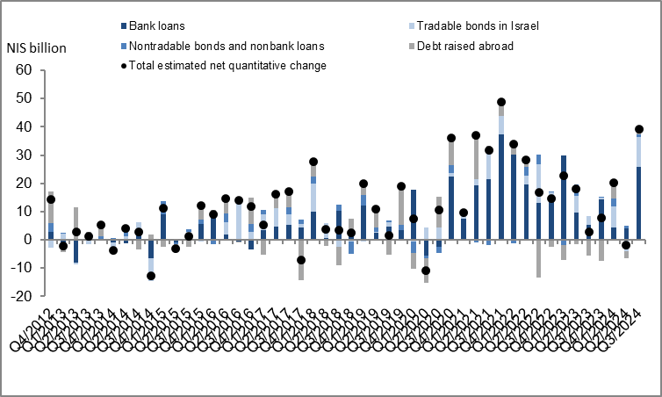

**Figure 2: Rate of Change (Year on Year) in the Business Sector's Bank and Nonbank Debt**

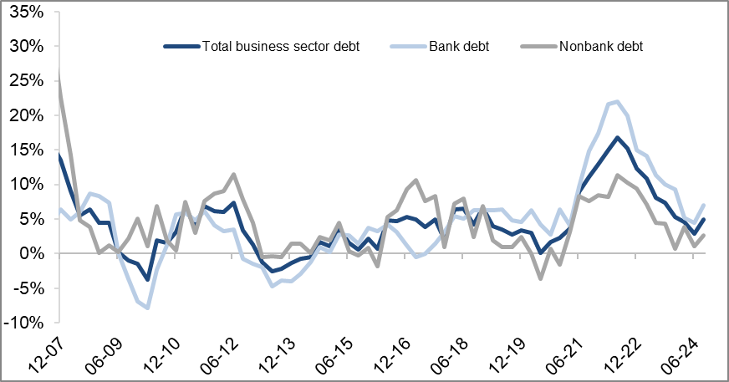

**Figure 3: Nonfinancial Business Sector Bond Issuance during the quarter, by Industry**

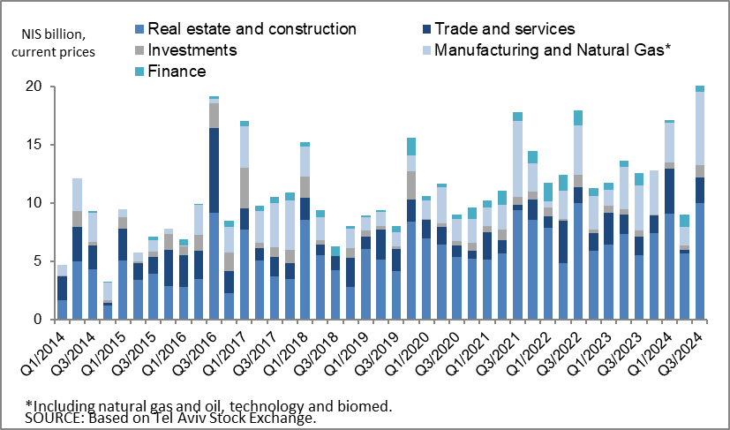

**Figure 4: Spread between Indexed Corporate Bonds (Tel-Bond 60) and Indexed Government Bonds (monthly average)**

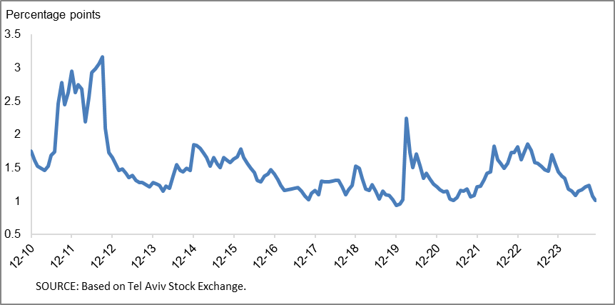

**Household debt**

* In the third quarter of 2024, the **balance of households’ outstanding debt** continued to increase, by about NIS 19 billion (about 2.3 percent) to about NIS 831 billion. Most of the increase was in the balance of **housing** debt, mostly to banks, which increased at a slightly higher rate than in the previous quarter (about 2.3 percent compared with about 1.8 percent in the previous quarter). **Nonhousing debt** increased by about NIS 5 billion (2.2 percent) to about NIS 234 billion, mostly in outstanding debt to banks and credit card companies.
* Due to these effects, the annual growth rate of housing debt increased to about 6 percent in the third quarter, further to the moderate increase since the beginning of the year. The annual growth rate of nonhousing debt also increased, but remained low at about 1 percent at the end of the quarter (Figure 5).
* The increase in housing debt is a result of the recovery in new mortgage borrowing from the banks, which began at the end of 2023. In the third quarter of 2024, after adjusting for seasonal effects, new mortgage borrowing totaled about NIS 24 billion, higher than the corresponding period of the previous year (about NIS 19 billion). In October–November 2024, the increase continued, mainly seasonal, with new mortgage borrowing averaging about NIS 9 billion per month, seasonally adjusted (Figure 6).

**Table 2: Outstanding Debt Balances of Households1**



**Figure 5: Rates of Change in Households’ Housing and Nonhousing Debt, Current Quarter vs. Corresponding Quarter of Previous Year**

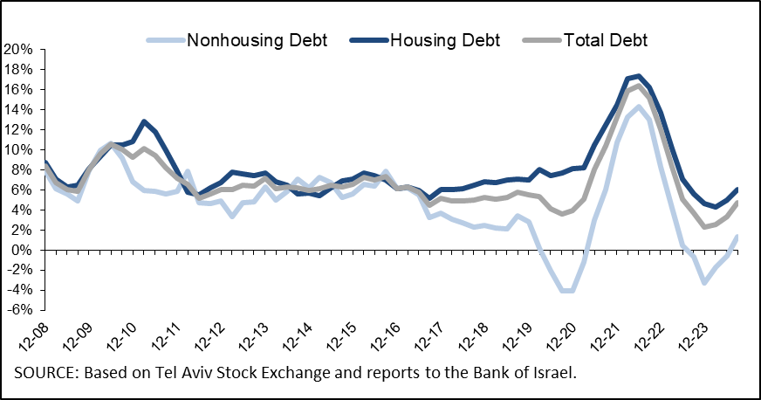

**Figure 6 :Amount of New Home Purchase Loans Provided by Banks to the Public (Mortgages)**

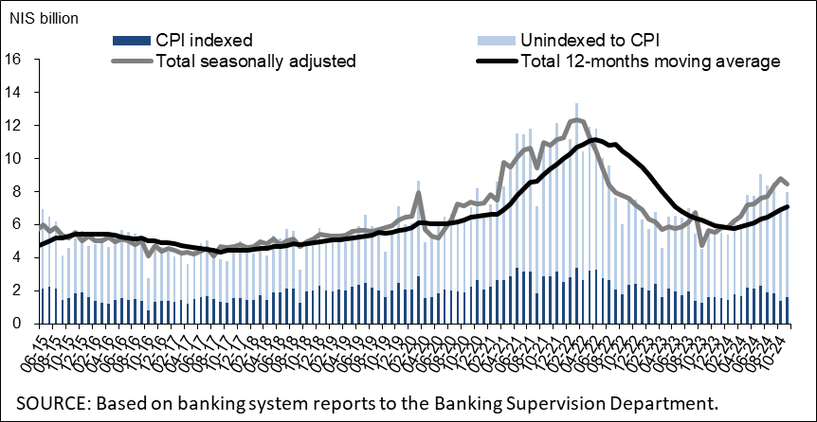

Links to Data and Statistics on the Bank of Israel website:

<https://www.boi.org.il/en/economic-roles/data-and-statistics/money-and-debt-aggregates/debt-and-credit/>

1. Israeli firms, excluding banks, credit card companies, and insurance companies.
2. CPI-indexed balances are calculated in accordance with information known at the time the financial statements are prepared, so that a change in the CPI refers to a change between the known CPI and the CPI in the month preceding that.
3. The change in the spread from one quarter to the next is calculated as the difference between the average spread in the final month of the reviewed quarter and the average spread in the final month of the previous quarter.