

BANK OF ISRAEL

Office of the Spokesperson and Economic Information

May 5, 2025

Press Release:

Israel’s foreign currency market in the first quarter of 2025

**1. Exchange Rate Development**

**A weakening of the shekel alongside a weakening of the dollar worldwide.**

During the course of the first quarter of 2025, the shekel weakened by about 2 percent against the US dollar, and by 6 percent against the euro, in contrast to the final quarter of 2024. In addition, the shekel weakened by 3.7 percent against the currencies of Israel's main trading partners, in terms of the nominal effective exchange rate (i.e., the trade-weighted average shekel exchange rate against those currencies).

In contrast, from the beginning of the year, the dollar weakened against most of the world’s major currencies (Figure 2), due as well to the lack of certainty related to the tariff policy in the US. Among other things, the dollar weakened by approximately 4.6 percent against the Japanese yen and by 3.8 percent against the euro.

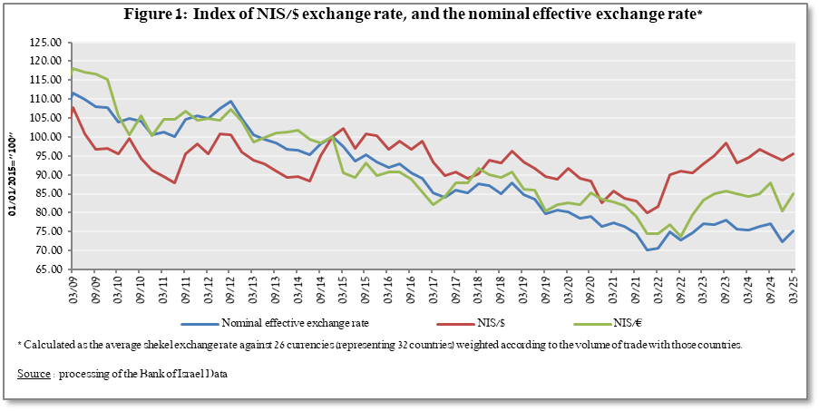

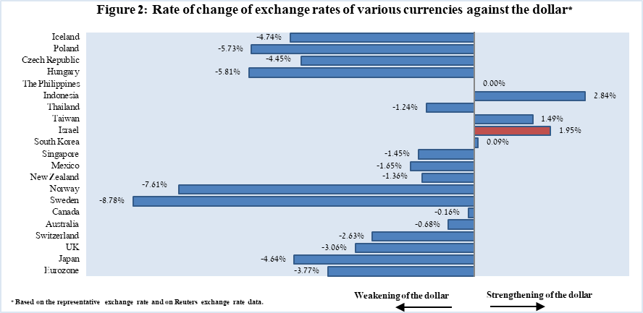

**2. Exchange Rate Volatility**

**Continued decline in actual volatility alongside a decline in implied volatility**

The average standard deviation of changes in the shekel/dollar exchange rate, which represents its **actual** volatility, declined by 1.5 percentage points during the quarter, to an average level of 8.2 percent.

The average implied volatility in over-the-counter shekel/dollar options—those traded outside the stock exchange—which is an indication of **expected** exchange rate volatility, decreased by 1.5 percent during the quarter, to an average level of about 8.7 percentage points at the end of the quarter.

This is alongside the average level of implied volatility in foreign exchange options in emerging markets, which decreased by 0.7 percentage points compared to the previous quarter, to 10.3 percent at the end of the quarter. In advanced economies, there was a moderate increase of about 0.1 percent in its average level, to 8.2 percent at the end of the quarter (Figure 4).

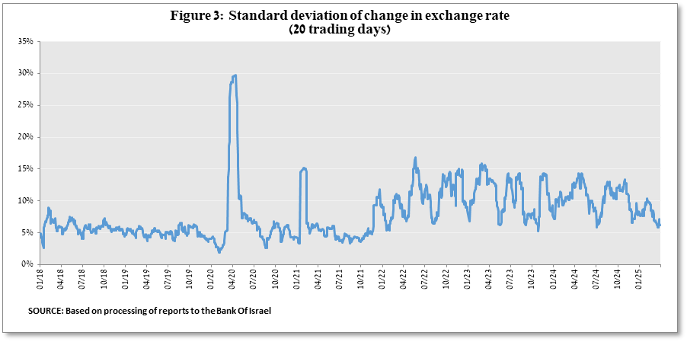

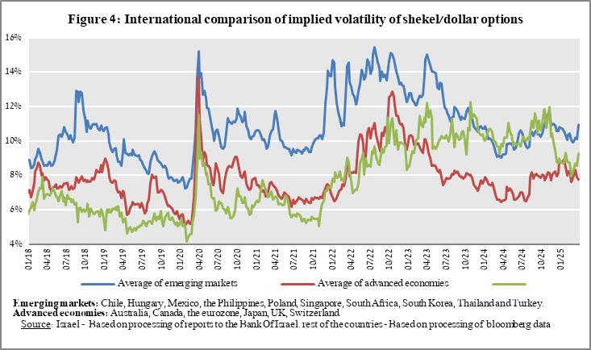

**3. The Activity of the Main Segments in the Foreign Exchange Market[1],[2]**

An estimate of activity by the **main** segments in the foreign exchange market indicates that during the First quarter **institutional investors (pension funds, provident funds, and insurance companies) purchased $2.9 billion and the financial sector purchased $2.1 billion. In contrast, nonresidents sold $2.9 billion and the business sector sold $2.3 billion.**

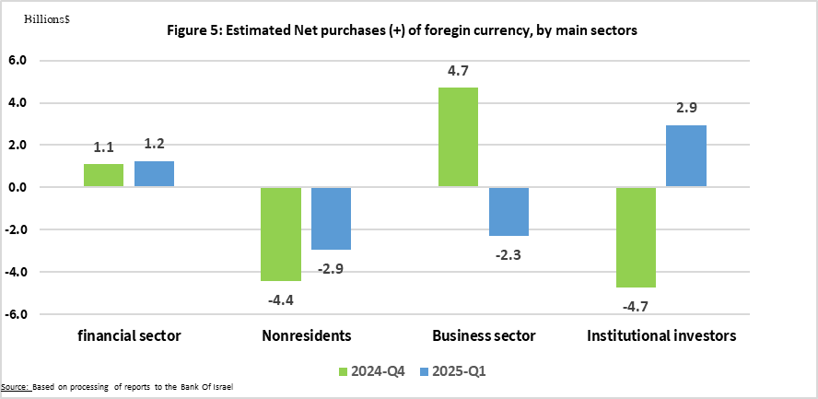

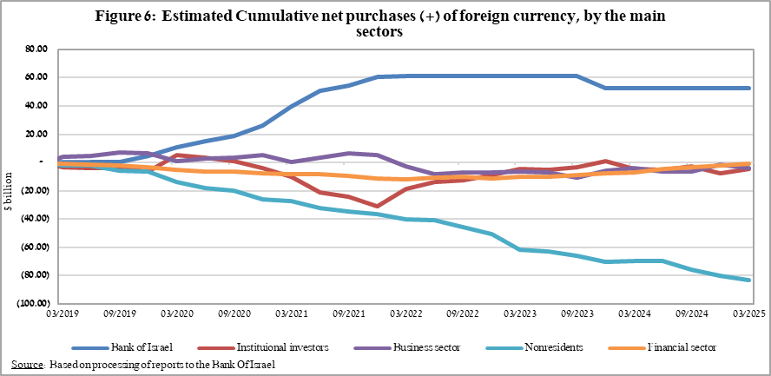

**4. Trading Volume in the Foreign Currency Market—Tables and Figures**

**Trading volume vis-à-vis the domestic banking system[3]**

**The average daily trading** **volume** increased moderately by about 0.6 percent during the quarter to $13.3 billion, with most of the increase deriving from an increase in the daily trading volume in swap transactions.

**Nonresidents' share of total trading volume vis-à-vis the domestic banking system** (spot and forward transactions, options, and swaps) declined by about 0.9 percentage points to about 40.4 percent at the end of the first quarter.

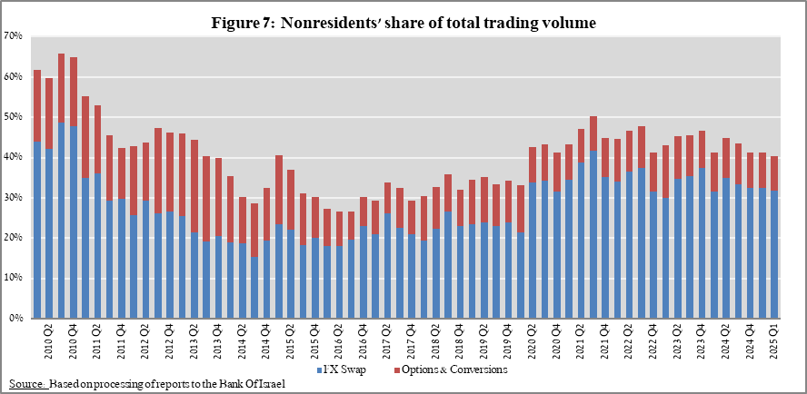

|  |  |  |  |  |  |  |  |
| --- | --- | --- | --- | --- | --- | --- | --- |
|  |  | **Conversions (1)** | **Swaps1 (2)** | **Cross Currency swap2 (3)** | **Options3 (4)** | **Total volume of trade (1)+(2)+(3)+(4)** | |
| **First quarter 2025 (Not final)** | **Total** | **192,569** | **601,971** | **1,919** | **26,715** | **823,173** | |
| **Daily average (59 days)** | **3,106** | **9,709** | **31** | **431** | **13,277** | |
| **Nonresidents** | 63,054 | 261,002 | 764 | 7,389 | 332,209 | |
| of which **Foreign financial institutions** | 62,484 | 261,001 | 764 | 7,389 | 331,637 | |
| **Residents** | 129,515 | 340,969 | 1,155 | 19,326 | 490,965 | |
| of which **Real sector** | 42,050 | 24,593 | 361 | 7,856 | 74,860 | |
| **Financial sector** | 39,097 | 164,284 | 138 | 1,363 | 204,882 | |
| **Institutions (incl. insurance companies)** | 26,097 | 116,150 | 52 | 7,195 | 149,494 | |
| **Individuals** | 5,077 | 221 | 0 | 167 | 5,465 | |
| **Other4** | 570 | 1 | 0 | 0 | 571 | |
| **Domestic banks5** | 8,095 | 21,345 | 207 | 1,827 | 31,474 | |
| **Fourth quarter 2024** | **Total** | **195,058** | **558,945** | **1,180** | **23,126** | **778,309** | |
| **Daily average (61 days)** | **3,306** | **9,474** | **20** | **392** | **13,192** | |
| **Nonresidents** | 59,655 | 253,262 | 517 | 7,608 | 321,042 | |
| of which **Foreign financial institutions** | 59,009 | 253,262 | 517 | 7,608 | 320,395 | |
| **Residents** | 135,402 | 305,683 | 663 | 15,518 | 457,267 | |
| of which **Real sector** | 42,456 | 22,636 | 145 | 7,230 | 72,468 | |
| **Financial sector** | 41,820 | 149,698 | 341 | 1,024 | 192,883 | |
| **Institutions (incl. insurance companies)** | 27,758 | 100,226 | 0 | 4,958 | 132,942 | |
| **Individuals** | 5,238 | 615 | 0 | 134 | 5,987 | |
| **Other4** | 646 | 0 | 0 | 0 | 647 | |
| **Domestic banks5** | 10,393 | 20,160 | 0 | 1,743 | 32,296 | |
|  |  |  |  |  |  |  | |
| 1 Only one leg of the swap, i.e., the nominal value of the transaction (in accordance with the BIS definition) | | | | | | | |
| 2 The exchanged founds through Cross Currency Swap transactions considered for the volume, as one leg only in cases where the two legs offset each other. | | | | | | | |
| 3 The national value, that includes purchases and sales of put and call options. | | | | | | | |
| 4 Including other entities such as portfolio managers, nonprofit organizations, national institutions, and those not included elsewhere. | | | | | | | |
| 5 Total interbank trade, divided by 2 | | | | | | | |

**Estimated total trading volume[4]—domestic banking system and foreign reporting entities**

The estimated total activity in transactions against the shekel, as reflected in reports from the domestic banking system and foreign reporting entities, indicates that nonresidents’ relative share of trading volume in spot and forward transactions (excluding swaps and options) was about 86 percent in the first quarter.

Trade between nonresidents constituted about 77.1 percent of the volume, which had a daily average of about $9.3 billion.

|  |  |  |  |  |  |  |
| --- | --- | --- | --- | --- | --- | --- |
|  |  | Relative share of total trading volume | | |  |  |
|  |  | Trade between nonresidents | Trade between a nonresident and a resident1 | Trade between the domestic banking system and residents | Total volume ($ million) | Daily average ($ million) |
| 2025-Q1 (Tentative figure) | Trading volume in spot and forward transactions | 74.1% | 9.3% | 16.6% | 793,206 | 12,794 |
| Trading volume in swap and options transactions | 49.0% | 24.8% | 26.1% | 1,211,096 | 19,534 |
| 2024- Q4 | Trading volume in spot and forward transactions | 77.1% | 9.0% | 13.9% | 568,113 | 9,629 |
| Trading volume in swap and options transactions | 49.4% | 24.0% | 26.6% | 902,726 | 15,300 |
| 1 Trade between a nonresident and a resident includes: (a) reports by foreign reporting entities regarding transactions with residents; and (b) reports by domestic banks regarding transactions with nonresidents. | | | | | | |

1. For additional information on the segments’ activity in the foreign exchange market, see “Statistical Bulletin 2024—Chapter D” (translation forthcoming).

   <https://www.boi.org.il/publications/regularpublications/statistic_bulletin/bulletin2024/>
2. The main segments presented do not make up the entire market—for additional information, see the section on “The Database of Foreign Exchange Market Activity” in the Bank of Israel's "Statistical Bulletin" for 2024 (forthcoming):

   <https://boi.org.il/en/communication-and-publications/regular-publications/statistical-publications/statistical-bulletin-2018/>
3. From the beginning of 2020, the data do not include branches of foreign banks in Israel.
4. Total trading volume is an estimate of total activity in transactions against the shekel, based on reports by the domestic banking system and by foreign reporting entities.