

BANK OF ISRAEL

Office of the Spokesperson and Economic Information

March 30, 2025

Press Release:

# The public's financial assets portfolio in the fourth quarter of 2024

* **In the fourth quarter of 2024, the balance of the public’s financial assets portfolio increased by approximately NIS 244.4 billion (4.1 percent), to about NIS 6.2 trillion at the end of the year. For the year overall, the portfolio balance increased by 15 percent, notably higher than the average increase in the portfolio over the past five years (about 8 percent).**
* **The increase in the portfolio’s value in the fourth quarter derived mainly from increases in the balance of equities in Israel (16.8 percent) and in the balance of corporate bonds(2.6 percent).**
* **The balance of the asset portfolio managed by institutional investors increased in the fourth quarter by approximately NIS 89 billion (3.2 percent), to NIS 2.86 trillion at the end of the quarter.**
* **The value of the portfolio managed by mutual funds in Israel increased by approximately NIS 39.3 billion (7 percent) in the fourth quarter, to NIS 597 billion. There were net new investments, mainly in funds specializing in domestic equities and in funds specializing in foreign equities.**

# 1. The public’s total assets portfolio

**In the fourth quarter of 2024,** the balance of the public’s financial assets portfolio increased by approximately NIS 244.4 billion (4.1 percent), to about NIS 6.2 trillion (Figure 1), **thus rising by 15 percent for the full year.** The share of the public’s financial assets portfolio relative to GDP increased by approximately 4 percentage points, to about 312 percent at the end of the quarter, as a result of an increase in the asset portfolio that was greater than that of the GDP.

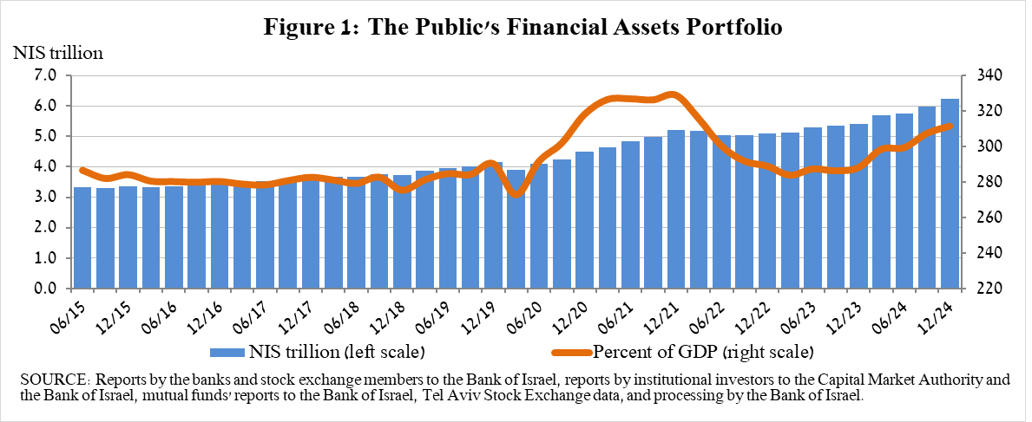

**2. Analysis of the changes in the overall portfolio**

Over the course of the fourth quarter, there were increases in the balances of the public’s holdings in all components of the portfolio. The increases in equities in Israel (16.8 percent) and corporate bonds (2.6 percent) were notable.

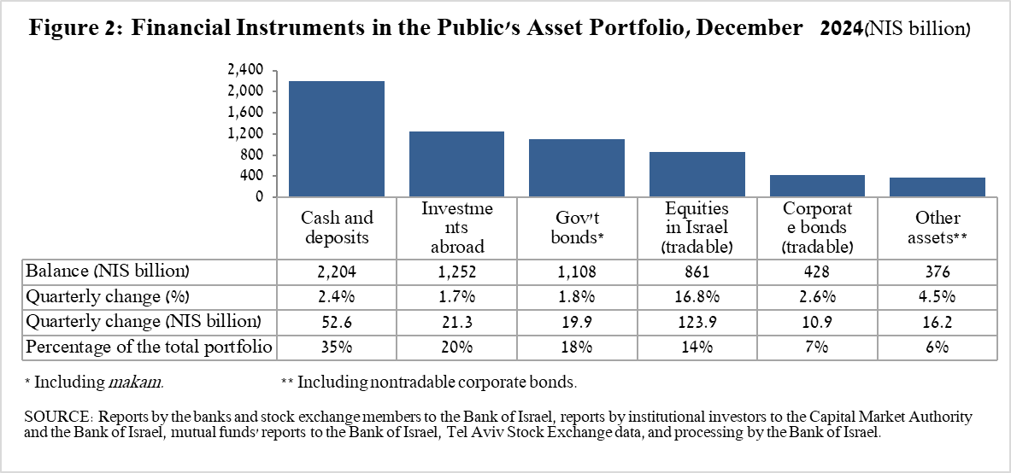

* The balance of **equities in Israel** increased by about NIS 124 billion (16.8 percent), mainly in view of price increases on equity indices alongside net investments.
* The balance of **cash and deposits** increased during the fourth quarter by about NIS 52.6 billion (2.4 percent) to about NIS 2.2 trillion, which is about 35 percent of the total portfolio.
* The balance of **government bonds** (tradable and nontradable) and ***Makam*** increased during the quarter by about NIS 19.9 billion (1.8 percent) to about NIS 1.1 trillion at the end of the quarter. The increase was mainly due to the increase in tradable government bonds (about NIS 28.3 billion), and in contrast a decline in the balance of nontradable government bonds and in the Makam balance.
* The balance of **tradable corporate bonds in Israel** increased by about NIS 10.9 billion, to about NIS 428 billion at the end of the quarter, due to a combination of price increases and net investments (estimated at about NIS 4.8 billion).

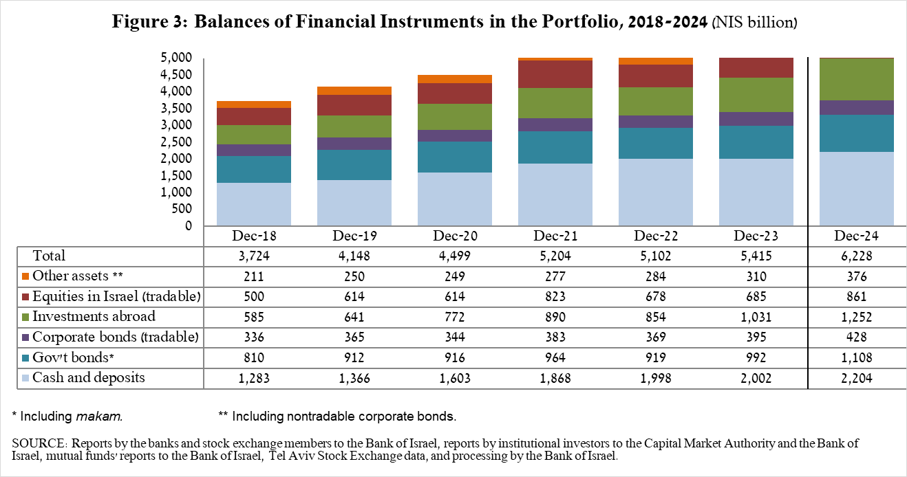

The balance of investments abroad increased by approximately NIS 21 billion (1.7 percent) during the quarter, to NIS 1.25 trillion at the end of the quarter, making up approximately 20 percent of the total asset portfolio. The development in the balance of investments abroad was mainly due to the following components:

* The balance of **equities held abroad** increased by approximately NIS 30 billion (4.3 percent), to about NIS 730 billion. This was due to a combination of net investments (estimated to be about NIS 21.8 billion) and price increases.
* The balance of **tradable (corporate and government) bonds abroad** decreased by approximately NIS 7.4 billion (2.6 percent) during the quarter, to about NIS 272.9 billion. This decrease was mainly due to net realizations totaling NIS 5.1 billion and price declines.

As a result of the developments during the quarter, there was a decline in the share of foreign currency assets of around 0.8 percentage points (from 27.4 percent to 26.6 percent) and in the share of foreign assets of 0.5 percentage points (from 20.6 percent to 20.1 percent).

# 3. The portfolio managed by institutional investors[1]

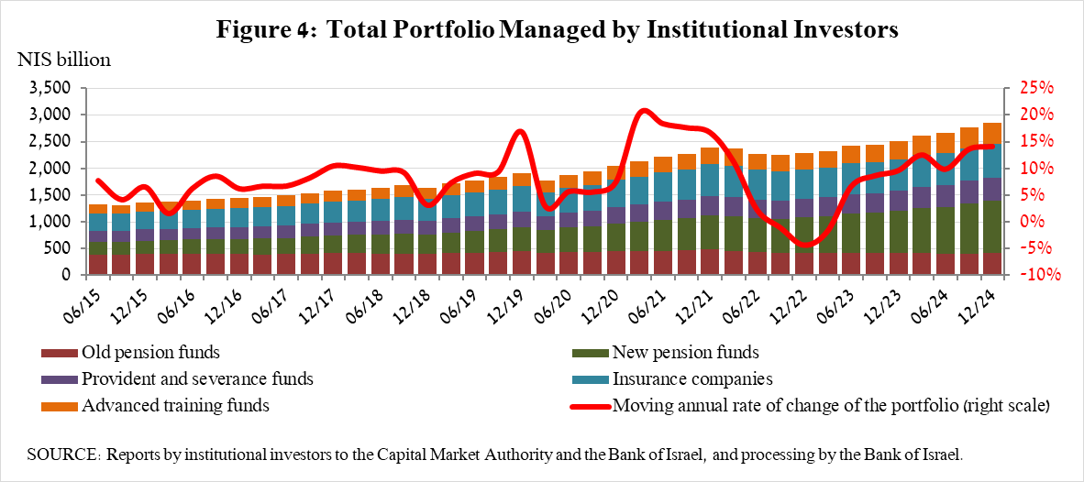

* **The balance of assets managed by all institutional investors** increased in the fourth quarter by about NIS 89 billion (3.2 percent), to about NIS 2.86 trillion (approximately 46 percent of the public’s total financial assets portfolio). The increase in the balance was reflected in all institutional investors. The increase in the balance of the managed portfolio during the quarter was mainly due to price increases in the capital markets, and was reflected in the following components: equities in Israel—an increase of NIS 33.2 billion (13.9 percent) in view of price increases and despite withdrawals; ETFs abroad that track equity indices—an increase of NIS 18.6 billion (8.3 percent), a combination of price increases and purchases; cash and deposits in Israel—an increase of NIS 14.8 billion (5.4 percent); government bonds and *Makam—*an increase of about NIS 11.5 billion (1.3 percent).

# 4. The portfolio managed by mutual funds

The value of the portfolio managed by Israeli mutual funds increased in the fourth quarter by approximately NIS 39.3 billion (7 percent), to about NIS 597 billion at the end of the quarter, constituting about 9.6 percent of the public’s asset portfolio.

The increase in the fourth quarter derived from a combination of net new investment totaling NIS 19.3 billion in funds and from price increases. Most of the new investment was in funds specializing in equities in Israel, totaling approximately NIS 6.1 billion, and in funds specializing in equities abroad, totaling about NIS 5.1 billion.

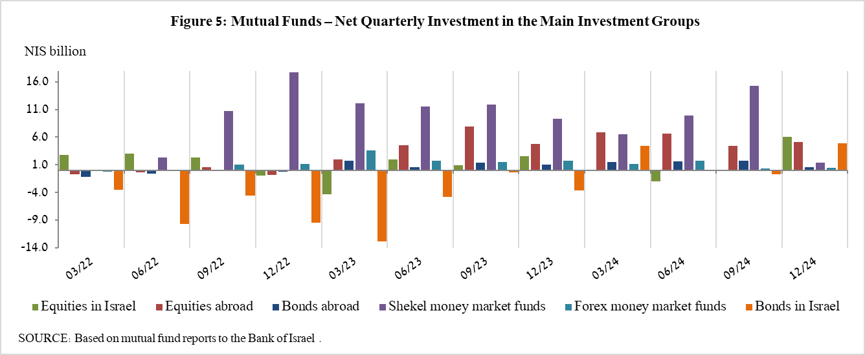

**Further information and details:**

Long-term tables on the asset portfolio are available here.

Long-term tables on institutional investors’ exposure to foreign exchange and to foreign assets are available here.

Long-term tables on mutual funds are available here.

1. Excluding mutual funds.