

BANK OF ISRAEL

Office of the Spokesperson and Economic Information

June 28, 2023

Press Release:

Debt Developments in the Nonfinancial Private Sector,

First quarter of 2023

The following is a summary of developments in nonfinancial private sector debt in the first quarter of 2023:

* The balance of **business sector** debt increased by approximately 2.4 percent (NIS 30 billion), to NIS 1.3 trillion, in the quarter, however, the slowdown in the balance’s year-over-year growth rate, which began in the second half of 2022, continued.
* The balance of **households’ debt** also continued to increase in the quarter, by approximately NIS 5 billion, to approximately NIS 780 billion, though at a slower pace than in the previous quarter, at about 0.6 percent compared to 1.3 percent.
* The source of the increase in the balance of households’ debt is the **balance of housing debt,** which increased by about 1.2 percent this quarter, lower than the 1.7 percent in the previous quarter, to about NIS 549 billion. For the first time since the third quarter of 2020, the balance of **nonhousing debt** declined, by about NIS 2 billion (0.9 percent), to NIS 231 billion. This was a result of a decline in the balance of debt to institutional investors, which was partly offset by an increase in the balance of debt to credit card companies. The balance of debt to banks was unchanged.

**The nonfinancial business sector’s outstanding debt[1]**

* In the first quarter of 2023, the **balance of business sector debt** continued to increase, by approximately NIS 30 billion (2.4 percent), to a level of about NIS 1.3 trillion. However, the slowdown in the balance’s year-over-year growth rate, which began in the second half of 2022, continued.
* The increase in the debt balance in the quarter derived mostly due to net debt raised totaling about NIS 21 billion, most of which was in bank loans, mainly to companies in the construction industries. A depreciation of 2.7 percent in the shekel vis-à-vis the dollar, and an increase of 1.1 percent in the CPI[2] also contributed to the increase in value of debt that is foreign currency-denominated, foreign currency-indexed, and CPI-indexed; these increases were partly offset by net redemptions of debt raised abroad and of tradable and nontradable bonds in Israel (Figures 1, 2).
* The year over year growth rate of the balance of debt to banks and to nonbank lenders continued to decline in the first quarter as well, following a decline that began in the second half of 2022, but it remains high—debt to banks grew by an annual rate of about 14 percent, compared to 15 percent in the preceding quarter, and debt to nonbank lenders grew by about 5 percent compared with 7 percent. In the past two years, the annual growth rate in the balance of debt to banks has been higher than the annual growth rate of debt to nonbank lenders.
* In the first quarter, the **business sector** **issued** about NIS 12 billion in bonds, slightly lower than the average quarterly issuance of the past 4 quarters (about NIS 13 billion per quarter, on average). About half the issuances in this quarter were carried out by companies in the real estate and construction industry, similar to the previous quarter (Figure 3).
* In April 2023, the business sector issued bonds worth about NIS 1.2 billion, all through tradable bonds. Companies from the real estate and construction industry continued to lead issuance in that month as well—about 74 percent of total issues in those months were carried out by them.
* In the first quarter, **the spread[3] between yields on corporate bonds that are included in the Tel Bond 60 Index and the yields on CPI-indexed government bonds** widened slightly, by about 0.4 percentage points, to about 1.86 percentage points. However, in April 2023, the spread narrowed, and continued to narrow in May, to about 1.58 percentage points (Figure 4).

**Table 1: The Composition of Business Sector Debt**



**Figure 1: Estimated Net Quarterly Quantitative Change in Business Sector Debt**

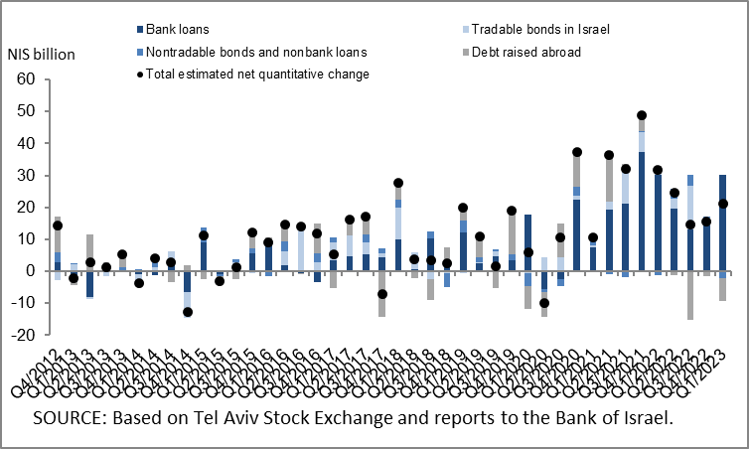

**Figure 2: Rate of Change (Year on Year) in the Business Sector's Bank and Nonbank Debt**

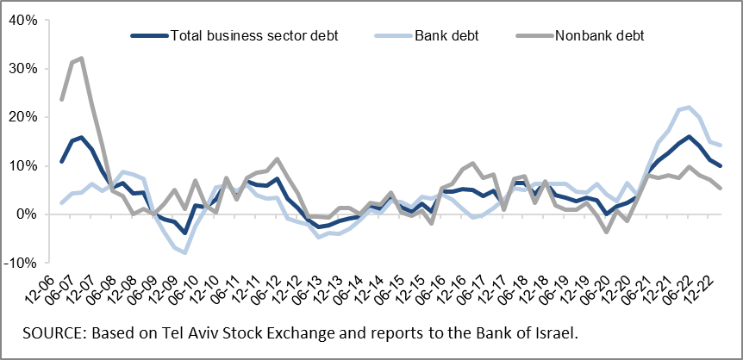

**Figure 3: Nonfinancial Business Sector Bond Issuance during the quarter, by Industry**

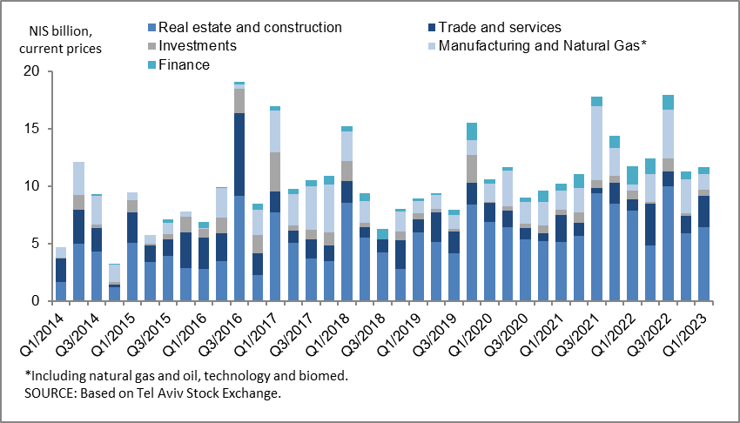

**Figure 4 : Spread between Indexed Corporate Bonds (Tel-Bond 60) and Indexed Government Bonds (monthly average)**

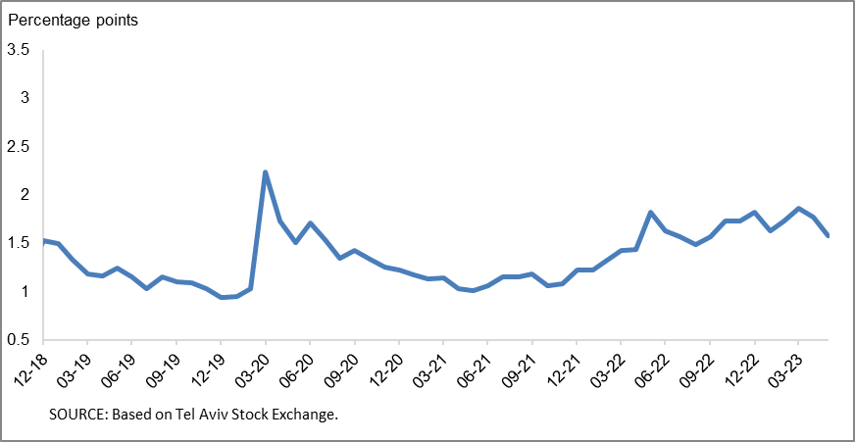

**Household debt**

* The growth in the **balance of households’ outstanding debt** continued in the first quarter of 2023, to NIS 780 billion, (an increase of about NIS 5 billion). However, the slowing in its rate of growth continued in the quarter, about 0.6 percent compared to 1.3 percent in the previous quarter.

The increase in outstanding **housing debt** continued (about NIS 7 billion), mostly to banks, though at a lower pace than that in the previous quarter—1.2 percent, compared to 1.7 percent; for the first time since the third quarter of 2020 **nonhousing debt** declined, by about NIS 2 billion, to NIS 231 billion, as a result of a decrease in the balance of debt to institutional investors that was partly offset by an increase in the balance of debt to credit card companies. The balance of nonhousing debt to banks remained unchanged in the quarter, at about NIS 161 billion.

* These effects led to a continued slowing in the annual growth rate of the balance of housing debt and nonhousing debt, which began in the second half of 2022. However, the annual growth rate of both debt balances remained positive—an annual growth rate of about 10 percent in the balance of housing debt, and about 4 percent in the balance of nonhousing debt (Figure 5).
* In the first quarter of 2023, new mortgages taken out totaled about NIS 19 billion, lower than in the corresponding quarter of the previous year (about NIS 35 billion). In April 2023, the decline in new mortgages taken out that began in May 2022 continued, and they totaled about NIS 5.5 billion, seasonally adjusted. However, in May 2023 there was a slight increase in new mortgage volume, totaling about NIS 5.9 billion, seasonally adjusted (Figure 6).

**Table 2: Outstanding Debt Balances of Households1**



**Figure 5: Rates of Change in Households’ Housing and Nonhousing Debt, Current Quarter vs. Corresponding Quarter of Previous Year**

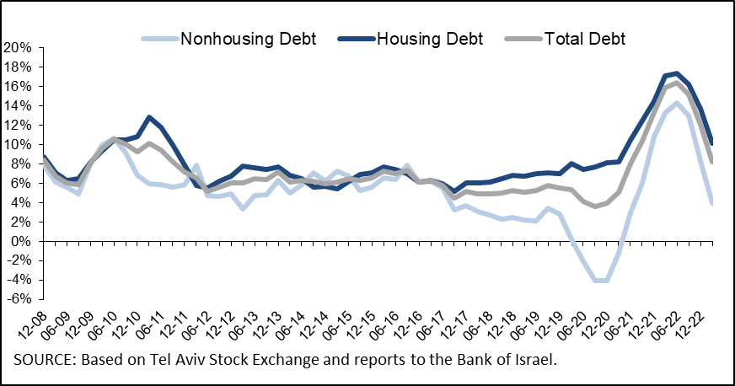

**Figure 6 :Amount of New Home Purchase Loans Provided by Banks to the Public (Mortgages)**

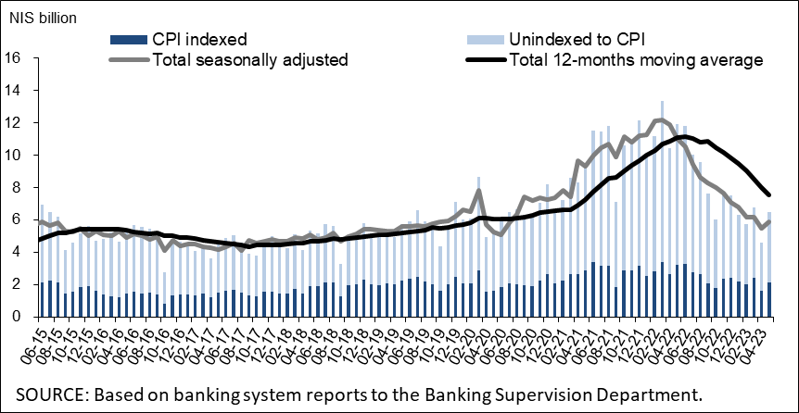

Links to Data and Statistics on the Bank of Israel website:

<https://www.boi.org.il/en/economic-roles/data-and-statistics/money-and-debt-aggregates/debt-and-credit/>

1. Israeli firms, excluding banks, credit card companies, and insurance companies.
2. CPI-indexed balances are calculated according to the CPI reading known at the time the financial statements are compiled, so the change in CPI refers to the change between the known CPI and the CPI of the preceding month.
3. The change in the spread from one quarter to the next is calculated as the difference between the average spread in the final month of the reviewed quarter and the average spread in the final month of the previous quarter.