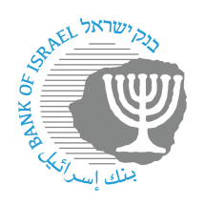
BANK OF ISRAEL
Office of the Spokesperson and Economic Information

Press release

June 17, 2024

Bank of Israel Governor Prof. Amir Yaron traveled to Croatia

Bank of Israel Governor Prof. Amir Yaron returned to Israel yesterday from a working visit to Croatia.

The Governor participated in the 30th annual Croatian National Bank (HNB) economic conference. The Governor delivered remarks as chairman of the Bank for International Settlements (BIS) SOE (small open economies) group. His speech dealt with setting monetary policy in a small open economy, as well as a survey of the Israeli economy. The conference was hosted by HNB Governor Boris Vujčić, and its participants included senior central bank officials and academics from around the world.

