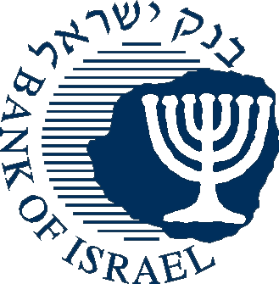

BANK OF ISRAEL

Office of the Spokesperson and Economic Information

April 6, 2014

**Press Release**

**Nonresidents' investments in Israel, and Israelis' investments abroad in February 2014**

**NONRESIDENTS**

**Nonresidents’ investment in Israeli shares**

**Bonds and *makam***: In **February**, nonresidents realized about $100 million, net, in government bonds traded in Tel Aviv, compared with net investments of about $30 million in January. Nonresidents realized about $400 million in government bonds traded abroad.

**Investments in Israeli shares**: In **February**, nonresidents invested approximately $300 million, net, in shares on the Tel Aviv Stock Exchange (TASE), mainly in companies in the pharmaceuticals and communications fields. In contrast, nonresidents sold about $150 million in Israeli shares traded abroad.

**Nonresidents' direct investment in Israel**: In **February**, nonresidents' net direct investment in Israel via the banking system totaled about $500 million. The investments were primarily in the high technology industry.

**RESIDENTS**

**Continued investments by institutional investors and households in foreign securities**

In February, the three sectors—the business sector, households, and institutional investors—invested about $1.7 billion, combined, in financial investments (bonds and shares) abroad.

**Shares**: In **February**, institutional investors invested about $650 million in shares traded abroad, while households and the business sector each invested about $220 million dollars in shares traded abroad.

**Bonds**: In **February**, Israeli residents made net investments of about $640 million in bonds traded abroad—investments of about $400 million by households in parallel with investments of about $230 million by institutional investors. The net activity of the business sector in bonds traded abroad was minor.

**Direct investments abroad**: In **February**, residents invested about $60 million, net, in direct investments abroad, distributed among the various industries.

[External Sector > Balance of payments - Current Account](https://e.boi.org.il/en/DataAndStatistics/Pages/MainPage.aspx?Level=2&Sid=24&SubjectType=2)

