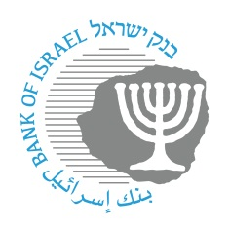

BANK OF ISRAEL
Office of the Spokesperson and Economic Information

Press Release
April 26, 2026

The Bank of Israel Governor traveled to the US for the International Monetary Fund’s Spring Conference

Bank of Israel Governor Prof. Amir Yaron returned from the US following his participation in the annual Spring Conference of the International Monetary Fund and the World Bank. The Conference featured the participation of central bank governors from around the world, and dealt with the state of the global economy and issues of international important in view of the global geopolitical uncertainty, such as the growth forecast and financial stability.

During the Conference, Governor Yaron met with many global economic professionals, including other central bank governors, senior investment bank officials, business and private sector investors, and senior academicians.

As part of the Conference, Governor Yaron met with Federal Reserve Chairman Jerome Powell, and presented him with a copy of the book recently published by the Bank of Israel, “Why A New Shekel?”

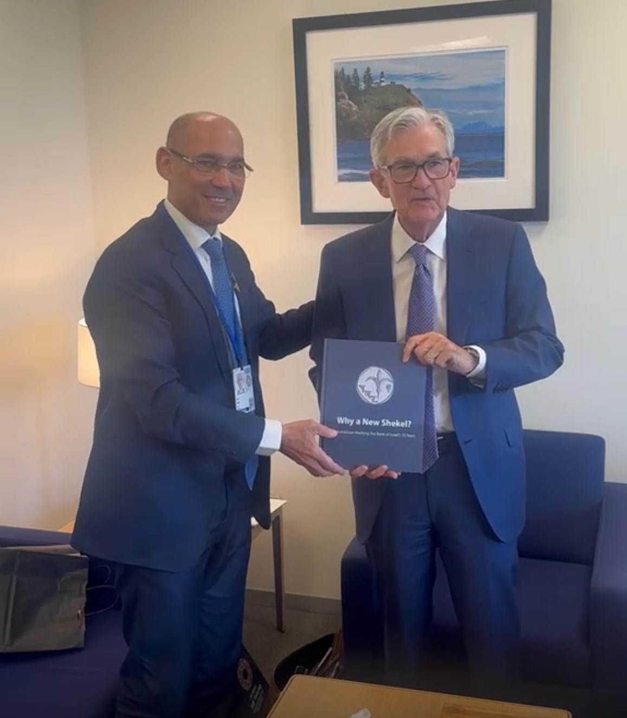

Credit: Bank of Israel Office of the Spokesperson and Economic Information

