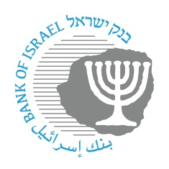

**BANK OF ISRAEL**

Office of the Spokesperson and Economic Information

May 8, 2024

Press release:

**“Israel Stands Together”—the Bank of Israel issues a commemorative coin in the Independence Day series**

**The Bank of Israel announces the issue of a commemorative coin, with the theme of “Israel Stands Together”, marking the 76th Independence Day of the State of Israel, and under the shadow of the events of October 7th and the “Swords of Iron” War that erupted as a result. Commemorative coins in the Independence Day series have been issued by the Bank since 1958, and they mark outstanding events in the life of the nation and the State, values incorporated in society, and its representative symbols.**

The terror attack on October 7, and the “Swords of Iron” War that erupted as a result, brought, in addition to the terrible tragedy, broad displays of unity and national resilience. The presence of soldiers of the Israel Defense Forces and those in the reserves at the front, and the citizens on the home front, supporting each other, brought to light the unity, social cohesion, and the mutual assistance that have characterized Israel’s society since the founding of the State. This extensive social action raises the hope for unity in Israeli society both in times of peace and in war, which will help in the continued existence and prosperity of the State of Israel.

The coin’s reverse side, designed by Zvika Roitman, displays extended hands, just before grasping each other. In the bottom section of the coin there is a tractor riding alongside rows, and in the background there are homes and flora typical of the localities in the Gaza envelope. On the upper section of the coin is the wording “Israel Stands Together”, against a background of the number 76 to mark the 76th Independence Day of the State of Israel. The coin’s obverse side, designed by Eytan Alon, has 6 hands grasping each other as a symbol of unity.

The coin is issued in face values of NIS 10 (gold proof), NIS 2 (silver proof), and NIS 1 (silver prooflike), and is available for sale and marketed to the public through the Israel Coins and Medals Corporation Ltd. and the G.R.A.S. design company, which market the commemorative coins issued by the Bank of Israel.

**Pictures of the coins:**

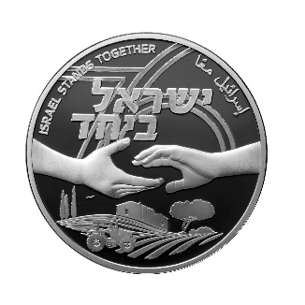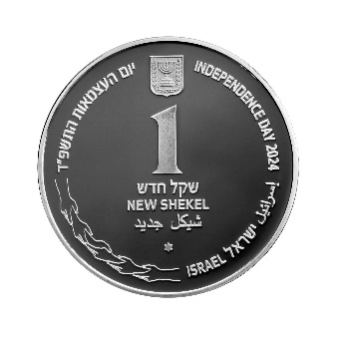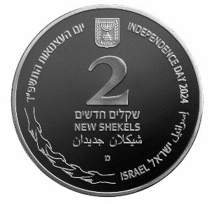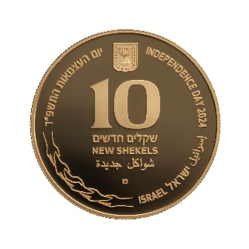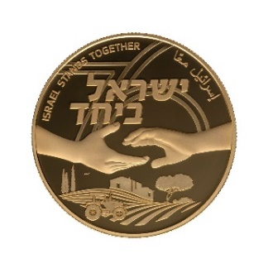

Courtesy of the Israel Coins and Medals Corporation Ltd., photo by Eli Gross.