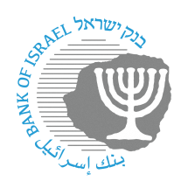

BANK OF ISRAEL

Office of the Spokesperson and Economic Information

Press release

September 26, 2024

**The Bank of Israel’s response to the NIS 200 banknote matter: Cancellation of the NIS 200 banknote is not being considered**

Pursuant to the law, the authority to cancel banknotes rests with the Governor of the Bank of Israel. Even though the matter has been raised, no sufficiently established professional justification to cancel any banknote has been presented to the Governor. The Governor of the Bank of Israel does not intend to use his authority to work toward cancelling any banknote or to change the mix of banknotes in circulation.

We emphasize that the NIS 200 banknote that is in circulation, similar to the other banknotes and coins, will continue to be used as usual.