  ISRAEL POLICE  Investigations and Intelligence |  | 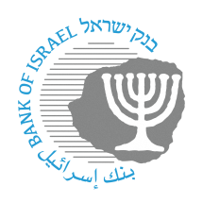  BANK OF ISRAEL  Office of the Spokesperson and Economic Information | 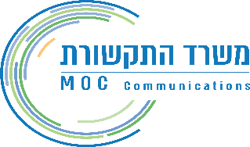  MINISTRY OF COMMUNICATIONS

September 25, 2024

Joint Press Release:

Establishment of a dedicated multisector work team to reduce financial fraud

Financial fraud, which can involve the unauthorized use of a bank account or credit card, leads to the fraudulent withdrawal of money from customers and causes damage to targeted customers. Fraud is directed at all customers, but there is a noted focus on people with low financial and digital awareness. The phenomenon hurts the general public and is a threat to the public’s trust in the financial system and in the entire Israeli digital space.

The Banking Supervision Department, the Ministry of Communications, and the Israel Police attribute great importance to the prevention of fraud against customers by digital means, and are working in a variety of ways, together with other partners, including the Israel Association of Banks, the banking corporations, the credit card companies, and communications companies, to reduce this phenomenon.

Advancing the processes necessary to deal with fraud is a complex task that requires integrated efforts, the allocation of resources, and the removal of legislative, regulatory, and technological barriers. In view of these challenges, and further to steps that have already been taken, Supervisor of Banks Daniel Hahiashvili, Ministry of Communications Director General Inbal Mashash, and the Israel Police’s Head of Investigations and Intelligence, Police Maj. Gen. Yigal Ben Shalom decided to establish a dedicated and multisectoral working team that will work to reduce fraud. The team will include the relevant staff members from the Banking Supervision Department, the Ministry of Communications and the Israel Police, and will work to advance cross-sectoral solutions while removing existing barriers and leading cooperative work among all relevant agencies.

In addition, a steering committee has been established, with the participation of the Supervisor of Banks, the Director General of the Ministry of Communications, and the head of Investigations and Intelligence at the Israel Police, and led by Ms. Tal Harel, Deputy Supervisor of Banks and Head of the Technology, Innovation, and Cyber Division in the Banking Supervision Department. The steering committee will convene on a quarterly basis, during which time the working team’s progress will be presented and issues will be raised for discussion and decision.

