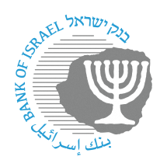
BANK OF ISRAEL
Office of the Spokesperson and Economic Information

Press release

July 1, 2024

Bank of Israel Governor Prof. Amir Yaron traveled to the annual BIS conference in Basel

Bank of Israel Governor Prof. Amir Yaron returned to Israel yesterday from a working visit to Basel, Switzerland.

The Governor participated in the 23rd annual conference of the Bank for International Settlements (BIS) entitled “Opportunities and Risks for Central Banks”. During his visit, the Governor chaired the meeting of the Small and Open Economies (SOE) Forum, which he leads. The Governor also participated in a discussion on “Policy Approaches in Dealing with Risks in Integrating Artificial Intelligence in the World of Finance.”

