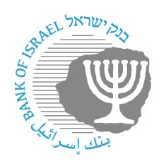

BANK OF ISRAEL
Office of the Spokesperson and Economic Information

Press Release
September 15, 2026

The consumer and financial guidance program for IDF soldiers dealing with economic hardship is officially launched
A joint initiative by the Bank of Israel, the Class Actions Fund, and the IDF Human Resources Directorate will provide personalized financial guidance to approximately 4,500 soldiers over the next three years. Since the program began operating in March 2026, around 600 soldiers have already taken part.
On Wednesday, the Bank of Israel hosted an event marking the official launch of a consumer and financial guidance program for IDF soldiers facing economic hardship. The event was attended by Bank of Israel Governor Prof. Amir Yaron, Chairman of the Class Actions Fund, retired Judge Yaakov Shinman, and Head of the IDF Human Resources Directorate, Major General David (Dado) Bar Kalifa.
The program, a joint effort of the Bank of Israel, the Class Actions Fund, and the IDF Human Resources Directorate, is designed to help soldiers who lack a financial support network achieve cash-flow stability, strengthen their financial resilience, and equip them with tools for long-term economic stability and growth.
As part of the program, about 4,500 soldiers are expected to receive personal guidance over the next three years. Each year, around 1,500 soldiers will participate, identified by the IDF’s welfare support system and commanders according to established criteria. The program’s budget, provided by the Class Actions Fund, is approximately NIS 7.2 million.
The program offers each participant a personalized support package tailored to their needs. This includes a comprehensive review of their financial situation, building a personal budget, ongoing guidance in day-to-day financial management, assistance in claiming rights and benefits, financial knowledge and practical tools, and digital support through dedicated technological platforms. Its goal is to help soldiers reduce debt, improve control over income and expenses, and build a stable financial foundation for the future.
Following a public call for proposals and a professional review process, two groups were selected to operate the program: the nonprofit organization Pitchon Lev in partnership with RiseUp, and the nonprofit organization Hatachtit in partnership with Citizen Impact. Both operating organizations combine one-on-one human support with technological tools, with the aim of providing soldiers with continuous, accessible, and needs-based assistance.
The Bank of Israel is supporting the program on the professional level as part of its efforts to promote financial education and public outreach. It is assisting in the development of the guidance content and in evaluating the program’s effectiveness, in line with internationally accepted principles and standards in the field of financial education.
Bank of Israel Governor Prof. Amir Yaron said: “This project is an opportunity for the Bank of Israel to provide knowledge to soldiers serving during this challenging period—to give them tools and understanding that will help not only during their military service, but also later in life. Promoting education in Israel requires the allocation of public resources. In my view, this is not an ‘expense’ but an ‘investment.’ Investment in education today will bear fruit tomorrow and will be reflected in the continued growth and prosperity of the Israeli economy. Financial knowledge is not a luxury; it is a basic tool for independence. In today’s financial world, the importance of that knowledge is only growing, and that is also the broader meaning of economic resilience. Economic resilience does not mean there are never difficulties. It means having the knowledge, the tools, and the ability to deal with them when they arise. I would like to thank all the partners in this project. The success of the program will depend on the human connection—the ability to listen, to explain, and to give every soldier the tools that fit the reality of their lives.”
Retired Judge Yaakov Shinman, Chairman of the Class Actions Fund, said: “The Class Actions Fund decided to promote a program for holistic financial guidance for soldiers facing economic distress, as a meaningful social investment. We believe that giving soldiers tools for sound financial conduct will provide them with a better starting point and enable them to build a strong and stable economic future. This is one of a series of initiatives funded by the Fund with the aim of instilling sound financial and consumer conduct among different target populations, in a way that promotes the well-being of participants. The Class Actions Fund continues its efforts to fulfill the goals set by the courts in class action proceedings and supports a variety of initiatives that strengthen the resilience of Israeli society.”
Head of the IDF Human Resources Directorate, Major General Dado Bar Kalifa, said: “There is no greater gift you can give a person than education and the tools to make decisions—especially when those decisions affect the course of their lives. What you are doing for these soldiers gives me hope. Hope is not just the expectation that things will get better; it is active work to make them better, and that is exactly what this program does. It gives our soldiers the tools to enter civilian life better prepared. Its success also depends on the willingness of you, the soldiers, to take responsibility for your future. Our vision is to expand this initiative to the career-service track as well—for noncommissioned officers and officers in the field—in order to ease the economic burden they carry and enable the very best to continue serving with us and leading in the IDF.”
Photos from the event and a link to the video shown during the event are attached.
Link to the video

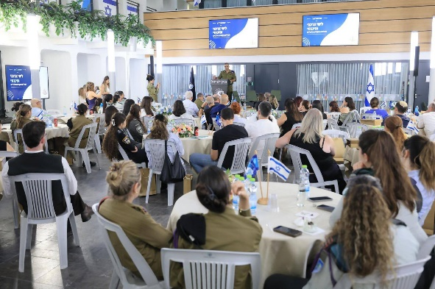
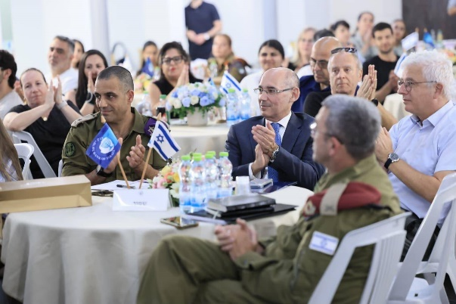
Credit: Bank of Israel.

