

BANK OF ISRAEL

Office of the Spokesperson and Economic Information

**Press Release**

May 19, 2014

An excerpt from the upcoming "Recent Economic Developments (137)" that will soon be published:

**Preliminary estimates ahead of the 2015 budget, and fiscal trends for the remainder of the decade**

* **The fiscal adjustment in the 2013–14 budget led to a reversal of the increase in the deficit, restored the credibility of the government’s commitment to the declining deficit path, and contributed to a decline in interest rate spreads between Israel and other advanced economies.**
* **There is great importance to continuing the reduction of the deficit in accordance with the framework set by law, because, given the economy’s cyclical position, the current level of the deficit remains high in international comparison, and does not allow an extended decline in the debt to GDP ratio.**
* **In order to meet the deficit target for 2015, a total of about NIS 18 billion in fiscal measures—reducing expenditures as well as steps to increase revenues—will be required.**
* **The level of the expenditure ceiling for 2015 will be affected to a large extent—more than NIS 4.5 billion—by the legal determination of whether a price adjustment is required, in respect of the gap between the development of prices in the past two years and the 2013–14 budget forecast.**
* **The expected government expenditures based on programs already approved are markedly higher than the expenditure ceiling—if a price adjustment is carried out the gap is about NIS 12 billion, and if not, the gap is about NIS 7 billion.**
* **Increasing expenditures in line with the ceiling will require policy actions to raise revenues—by about NIS 6 billion if a price adjustment is carried out, and about NIS 11 billion if not.**

1. **Introduction**

From the middle of 2013, the government budget deficit has been declining, reflecting to a large degree the effects of the fiscal consolidation plan which the government implemented alongside the approval of the 2013-14 budget. The plan included an increase in tax rates and a moderation of the increase in expenditure. The deficit in 2013 totaled 3.2 percent of GDP, lower than the deficit of 3.8 percent of GDP in 2012, and the cumulative deficit in the 12 months ended in April 2014 was 2.5 percent of GDP, compared with 4.2 percent of GDP in the 12 months ended in April 2013. Furthermore, actual deficit data do not reflect the full extent of the fiscal adjustment which was carried out, since without the adjustment the deficit was expected to increase markedly due to various expenditure programs approved by the government and lower tax revenues.

The success of the program restored the credibility of the government’s commitment to the declining deficit path set in 2009, which is expected to reduce the debt to GDP ratio to about 60 percent by the end of the decade. The strengthened credibility also contributed to the notable decline in the same period in the yield spreads between Israel and other advanced economies and thus to a decline in the interest payment burden in the coming years. With that, since a significant portion of the revenues which contributed to reducing the deficit were one-off revenues, and since based on most estimations the current output gap in Israel is low (the economy is near full employment), the level of the structural deficit remains too high to allow an extended decline in the debt to GDP ratio. An international comparison of the cyclically adjusted deficit (Figure 1) indicates that this deficit is high relative to deficits in most other advanced economies. Moreover, Israel’s cost of financing the deficit, as reflected in the interest rates on long-term bonds, is also relatively high compared with other advanced economies (Figure 1.A). Therefore, maintaining fiscal credibility presents the government with substantial budgetary challenges.

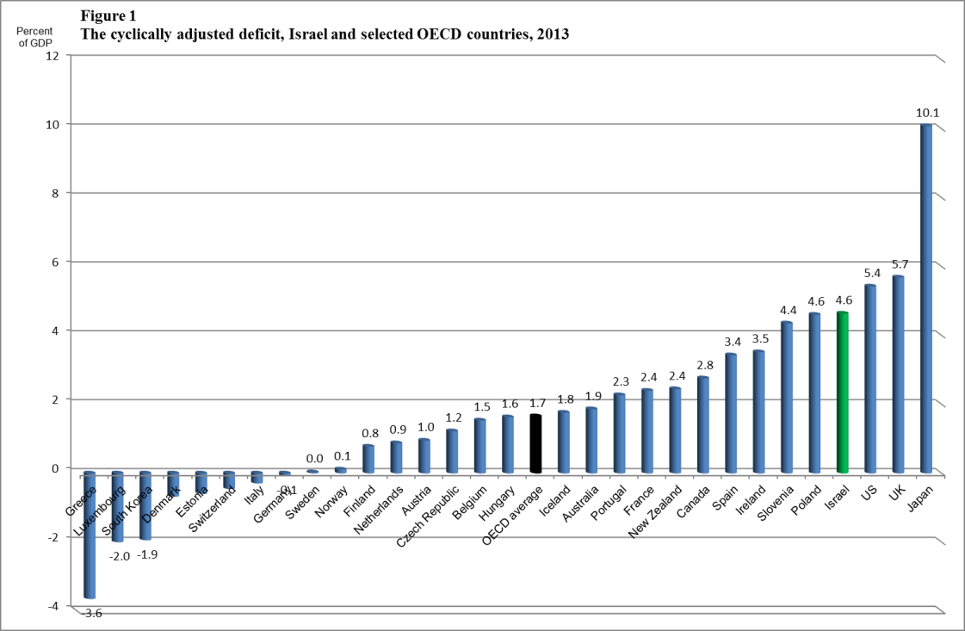

* Deficit data for Israel are adjusted to the common international definition.

After an extended decline in the past decade, the share of taxes in GDP increased slightly in 2013, and the share of public expenditure in GDP stabilized at around 39 percent (Table 1); both shares are low compared with most of the advanced economies. The ratio of public debt to GDP declined slightly and its level is low compared with most advanced economies.[1] The share of primary civilian expenditure in GDP stabilized in recent years at a very low level compared with other advanced economies, despite the decline in the share of total public expenditure, due to the extended decline in the ratio of defense and interest expenditure to GDP. Toward the end of 2013, when it became clear that the level of expenditure expected in 2014 was lower than originally budgeted, the government cancelled the plan to raise tax rates in 2014, deferred part of the increase in National Insurance fees, and reduced the expenditure ceiling for 2014 by an amount equal to the estimated loss of revenues, NIS 3.75 billion.[2] At the same time, the government and the Knesset changed the expenditure rule in a manner that will reduce the increase in public expenditure for the years 2015 and onward.[3]

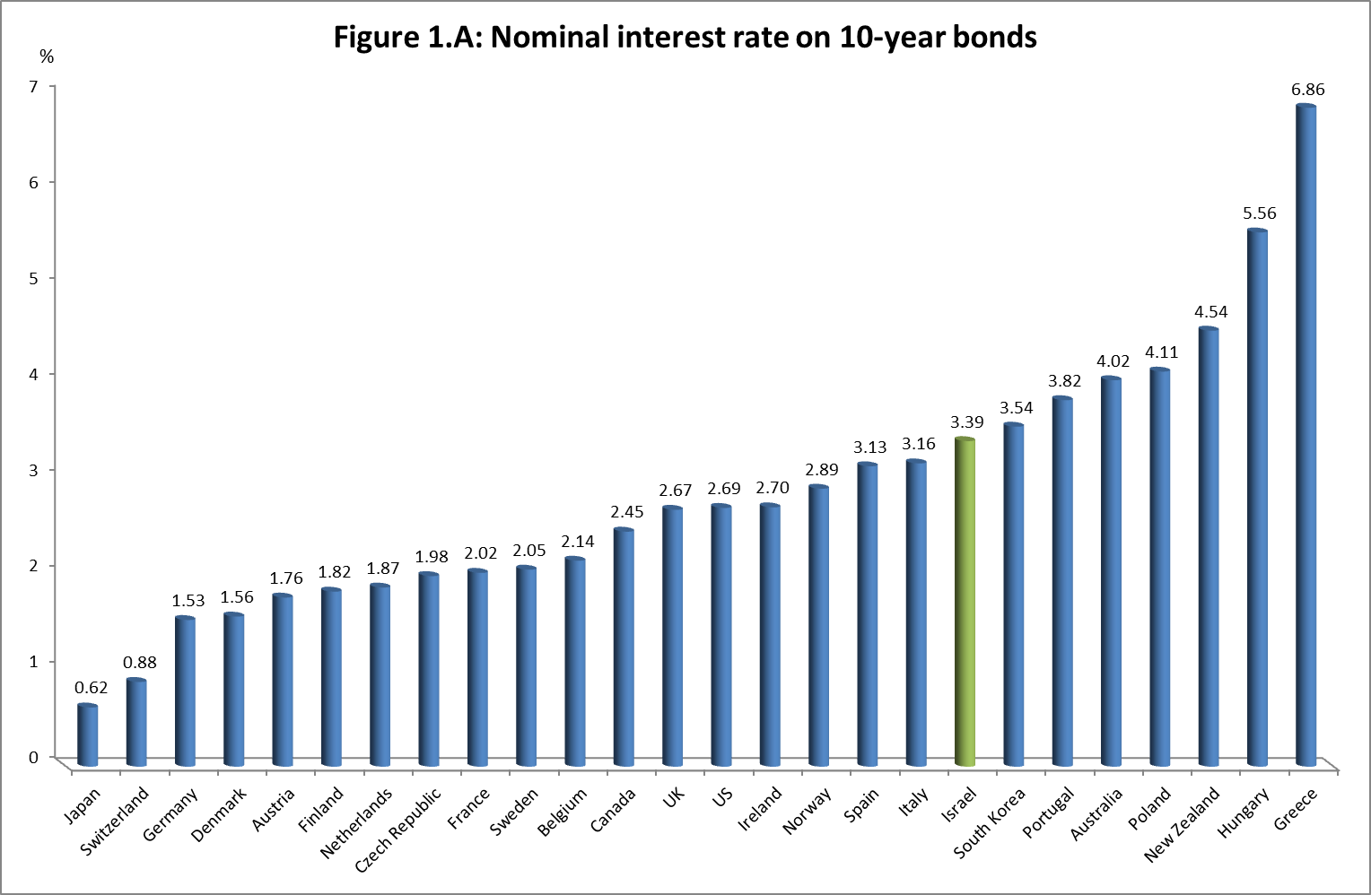

* Data as of April 2014.

After these changes, the expected deficit for 2014 is close to the target set by the government, 3 percent of GDP, assuming full performance of the budget. Tax revenues are expected to increase by about 5.5–6.0 percent in real terms, compared with 2013, due to a large extent to the increase in tax rates in the middle of 2013. The ratio of public debt to GDP is not expected to change significantly this year. With that, in the past two years, many changes have been made in tax rates and tax regulations in Israel which affect various companies, and the exceptional global interest rate environment provides an incentive for financial transactions that may have a significant impact on tax revenues in a given year. Therefore, the long-term relationship between tax revenues and real macroeconomic variables may be more volatile over the short term than previously. Additionally, the volatile environment is also reflected in notable changes in quarterly National Accounts projections, which may increase the volatility of tax estimates which are based on them.

**Table 1**

**Main budget aggregates, 2000–13**

**National Accounts Definition (in percent of GDP)**



1. **The expenditure ceiling and projected deficit for 2015**

The change in the fiscal rule which sets the expenditure ceiling reduced the permitted increase in government expenditures in 2015, following the reduction of the expenditure base itself from 2014 which was intended to allow the cancellation of tax increases. The new rule establishes that the real increase in government expenditures will be in accordance with the population growth rate in the preceding 3 years (1.8 percent over the determining years for 2015) plus the ratio of 50 (reflecting the long term target debt to GDP ratio) to the debt to GDP ratio in the last known year (67.4 percent at the end of 2013). Based on this calculation, the permitted real increase in the 2015 budget is 2.6 percent, which means an addition of NIS 8 billion (Table 2). With that, the real rate of increase in the government budget is adjusted each year (or every 2 years, when two-year budgets were administered) for the gap between the price forecast used in preparing the previous budget and actual prices in that year.[4] The significance of this adjustment, if implemented, is that the real increase in the 2015 budget will be only 1.1 percent, or NIS 3.3 billion. However, this year there is a legal question whether the price adjustment is required, since the government switched to a new expenditure rule and therefore it is not a routine update of the budget based on an existing rule.

Although the price adjustment in the 2015 budget is large compared to previous years, inter-alia because the 2013–14 budget is a two-year budget, significant price adjustments were necessary in past years as well. This process, which is implemented after the approval of the budget by the government, is a necessity as long as government budgets are based on a price forecast which varies from year to year, due to the concern that the projection will be used as a tool to increase or decrease the real budget.[5] Since the average rate of inflation over the past decade is in the middle of the target range set by government, because in Israel there is not a systematic gap between the rate of increase of public consumption prices and the CPI, and since annual changes in the CPI in any case are not considerably relevant to the government’s expenditure path, the time has come to switch to adjusting the expenditure ceiling each year on the basis of the midpoint of the inflation target range.[6] Such a move would save the need for retroactive adjustments of the expenditure ceiling, without exposing the process of setting budget prices to manipulations.

**Table 2**

**Calculation of expenditure ceiling for 2015**



A comparison of the expenditure ceiling to expenditure projections derived from the current level of expenditure, the added cost deriving from the plans approved by the government and by Knesset legislation, and from the effect of various demographic and economic trends, indicates that such projections are significantly higher than the ceiling. One of the reasons for the gap is that some of the measures adopted by the government in order to reduce expenditures in 2014 are nonrecurring, and added to that are an increase in the education budget based on previous decisions and the broad transportation infrastructure investment plan. To the extent that a price adjustment, as described above, is not carried out, the gap between expenditure estimates and the ceiling is assessed at about NIS 7 billion, and if the price adjustment is carried out it will grow to more than NIS 12 billion. This gap is calculated based on conservative assumptions that 1) defense expenditure in 2015 will be in accordance with the multiyear framework approved by the cabinet in parallel with the approval of the budget for 2013–14 by the government, and that such a framework will include the government’s expenses related to the agreement to consolidate and privatize Israel Military Industries; 2) that the law for implementing the long school day will be postponed again, 3) the Alaluf Committee recommendations for examining welfare policy will not have significant budget consequences in 2015, 4) that new wage agreements will not be signed in 2015 that will increase real public sector wages beyond that of regular wage creep[7], and 5) there will not be significant budget costs in 2015 from the reform in the Israel Broadcasting Authority and the crisis at Hadassah Medical Center. In contrast, the analysis assumes that several budget items in which expenditure was lower than budgeted in recent years will continue to be budgeted at similar sizes, so that they will allow at least partial offsetting of the possible additions.

The gap between the cost of programs approved by the government and the expenditure ceiling ahead of the 2015 budget is smaller than the one faced by the government when approving the 2013–14 budget. Nonetheless, it is a large gap compared with the previous years. This gap reflects to a large extent the tension between the endeavor to maintain the tax burden—and consequently the expenditure level—low, and the desire to provide a response to various social and economic needs, reflected in government decisions and in legislation requiring an increase in expenditures. With that, the lack of systematic monitoring of the gap between the cost of programs approved by the government and the expenditure ceiling set by the fiscal rule also contributes to the creation of the gap. As a result, various plans approved by the government are not implemented, in whole or in part, and it also creates uncertainty and planning difficulties in the government ministries, in households and businesses, which are affected by these programs. To avoid a repeat of the process which led to the current problem, it is important that the government soon adopts an effective system to control the framework of its expenditures in the coming years, which will monitor its expenditure commitments and require an immediate reaction to the development of deviations from the expenditure ceiling for coming years.[8]

The deficit ceiling set by law for 2015 is 2.5 percent of GDP, and based on estimates derived from the Bank of Israel Research Department’s tax model[9], policy measures to increase revenues or to reduce expenditures to below the ceiling will be required in order not to deviate from that level. The size of the required measures depends on whether a price adjustment will be made when calculating the expenditure ceiling. If the adjustment is made, and the expenditure increase will moderate by NIS 12 billion compared with the present estimation, the deficit is expected to be 3.0 percent of GDP, and the additional revenues that will be required in order not to deviate from the deficit ceiling will be about NIS 6 billion, an addition that reflects, among other things, revenue losses of more than NIS 2.5 billion related to the government decision to set a VAT rate of 0 percent on most first-time homebuyers, which is expected to be implemented by the beginning of 2015. If a price adjustment is not made, and the increase in expenditure is only moderated by NIS 7.3 billion, the deficit is expected to increase to 3.4 percent of GDP, and the additional revenues required will reach more than NIS 10.5 billion. The combination of required adjustments in order not to deviate from the deficit ceiling is thus about NIS 18 billion, which is 1.6 percent of GDP.

1. **Forecast and scenarios for 2015–20**

The deficit and expenditure ceilings set by law are multiyear and are intended to create a stable framework which allows government planning of its expenditures and tax rates over time, along with support for macroeconomic stability. Beyond the above analysis, which examined the development expected in 2015, it is therefore important to examine their effects on fiscal policy over the rest of the decade. This analysis is presented under the assumption that the economy’s growth rates from 2016 and onward will be, on average, 3 percent per year, a growth rate which takes into account the demographic changes occurring in Israel.[10] Based on the analysis, meeting the deficit target will allow the government to gradually reduce the debt to GDP ratio to about 60 percent in 2020 (the green line in Figure 2). However, meeting the expenditure ceiling without measures to increase revenues (including in 2015) will keep the debt to GDP ratio in coming years at its current level, in particular in a case in which no price adjustment is made in 2015 (the red line in Figure 2).

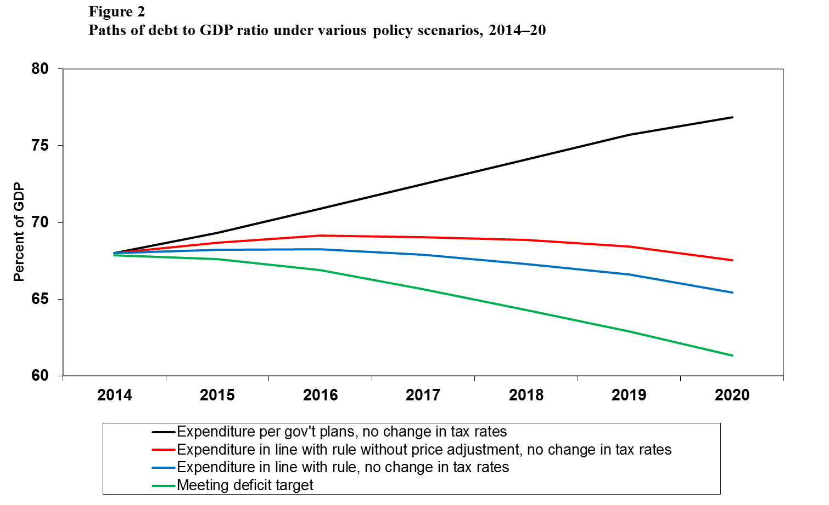

Based on the expenditure rule, the expenditure ceiling is expected to increase at an average annual rate of 2.5 percent. The impact of this framework is an extended decline in the share of public expenditure in GDP which by 2020 will reach more than 1.5 percentage points compared with 2013–14 (the blue and red lines in Figure 3). In order to realize this decline, the government will need to significantly reduce the expenditure programs, which it decided upon, in the years after 2015 as well, even if the entire adjustment in the 2015 budget will be based on permanent measures. The size of the additional adjustment required in 2016 is NIS 6 billion, and in 2017 an adjustment of another NIS 5 billion will be required (assuming that the adjustment in 2016 will also be permanent). This gap reflects the basic dynamic of the various items in the state budget such as education expenses, some National Insurance allowances, and health expenditures—which accounts for most of the increase allowed under the expenditure rule—along with decisions on the multiyear framework of defense expenditures adopted in 2013 and the multiyear investment plan in transportation infrastructure. In addition, the framework reflects the effects of a projected gradual increase in global interest rates over the rest of the decade.[11] The framework is presented by the black line in Figure 3, and the gap between it and the blue or red lines represents the size of the adjustment (in percent of GDP) that will be required in order not to deviate from the expenditure ceiling. It is important to note that this framework assumes that the government will not decide on any additional expenditure until the end of the decade without reducing another expenditure item by a parallel amount.

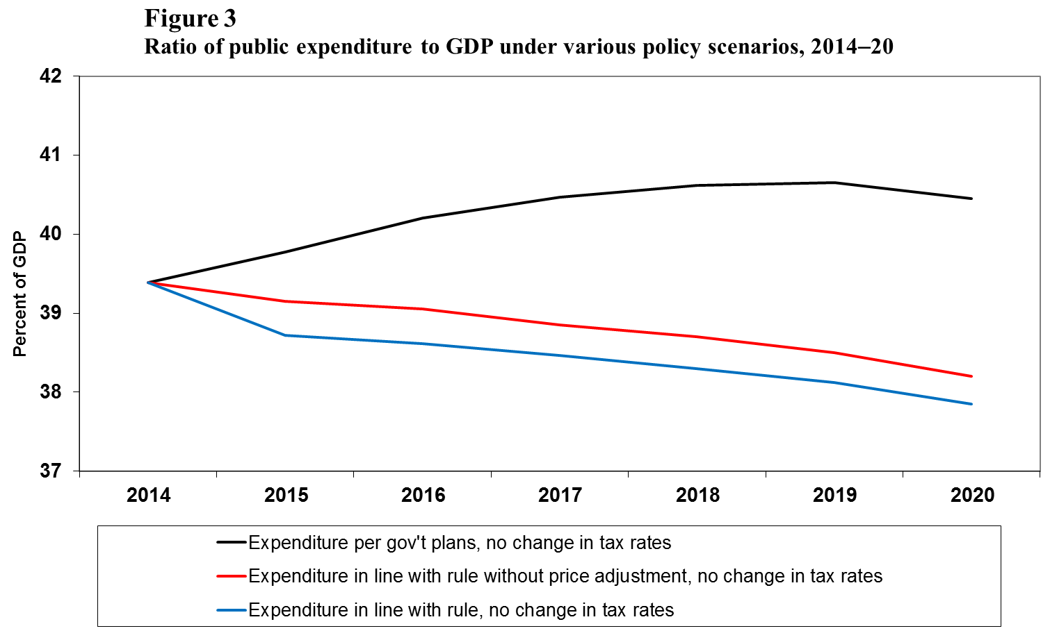

The Deficit Reduction Law sets declining targets: from 2.5 percent of GDP in 2015 to 2 percent of GDP in 2016 and to 1.5 percent of GDP in 2019 (the green line in Figure 4). Assuming that government expenditures increase in line with the expenditure rule, and that the required adjustments will be implemented in order not to deviate from the deficit ceiling in 2015, revenues will need to be increased by about NIS 4 billion in order to reduce the deficit in 2016 to the ceiling of 2 percent of GDP (the gap between the blue and red lines from the green line in Figure 4). The gap between the black line and the green line in Figure 4 reflects the total adjustments required each year—on the revenues and expenditures sides—in order not to deviate from the deficit ceiling.

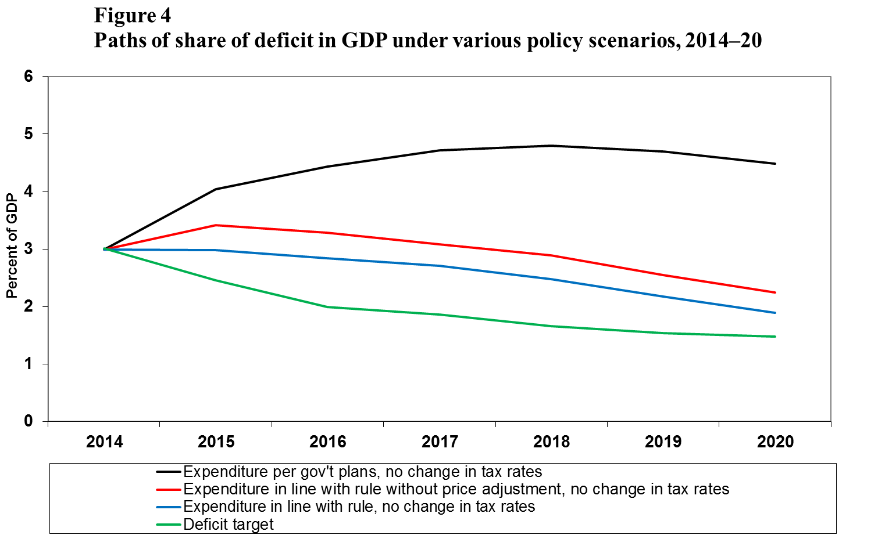

Meeting the deficit ceiling also has a marked impact on the interest payments that the government will need to pay in the future. For example, interest payments estimated for 2020 under the policy framework in which the expenditure ceiling is maintained throughout the period (without price adjustment in 2015) and without measures on the revenue side beyond existing legislation are about NIS 4.5 billion greater compared with the framework of meeting the deficit target. This gap highlights deficit reduction’s important contribution to making budgetary resources available over the long term, over and above its contribution to reducing the economy’s risk premium.

The analysis above is very sensitive to assumptions of the future growth rate of the economy. The present estimation was based on very similar assumptions to those of the OECD and other entities covering Israel’s economy, but there is still some uncertainty regarding them. An analysis of how the deficit path will be affected by a framework in which the government meets the expenditure ceiling but does not increase revenues indicates that if growth will be 4 percent per year, on average, the government will be able to meet the reduced deficit targets beginning in 2018 (the black line in Figure 5). In contrast, a decline in the assumed growth rate to an average of 2 percent is expected to lead to a gradual increase of the deficit (the red line in Figure 5) and to a concurrent increase in the debt to GDP ratio to over 70 percent of GDP.

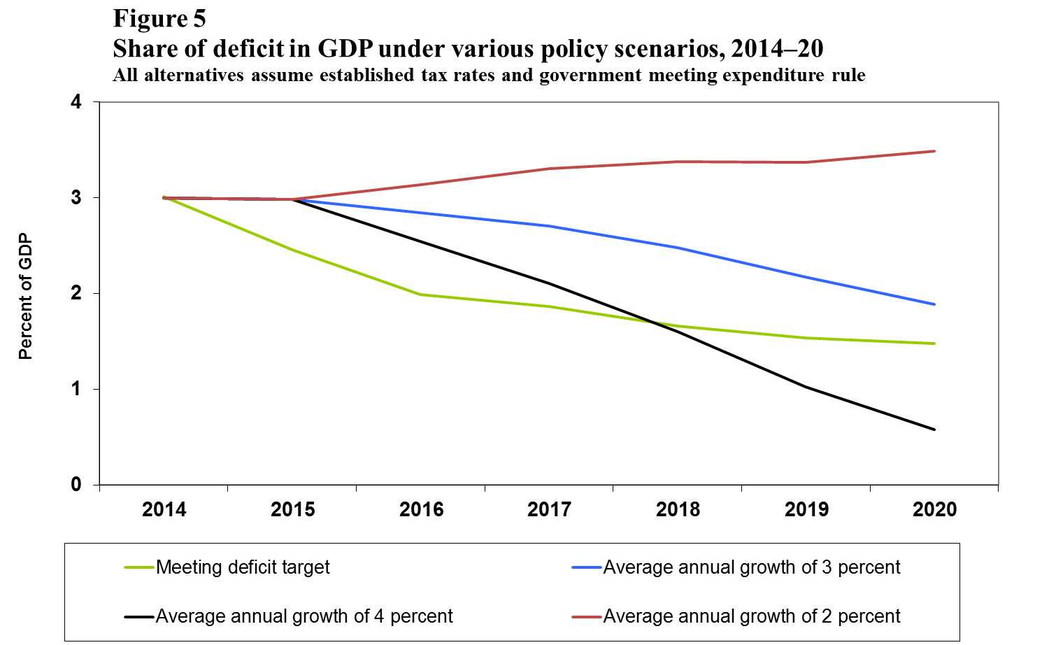

1. An international comparison of main aggregates was presented in the previous edition of Recent Economic Developments—number 136, (2014) Bank of Israel.
2. The decline reduces the budget base for coming years as well.
3. For further detail, see Chapter 6 of the Bank of Israel Annual Report for 2013.
4. In the 2015 budget, it is the difference between the increase in prices in 2013 and 2014 and the forecasts in the two-year budget approved in July 2013.
5. That is, that the price forecast will not be “inflated” so that expenditure is increased by more than permitted. The current mechanism guarantees that in such a case the government will need to reduce the budget in the following year in accordance with the deviation of the forecast from the actual increase in prices.
6. For a detailed discussion see Chapter 1 of the Bank of Israel Annual Report for 2013.
7. Wage creep in the public sector increases real wages by almost 1 percent per year and is responsible for two-thirds of the total increase in wages in the public sector—Mazar, Yuval “The Development of Wages in the Public Sector and Their Connection with Wages in the Private Sector”, Discussion Paper Series, 2014, Bank of Israel.
8. A discussion of the way that a lack of monitoring increases in government programs affects missing fiscal targets appears in Brender, Adi, “If You Want to Cut, Cut, Don’t Talk: The Role of Formal Targets in Israel’s Fiscal Consolidation, 1985–2007”, Israel Tax and Economics Quarterly, 33:129, May 2009, pp. 33–37. For documentation of the deviations from the deficit targets, see Chapter 6 of the Bank of Israel Annual Report for 2012.
9. A detailed description of the tax model appears in Brender, A. and G. Navon (2010), "Predicting Government Tax Revenues and Analyzing Forecast Uncertainty," *Israel Economic Review*, vol. 7 No 2, 81-111. The forecast for 2014 and 2015 is also based on the Research Department’s macroeconomic forecast which was published at the end of March 2014.
10. A discussion of the factors affecting the change in Israel’s long-term growth rate appears in Chapter 1 of the Bank of Israel Annual Report for 2011.
11. An increase in the interest rate on the public debt resulting from macroeconomic developments in Israel and worldwide is moderated in this analysis due to the effect of a reduction in the debt to GDP ratio on the risk premium of public debt in Israel. In policy frameworks and scenarios in which the debt ratio increases, interest expenses increase accordingly. For a discussion of the effect of fiscal policy on interest, see Ber, Brender, and Ribon (2005), “Are Fiscal and Monetary Policies Reflected in Real Yields? Evidence from a Period of Disinflation and Declining Deficit Targets”, Israel Economic Review, Vol. 2, No.2, 15–44.