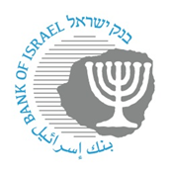
BANK OF ISRAEL
Office of the Spokesperson and Economic Information

December 26, 2023

Press Release:

The public's financial assets portfolio in the third quarter of 2023

- In the third quarter of 2023, the balance of the public’s financial assets portfolio increased by approximately NIS 59 billion (1.2 percent), to about NIS 5.07 trillion.
- The increase in the portfolio’s value in the third quarter was mainly due to an increase in the balance of equities in Israel (4.7 percent) and more moderate increases in most of the other components of the portfolio.
- The balance of the asset portfolio managed by institutional investors increased in the third quarter by approximately NIS 20 billion (0.8 percent), to about NIS 2.44 trillion at the end of the quarter.
- Institutional investors’ rate of exposure to foreign currency remained unchanged, at about 19.9 percent, while their exposure to foreign assets declined by about 0.4 percentage points, to about 41.5 percent.
- The value of the portfolio managed by mutual funds in Israel increased by about NIS 25.3 billion (6.3 percent) in the third quarter, to about NIS 429 billion. Net new investments continued, mainly in shekel money market funds and in funds specializing in foreign equities.

1. The public’s total assets portfolio

In the third quarter of 2023, the balance of the public’s financial assets portfolio increased by approximately NIS 59 billion (1.2 percent), to about NIS 5.07 trillion (Figure 1). The weight of the public’s financial assets portfolio relative to GDP declined by about 1.6 percentage points, to about 272 percent at the end of the quarter, as a result of an increase in GDP that was greater than the increase in the asset portfolio.
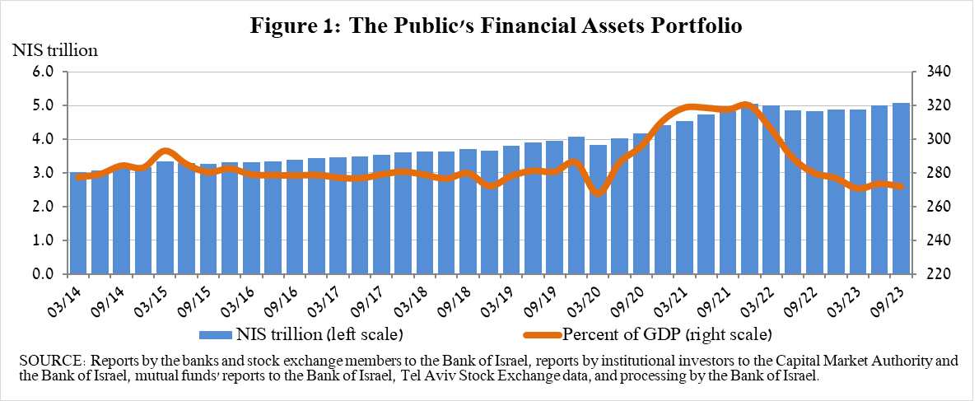

2. Analysis of the changes in the overall portfolio

Over the course of the third quarter, there were increases in the balances of the public’s holdings in most components of the portfolio. The increases in the balance of equities in Israel (4.7 percent), and the balance of other assets (about 2 percent) were notable.

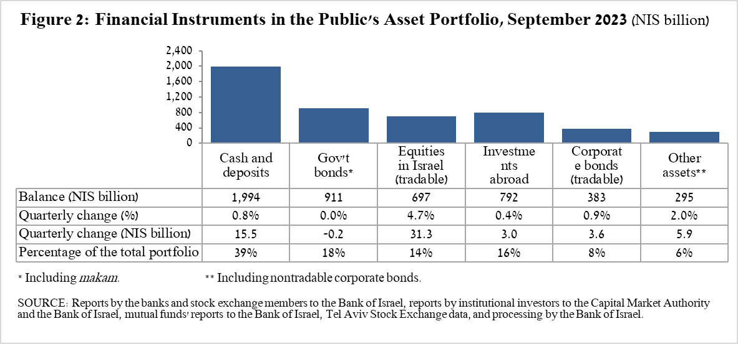

- The balance of equities in Israel increased by about NIS 31 billion (4.7 percent), in view of price increases on equity indices and net investments (estimated at about NIS 1.5 billion).
- The balance of tradable corporate bonds in Israel increased by about NIS 3.6 billion, to about NIS 383 billion at the end of the quarter. This was a result of price increases, which were slightly offset by net realizations.
- The balance of cash and deposits increased during the third quarter by about NIS 15 billion (0.8 percent) to about NIS 1.99 trillion.

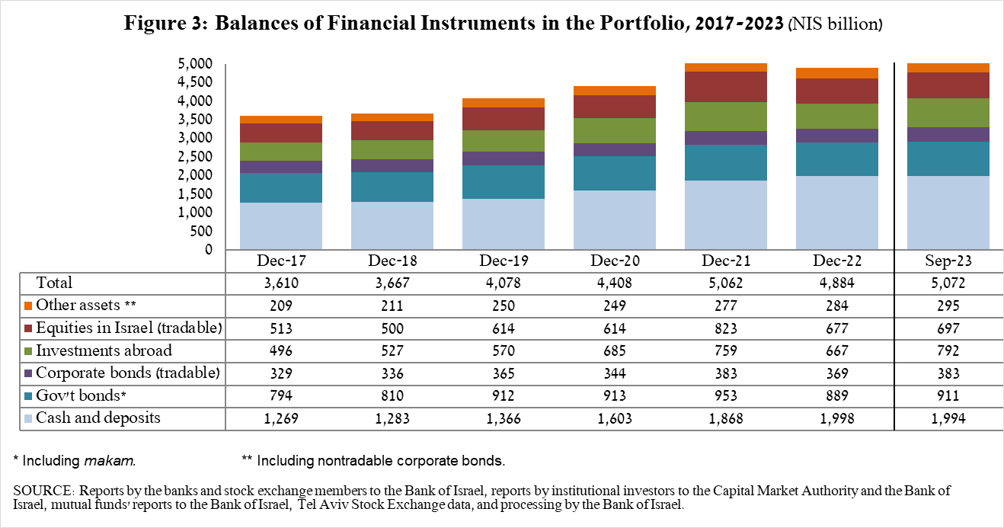

The balance of investments abroad increased by approximately NIS 3 billion (0.4 percent) during the quarter, to about NIS 792 billion, constituting about 16 percent of the total asset portfolio. The increase derived from the following two components:

- The balance of tradable (corporate and government) bonds abroad increased by about NIS 4.4 billion (2 percent) during the quarter, to about NIS 229 billion. This increase derived mainly from the depreciation of the shekel against the US dollar (3.4 percent), which was partly offset by price declined and net realizations totaling about NIS 3.8 billion.
- The balance of equities held abroad declined by about NIS 1.4 billion (0.3 percent), to about NIS 562 billion. This was mainly the result of a combination of price declines and net realizations, which were partly offset by the depreciation of the shekel against the US dollar (3.4 percent).

As a result of developments during the quarter, there were declines of about 0.1 percentage points (from 15.7 percent to 15.6 percent) in the share of foreign assets, and of about 0.3 percentage points (from 23.6 percent to 23.3 percent) in the share of foreign currency assets.

3. The portfolio managed by institutional investors
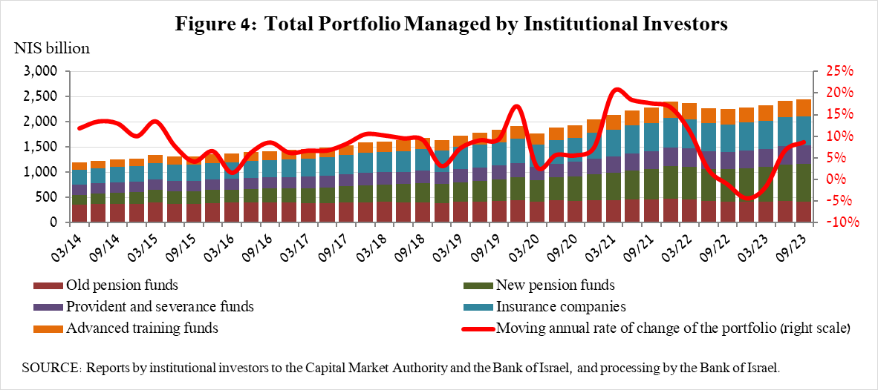

- The balance of assets managed by all institutional investors increased in the third quarter by about NIS 20 billion (0.8 percent), to about NIS 2.44 trillion (about 48 percent of the public’s total financial assets portfolio). The increase in the balance of the managed portfolio during the quarter was mainly due to changes in the following investment components: investment funds abroad—an increase of about NIS 11.8 billion (5.7 percent); ETFs on equities abroad—an increase of about NIS 5.8 billion (3.6 percent); equities in Israel—an increase of about NIS 6.8 billion (3.2 percent), mainly due to price increases; government bonds and Makam—a decline of about NIS 12.3 (1.5 percent), mainly in nontradable government bonds and Makam; and equities abroad—a decline of about NIS 3.9 billion (2.5 percent), mainly as a result of price declines.

- Exposure of the portfolio managed by institutional investors to foreign assets and to foreign currency

In the third quarter of 2023, the rate of institutional investors’ exposure to foreign assets declined by about 0.4 percentage points, to about 41.5 percent of total assets. This was a result of a decline in the balance of exposure to foreign assets (3.4 percent) that was greater than the decline in the balance of institutional investors’ total assets (2.4 percent) in dollar terms.
The decline in the balance of exposure to foreign assets (about $8.8 billion) derived mainly from a decline in exposure through futures contracts and options on foreign equity indices (about $4.2 billion), and in the balance of equities abroad (about $3 billion).

Exposure to foreign currency—During the third quarter of 2023, institutional investors’ rate of exposure to foreign exchange (including shekel/forex derivatives) remained unchanged at about 19.9 percent.

During the quarter, institutional investors made net purchases of foreign currency assets, totaling about $1.6 billion—sales totaling about $1.1 billion in assets denominated in and linked to foreign currency (mainly in demand deposits in Israel denominated in foreign exchange, and bonds), which were more than offset by net purchases of foreign exchange through derivative financial instruments totaling about $2.7 billion, meaning a decline in futures transactions for the sale of foreign exchange.
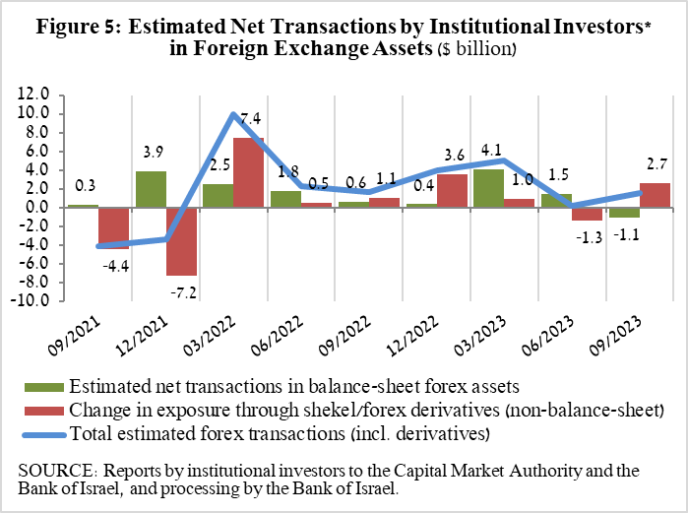
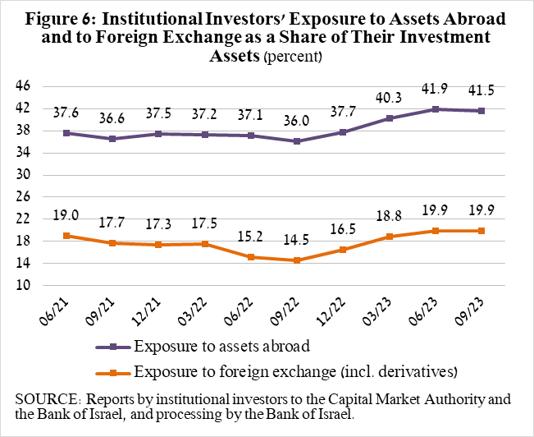

4. The portfolio managed by mutual funds

The value of the portfolio managed by Israeli mutual funds increased in the third quarter by about NIS 25.3 billion (6.3 percent), to about NIS 429 billion, constituting about 8 percent of the public’s total asset portfolio.

The increase in the third quarter derived mainly from net investment in the funds totaling about NIS 23 billion. Most of the new investment was in shekel money market funds, totaling about NIS 11.9 billion, further to the trend since the beginning of 2022, and in funds specializing in equities abroad totaling about NIS 7.9 billion. In contrast, there were net withdrawals of about NIS 1.5 billion from funds specializing in general bonds in Israel, and of about NIS 1.5 billion from funds specializing in government bonds in Israel.

Until the end of November, there were net new investments totaling about NIS 11.1 billion, and the balance of the portfolio managed by Israeli mutual funds increased to about NIS 441.5 billion. Most of the new investments were in shekel money market funds, totaling about NIS 8.7 billion.

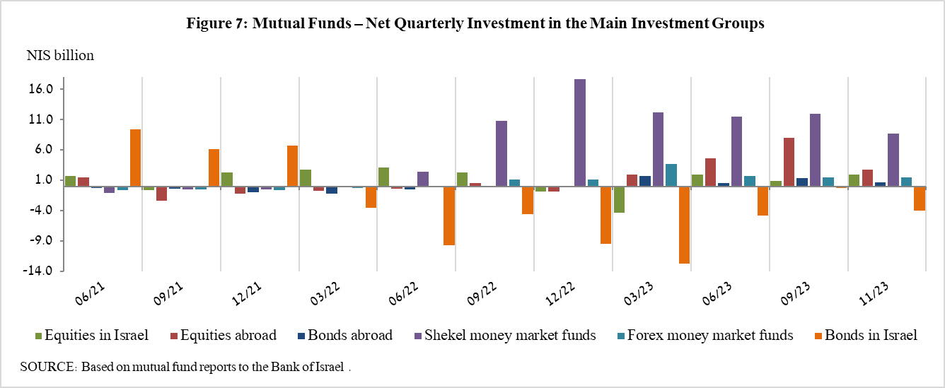

Further information and details:

Long-term tables on the asset portfolio are available here.

Long-term tables on institutional investors’ exposure to foreign exchange and to foreign assets are available here.

Long-term tables on mutual funds are available here.

Excluding mutual funds.
Estimates of members’ exposure (rather than exposure of the institutional investors themselves) to various risks in the portfolio managed for them by the institutional investors (excluding insurance policies with a guaranteed yield, where the risk is taken on by the institutional investors). For additional details on definitions, terms, and explanations, see “Measuring the Exposures of Institutional Investors to Foreign Currency and to Foreign Assets” in the Bank of Israel’s Statistical Bulletin for 2016.

