

BANK OF ISRAEL

Office of the Spokesperson and Economic Information

August 5, 2024

Press Release:

Israel’s foreign currency market in the second quarter of 2024

**1. The Exchange Rate**

**A weakening of the shekel alongside strengthening of the US dollar worldwide.**

During the course of the second quarter, the shekel weakened by 2.1 percent against the US dollar, and by 1 percent against the euro. In addition, the shekel weakened by 1.3 percent against the currencies of Israel's main trading partners, in terms of the nominal effective exchange rate (i.e., the trade-weighted average shekel exchange rate against those currencies).

In parallel, the US dollar strengthened against main currencies (Figure 2) during the quarter—by approximately 6.4 percent against the Japanese yen and by 1.1 percent against the euro. It weakened by about 1.9 percent against the Australian dollar.

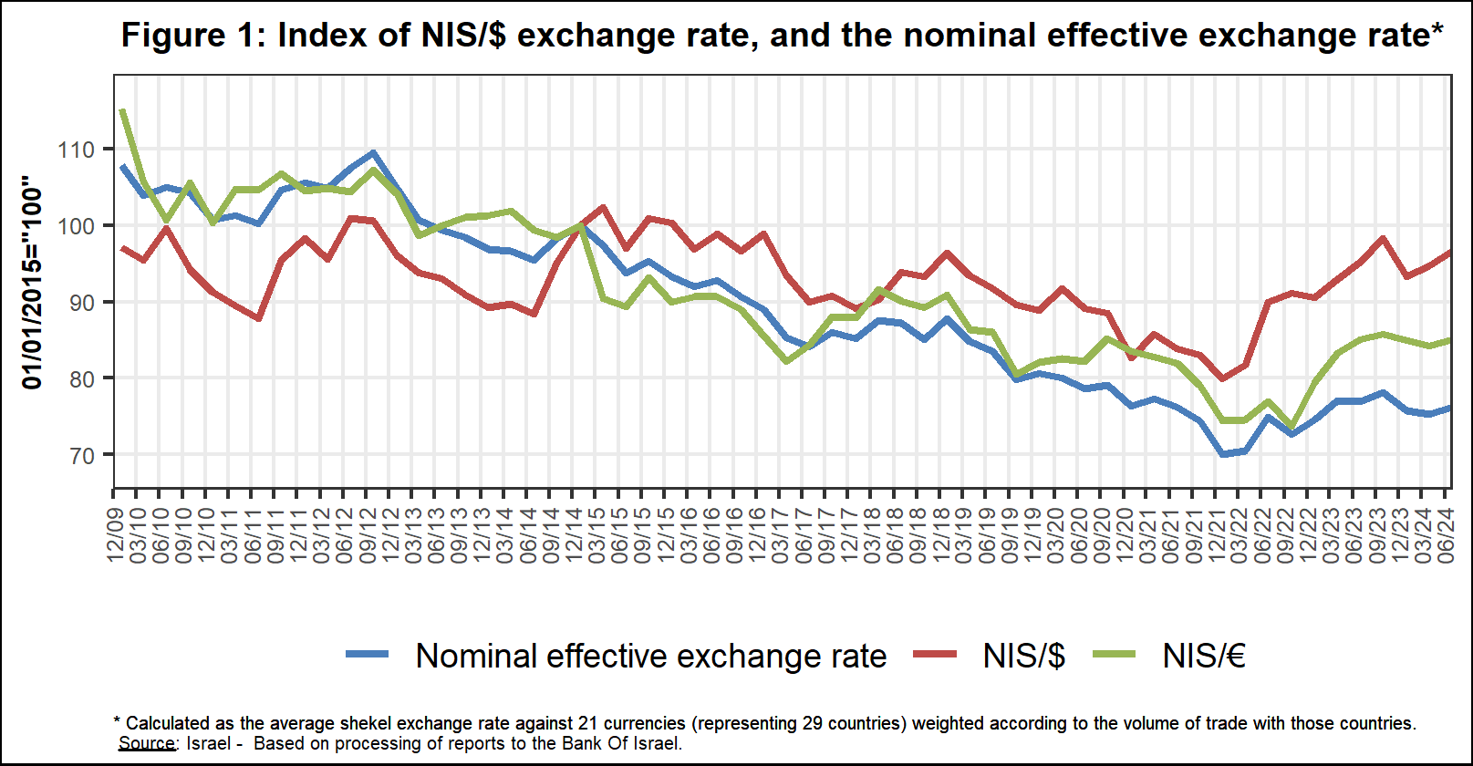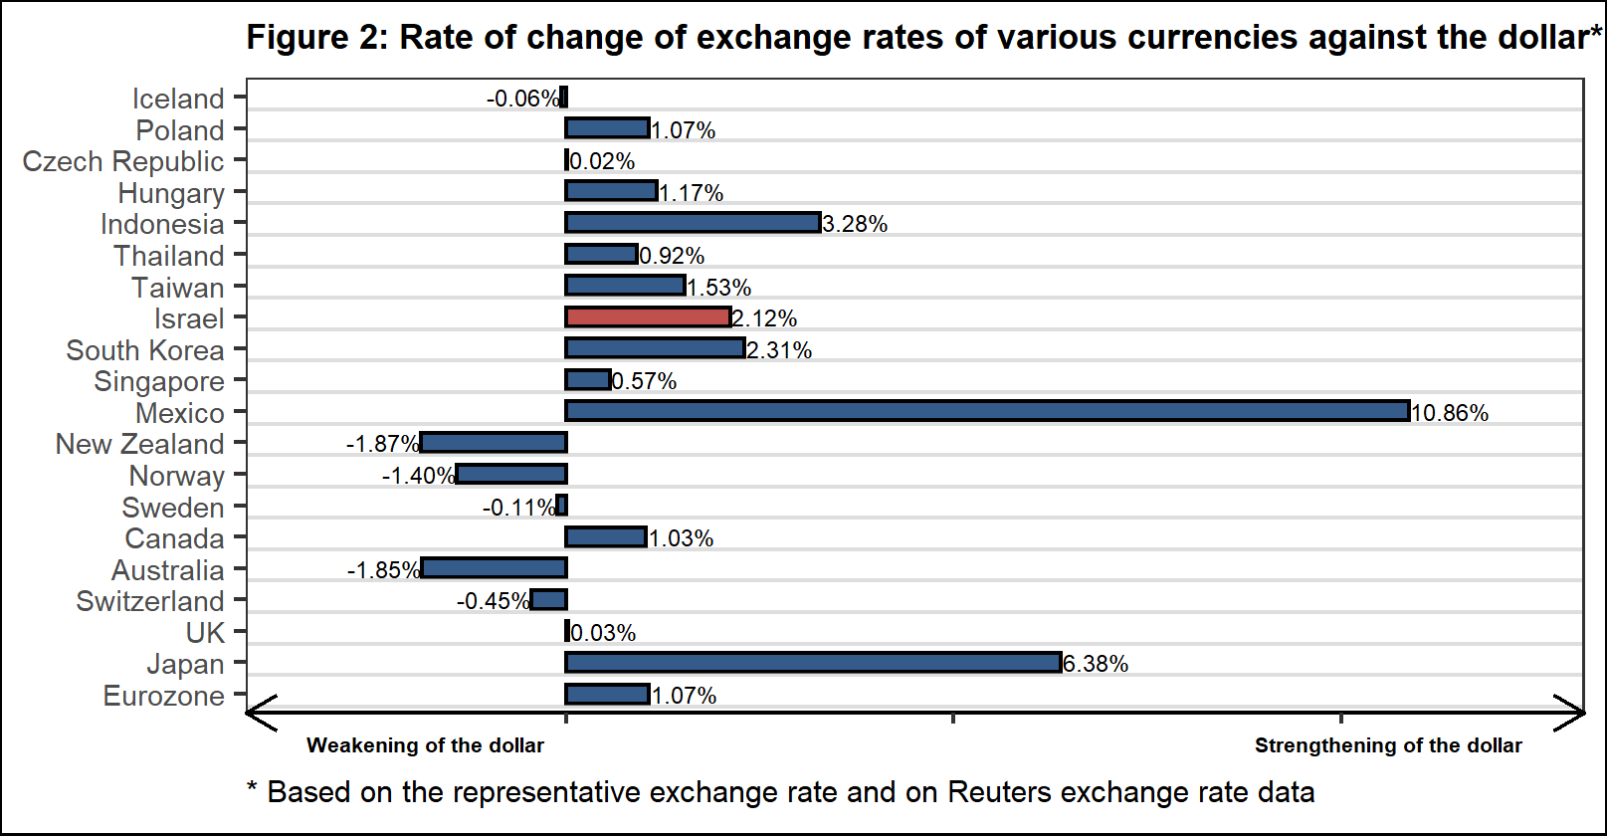

**2. Exchange Rate Volatility**

**An increase in actual volatility**

The standard deviation of changes in the shekel/dollar exchange rate, which represents its **actual** volatility, increased by 1.2 percentage points during the quarter, to an average level of 11.5 percent.

The average implied volatility in over-the-counter shekel/dollar options, an indication of **expected** exchange rate volatility, remained unchanged during the quarter, at an average level of about 10.1 percent.

For comparison, the average level of implied volatility in foreign exchange options in emerging markets was 9.8 percent at the end of the quarter, an increase of 0.1 percentage points from its level at the end of the previous quarter. The average level of implied volatility in advanced-economy markets was 6.9 percent during the quarter, a decline of about 0.2 percentage points from the previous quarter (Figure 4).

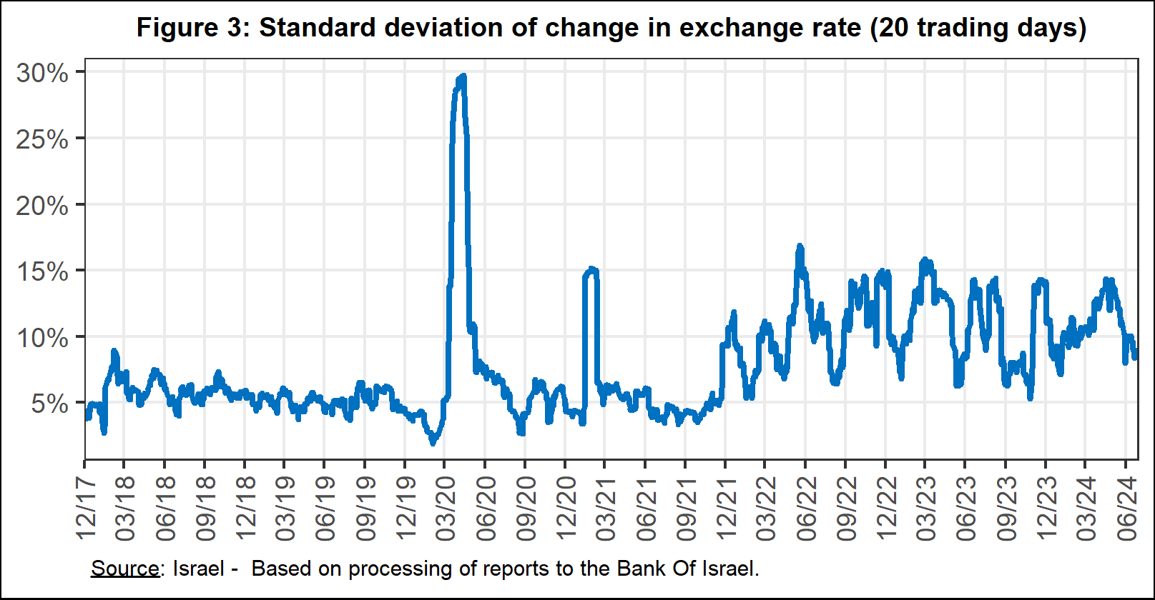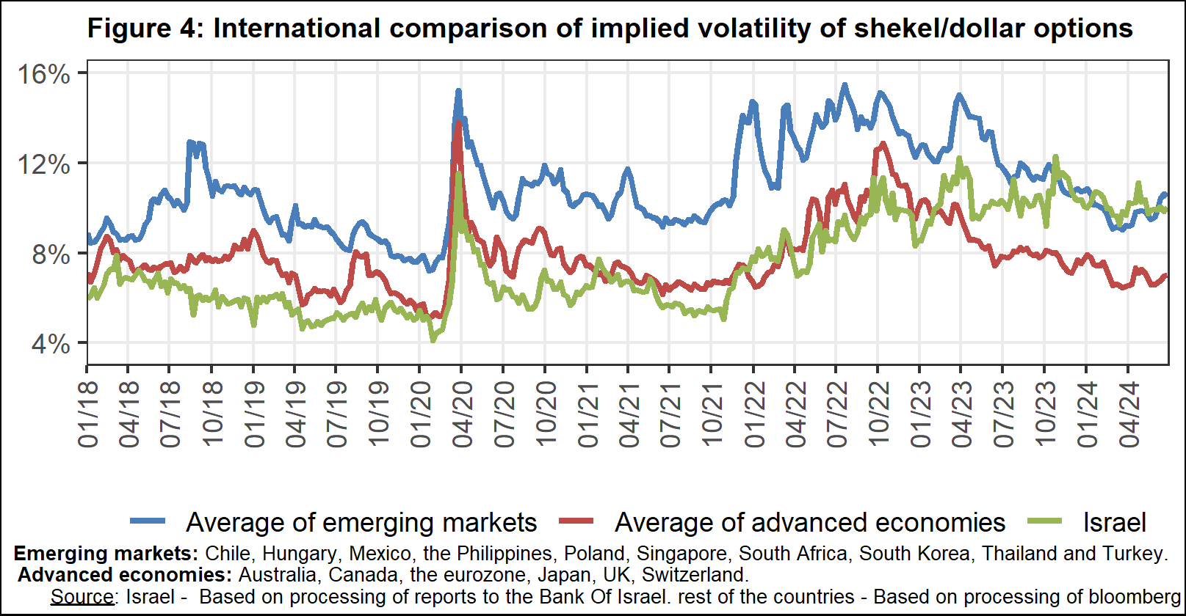

**3. The Activity of the Main Segments in the Foreign Exchange Market[1]**

An estimate of the activity of the **main** segments in the foreign exchange market indicates that during the course of the second quarter, **institutional investors (pension funds, provident funds, and insurance companies)** made net foreign currency sales of about $0.5 billion, and **the business sector** made net sales of about $2.5 billion. **The financial** sector made net purchases of about $1.4 billion, and **nonresidents** made net purchasesof about $0.4 billion.

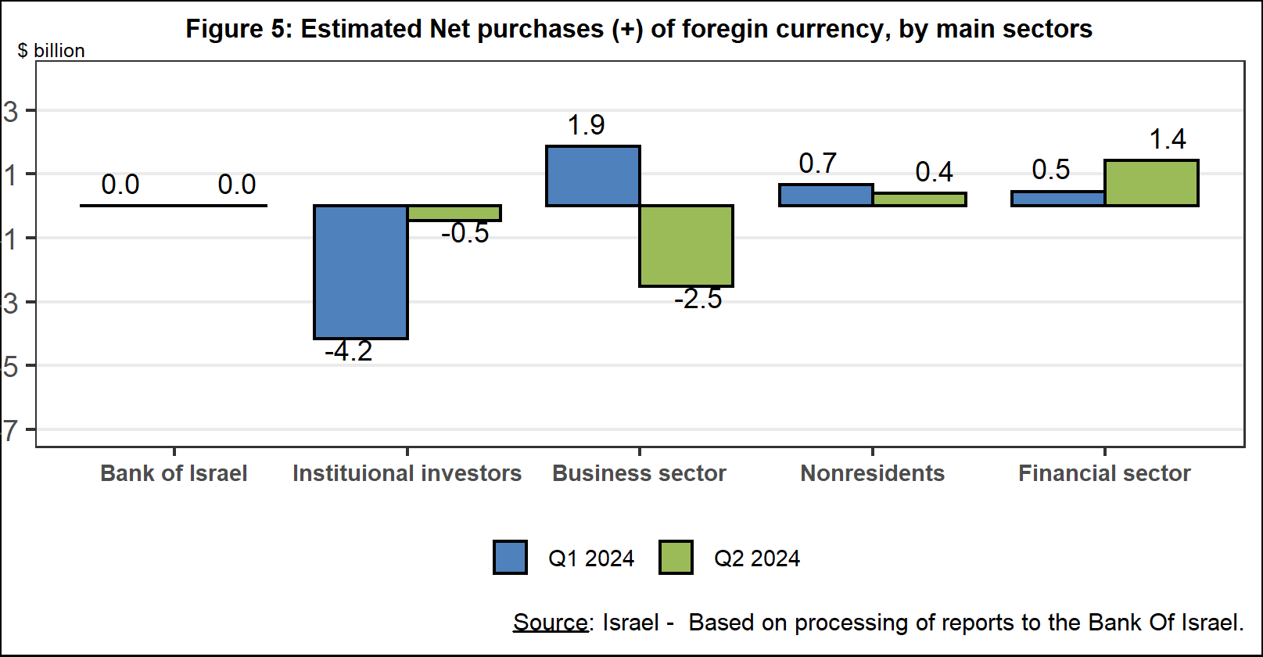

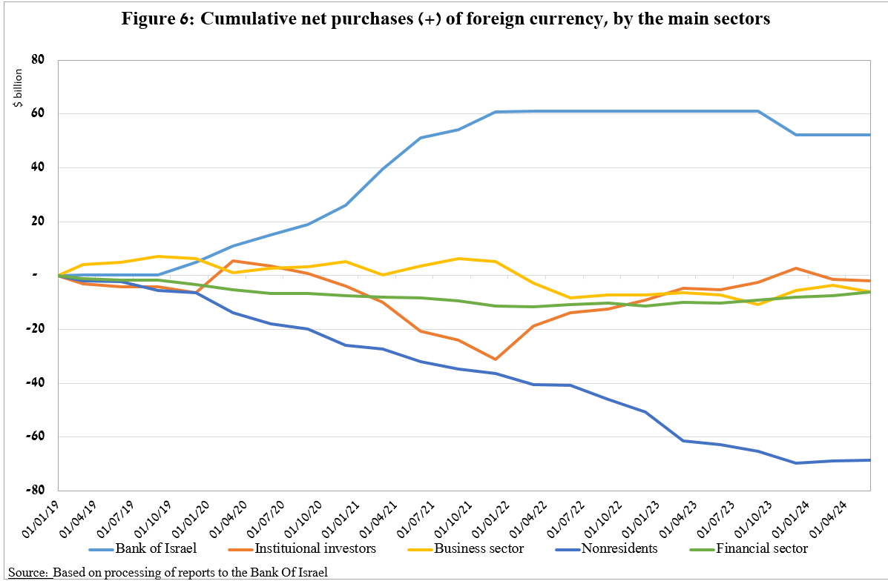

**4. Trading Volume in the Foreign Currency Market—Tables and Figures**

**Trading volume vis-à-vis the domestic banking system[2]**

**The average daily trading** **volume** increased by about 5.3 percent during the quarter to $10.9 billion, mainly due to an increase in the daily trading volume in swaps.

**Nonresidents' share of total trading volume vis-à-vis the domestic banking system** (spot and forward transactions, options, and swaps) increased by about 3.9 percentage points to about 45.1 percent at the end of the second quarter.

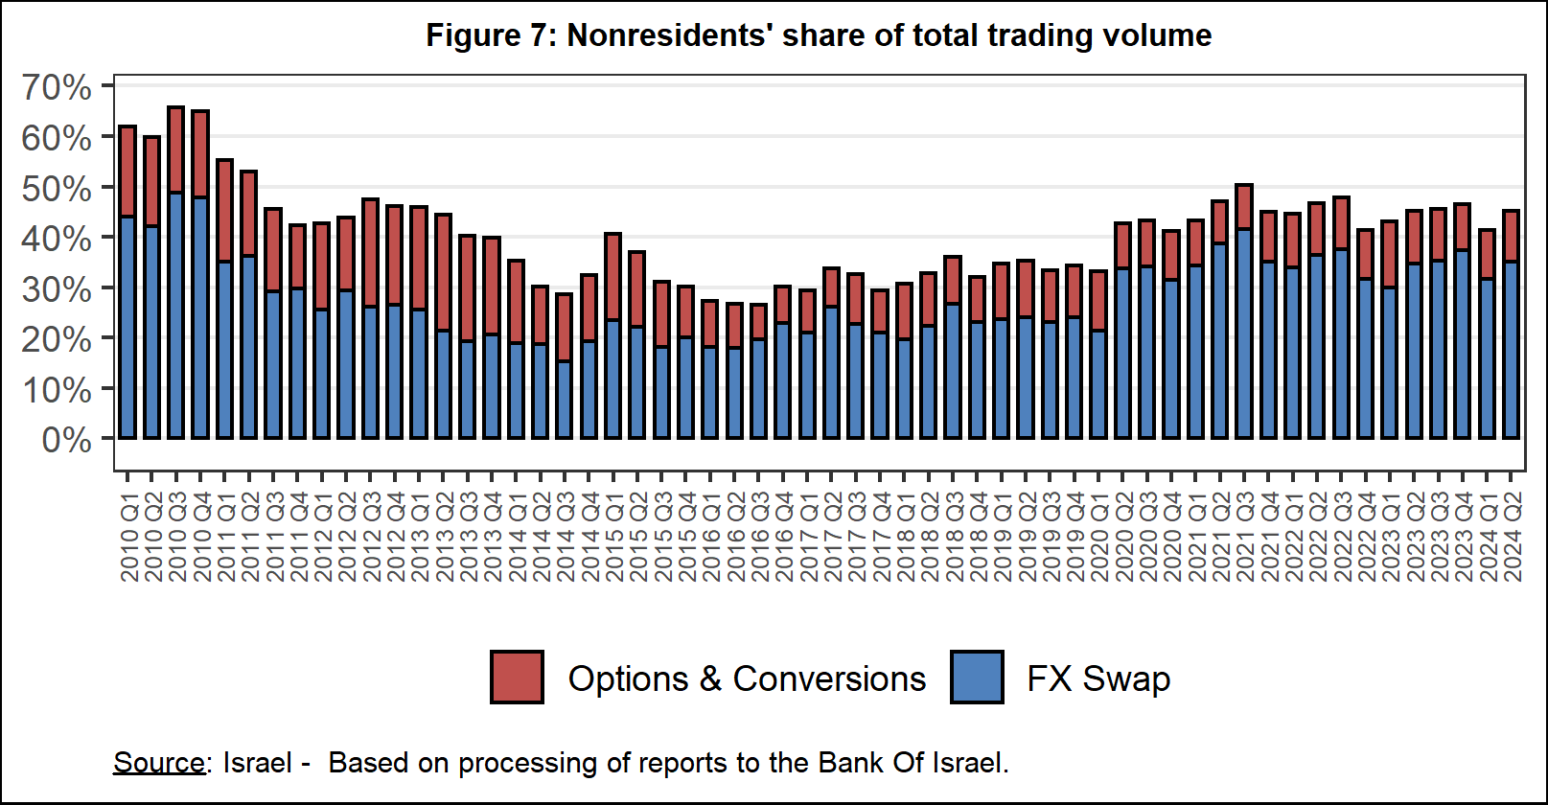



**Estimated total trading volume[3]—domestic banking system and foreign reporting entities**

The estimated total activity in transactions against the shekel as reflected in reports from the domestic banking system and foreign reporting entities indicates that nonresidents’ relative share of trading volume in spot and forward transactions (excluding swaps and options) was about 81 percent in the second quarter. Trade between nonresidents constituted about 71 percent of the volume, which had a daily average of about $10.3 billion.



1. The main segments presented do not make up the entire market—for additional information, see the section on “The Database of Foreign Exchange Market Activity” in the Bank of Israel's "Statistical Bulletin" for 2018:

   https://boi.org.il/en/communication-and-publications/regular-publications/statistical-publications/statistical-bulletin-2018/
2. From the beginning of 2020, the data do not include branches of foreign banks in Israel.
3. Total trading volume is an estimate of total activity in transactions against the shekel, based on reports by the domestic banking system and by foreign reporting entities.