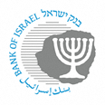

BANK OF ISRAEL

Office of the Spokesperson and Economic Information

February 7, 2021

Press Release:

Foreign Exchange Reserves at the Bank of Israel, January 2021

Israel’s foreign exchange reserves at the end of January 2021 stood at $179,507 million, an increase of $6,210 million from their level at the end of the previous month. The reserves represent 44.9 percent of GDP (Figure 1).

The increase was the result of:

* 1. Foreign exchange purchases by the Bank of Israel totaling $6,832 million.
  2. Government transfers from abroad totaling approximately $287 million.

In contrast, the increase was partly offset by:

1. A revaluation[1] that decreased the reserves by approximately $857 million.
2. Private sector transfers of approximately $52 million.

**Israel's Foreign Exchange Reserves (**$ million)

| **Date** | **Reserves excluding IMF (including reserves bought under the natural gas purchase program)** | **Reserves at the IMF[2]** | **Total Foreign Exchange Reserves** |
| --- | --- | --- | --- |
| January 2020 | 128,234c | 1,744 | 129,978c |
| February 2020 | 129,451c | 1,725 | 131,176c |
| March 2020 | 124,231c | 1,710 | 125,941c |
| April 2020 | 131,755c | 1,792 | 133,547c |
| May 2020 | 140,650 | 1,863 | 142,513 |
| June 2020 | 145,499 | 1,838 | 147,337 |
| July 2020 | 155,772c | 1,891 | 157,663c |
| August 2020 | 159,789 | 1,899 | 161,688 |
| September 2020 | 158,700 | 1,884 | 160,584 |
| October 2020 | 158,859c | 1,889 | 160,748c |
| November 2020 | 165,033c | 1,914 | 166,947c |
| December 2020 | 171,242c | 2,055 | 173,297c |
| January 2021 | 177,450 | 2,057 | 179,507 |

**Figure 1**

**Level of foreign exchange reserves, and their ratio to GDP, 2007–21**

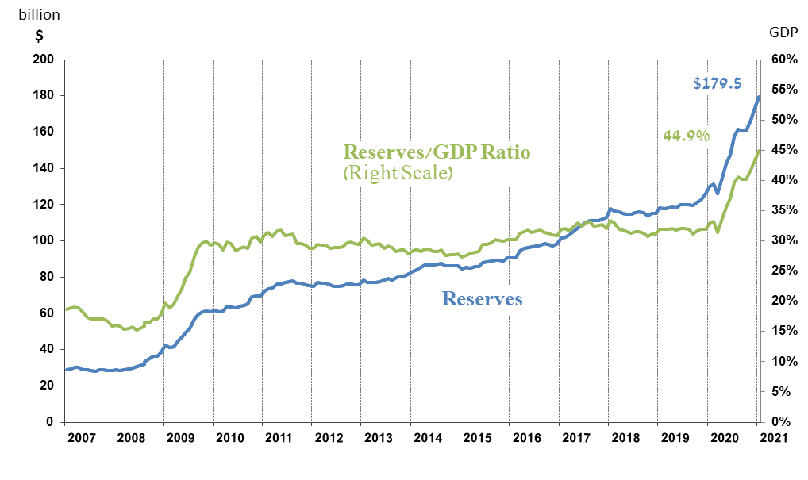

1. a Includes Bank of Israel payments and receipts in foreign currency.
2. b This column includes Special Drawing Rights (SDRs), the balance of NAB loans, and the balance of Israel's reserve tranche at the IMF.

   c Updated after the original date of publication.